

 **2017 FAST Act STSFA Grant**

**October 2021**

Regional RUC (OR/CA) Pilot project

Contents

Executive Summary 3

Project Description 3

Project Scope 4

Budget Costs 5

Project Schedule 5

Grant Objectives 5

Core System Functions 6

Architecture 6

System Design, Build & Load 8

Data 8

Demonstration Approach 8

Data Flow 9

Data Sets 10

Reporting 10

Transaction Log 10

Totals by Jurisdiction 11

RUC and Fuel Credit Summary 12

Statement of Deposit 13

Learnings & Observations 13

1. Data Conformance and Open Architecture 13

2. Prototype System Performance 14

3. Sharing RUC Data 14

Recommendations 15

Next Steps 15

Conclusion 16

Appendix 17

Additional Reports 17

# Executive Summary

Since 2013, RUC West has tackled many of the policy, organizational, technical, and operational challenges to advance transportation funding. The consortium has brought 19 states together to lay the groundwork for per-mile road usage charging (RUC). RUC West has addressed, or is actively addressing, issues such as interoperability, privacy, public education, and rural/urban equity through years of research and pilots. In 2017 RUC West’s proposal for the Regional RUC Pilot was awarded a grant by the Federal Highway Administration (FHWA) under the Surface Transportation System Funding Alternative (STSFA) program within Fixing America’s Surface Transportation Act (FAST Act). This is an Evaluation and Assessment report of the project’s outcomes and learnings.

This project is a research and development (R&D) initiative in collaboration with RUC West including nine contributing member states. Oregon and California as lead states. The intent of this project was to show the value of interoperability by demonstrating the functions of a RUC clearinghouse. A RUC clearinghouse will be necessary to expand and support RUC programs across states and jurisdictions by aggregating and distributing RUC data both from and to multiple sources (including states, jurisdictions and business partner systems).

The demonstration illustrated how a RUC clearinghouse would accommodate multiple sets of RUC requirements, processes, systems, and rates from across different states and/or jurisdictions. Throughout the entire process of designing, building and loading data, lessons learned were gathered as inputs to the recommendations and future requirements.

This Report will present compelling information illustrating the benefits of moving from today’s state- centric model to interstate RUC interoperability and the recommendations for that evolution.

# Project Description

The project laid a foundation to build a case in support of interoperability by demonstrating how a clearinghouse could aggregate and distribute RUC data from multiple sources. By doing so, states would have access to the travel data and RUC revenue representing miles driven in their states from another state’s RUC program. This will be necessary for a regional or nation-wide RUC program. With a centralized clearinghouse, states and jurisdictions will need RUC data parsed and distributed indicating:

* Miles driven by residents in and out of state;
* Taxes owed by miles driven in state and/or jurisdiction.

The project illustrated how a clearinghouse could meet the needs of an interoperable model by accommodating multiple sets of RUC requirements, processes, systems, and rates from across different states and/or jurisdictions. In this model, each state and/or jurisdiction has the freedom to maintain their own set of requirements and rates; and the clearinghouse takes care of consolidating and disseminating that information back to the states.

The graphic below is an illustration of the complexity without a clearinghouse verses the simplicity with a clearinghouse:

* The Account Manager (AM) is a business partner that provides the user interface and services necessary to capture RUC data. The Account Manager processes and transfers the data to the state/jurisdiction. A clearinghouse would simplify the need for Account Managers to create and maintain several interfaces across all the states in which they do business.
* The Administrator (Admin) is managed by the state or jurisdiction to process RUC data. This diagram illustrates how the state will benefit from the simplicity and cost reduction because they will receive reports from a single source as opposed to all the Account Managers that they do business with.

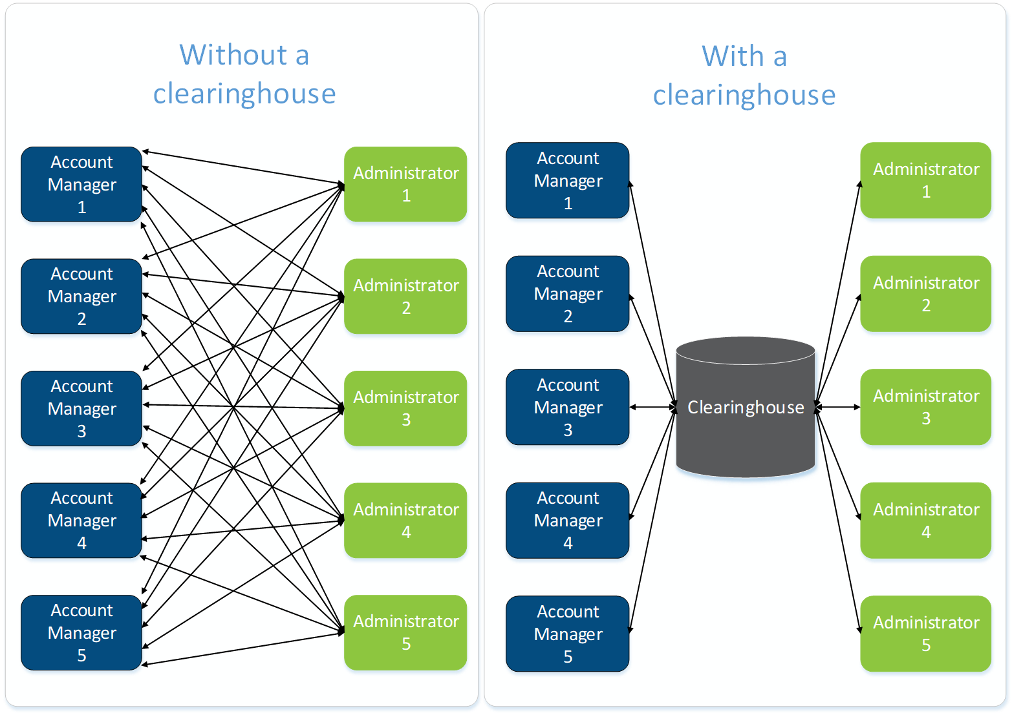

The project leveraged a pre-existing RUC platform, built by Oregon for such R&D initiatives, to build a clearinghouse and used pre-existing anonymized RUC data to process through the clearinghouse.

ODOT evaluated the outcomes and made recommendations in preparation for future program enhancements. The following Regional RUC Evaluation and Assessment Report is provided to FHWA and RUC West and will be shared with the RUC Community of Interest.

# Project Scope

Since the grant’s inception, the project’s scope was changed to focus on the core elements of the project objectives. In April of 2020, RUC West Members and FHWA approved a revised scope and budget.

The revised project would build the clearinghouse and use test data to demonstrate the clearinghouse functionality as opposed to using data collected from live pilot participants. This eliminated the need to recruit volunteers to replicate work that can be observed in today’s operating programs and in previous pilots – driving across geographic boundaries. This resulted in eliminating the following significant project and cost components: procurements, certification, and participant recruitment and incentives. The revised budget was $1 million from the original budget of $2.59 million. To date the project costs were 68% of the budget.



## Budget Costs

The project was running concurrent with the Local RUC pilot (another FHWA grant initiative). The project was paused at times or phases ran longer due to resource constraints.

## Project Schedule



# Grant Objectives

The following objectives were outlined in the grant agreement. The corresponding achievement column reflects the outcomes:

|  |  |  |
| --- | --- | --- |
| **Criteria:** | **As Measured By:** | **Achieved** |
| The clearinghouse is accurately creating state specific reporting | Data collected are aggregated and reconciled to the appropriate corresponding states as confirmed by manual verification against the data | Yes – New reports have been created (RUC and Fuel Credit Summary Report, Totals by Jurisdiction Report and Statement of Deposit Report) that breaks out the travel data and revenue for each jurisdiction by Account Manager |
| The clearinghouse performs validation functions on the fields within the data sets using defined business rules, thus confirming the passed data is in the correct format | Data submitted is validated by the clearinghouse using rules defined in the requirements to ensure each Administrator receives reports with accurate calculations for RUC and travel data totals by VIN and jurisdiction | Yes - The project team have verified the clearinghouse functions, the accuracy of the calculations and the compiled reporting, as well as the granularity of the RUC data |
| Lessons are learned, captured and shared with the RUC community | Lessons are captured and documented throughout and reports are prepared and disseminated to the following entities:   * Project Team Lessons Learned * RUC West Evaluation Report * FHWA Evaluation Report | Yes – Much documentation has been gathered, documented for distribution regarding the demonstration outcomes, and the process of loading the data. Project lessons learned have also been documented for the benefit of continuous improvement |

# Core System Functions

The following elements were considered when defining the system design related to functions performed by the clearinghouse:

* Account Managers have one common end point for all communications with multiple Administrators
* Clearinghouse accepts messages that contain records for different Administrators and distributes them correctly
* Clearinghouse validates data for basic content and common rules across all Administrators
* Clearinghouse stores data for further
  + - Validation
    - Processing
    - Distribution
    - Reporting/Oversight

The clearinghouse also has reporting tools enabling oversight of the activities. These reports can be used to ensure transactions are being processed as expected and for handling exceptions if research is needed.

## Architecture

The pilot demonstration had an architectural vision where the clearinghouse hosts a single set of endpoints for all Account Managers to use. There is a single source for distribution to Administrators, thus reducing overhead.

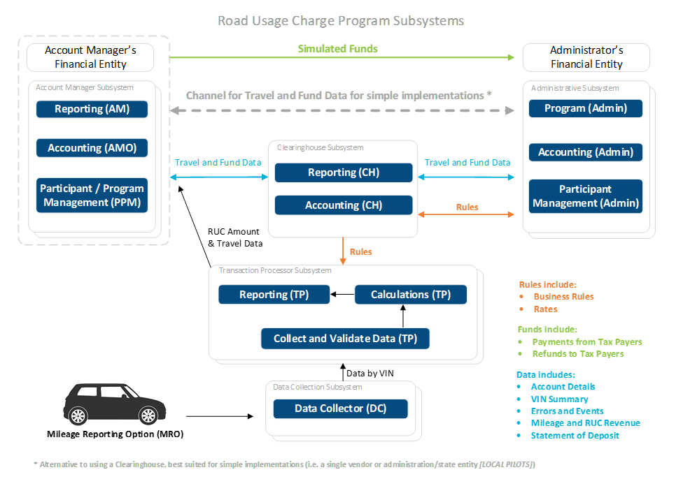

For the demonstration the project built simulated subsystems representing these four entities:

1. Clearinghouse
2. Oregon Administrator
3. California Administrator
4. Other State Administrator

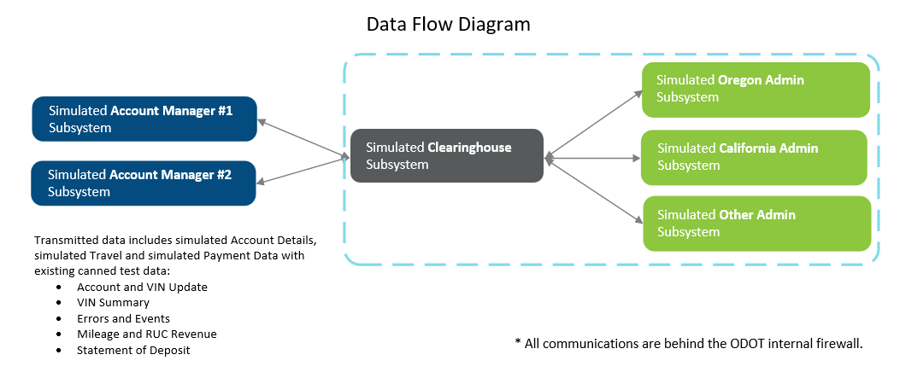

The clearinghouse is designed to receive and process messages posted and:

* Store them
* Parse the records according to what each Admin needs to know
* Send the appropriate data to each Admin

A key concept of the design in the interoperable model is that the Account Managers will not have to create Administrator specific messages. Each Account Manager’s message would include the data for all the people they have accounts for regardless of which RUC program they subscribe to.

In addition to the clearinghouse, three individual Admin subsystems were built. Each had independent communication endpoints, web applications and databases. Each was individually configured based on the rates and rules of that jurisdiction. Data was sent to the clearinghouse representing account details, travel and payment data from both Account Managers. Each of the Admin subsystem received data relevant to their programs from the clearinghouse.

## System Design, Build & Load

The system design and requirements definition started in February 2021. Foundational to the clearinghouse demonstration, the project replicated an existing system designed to research and develop for proof of concept demonstrations.

## Data

Use cases involving thirteen distinct Vehicle Identification Numbers (VIN’s) and associated simulated travel data and payment information were defined to test unique scenarios. Corresponding messages were manually created to load into the clearinghouse.

Before loading use case messages into the system, the database was refreshed and all data was removed. This ensured accurate test results by guaranteeing the individual report outcomes could be manually verified against data that was 100% associated with the use cases. The data was designed to represent real world scenarios.

In addition to manually created use case data, travel data from Oregon’s operating program and California’s (CalTrans) 2016-2017 RUC Pilot were loaded and tested as well. Oregon provided travel data for 20 distinct VINS, while 3,224 VINS (6,000 were provided in total) were loaded from CalTrans data. The California data was delivered in June. Work to adjust the data to conform to the requirements defined in the Interface Control Document (ICD) began in July. This effort proved to be more involved than anticipated. This additional effort was related to the volume of test data, the message structure and completeness of the dataset. Refer to Lesson Learned (#3) for more details.

## Demonstration Approach

To demonstrate the functionality as designed, use cases were prepared to cover scenarios that would reflect real life, considering these assumptions:

* Each state is likely to partner with more than one Account Manager (the model supports multiple or a single Account Manager partnerships).
* Participants will be driving in and out of state

When multiple state RUC programs are engaged, the miles driven in each state are reported accordingly to ensure that each state gets the revenue they are owed – even for miles that are driven by out-of-state drivers.

The project curated messages based on the needs described in the use cases to prove out the clearinghouse data processing and handling. These scenarios were considered:

1. Two Account Managers (AMs)
2. Three Administrators (Admins)
3. Multiple Participants
   * Enrolled across different Account Managers
   * Participating across different Administrators’ programs
   * Driving across several states

# Data Flow

The data flow in this diagram assumes Oregon and California RUC Administrators. The simulated VIN data is collected by their Account Managers. For example, the Account Manager 1 has participants that belong to Oregon’s program and also VINs that belong to California’s program.

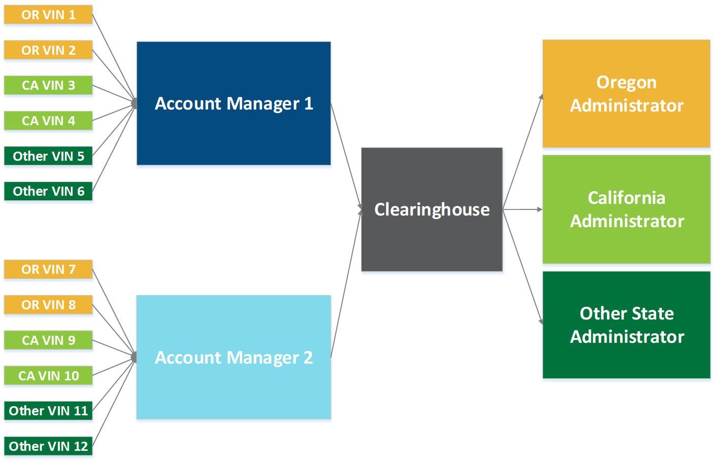

The data flows from the vehicles to the Account Managers. Account manager 1 will send a single VIN Summary message with data for all 6 of these VINs.  The clearinghouse then distributes the VIN level data to the correct administrator.

There are two data elements that allow this model to work.

* AM ID identifies the Account Manager
* Admin ID identifies the RUC program the VIN belongs to

Both data elements are sent to the clearinghouse from the Account Manager and allow the clearinghouse to properly identify where to report the data.

# Data Sets

Three data sets were collected and used to process through the systems:

1. **Use Case Test Data -** The project curated messages to meet needs described in the use cases to prove out the clearinghouse data processing and handling.
2. **Caltrans 2016 – 2017 Pilot Data -** Caltrans provided data from about 5,000+ VINs to process through the clearinghouse. This included data from four Account Managers for VINs sent to the California administrator system.
3. **OReGO Program Sample Data -** A sampling of 20 VINs from Oregon’s program. This included data from two Account Managers for VINs sent to the Oregon administrator system.

Using a combination of these datasets the project was able to illustrate the clearinghouse function and reporting. The value of interoperability is a story told by the reporting.

# Reporting

For the administering states, the clearinghouse reporting solves today’s state centric reporting gaps. The report examples below illustrate how the project meets a key grant objective “data collected can be verified it is going to the correct corresponding state.”

*Illustration 1*

### Transaction Log

The Transaction Log illustrates the main purpose of the clearinghouse. It stores the details and records for every message received from each Account Manager, and also every message sent out to the Administrators.

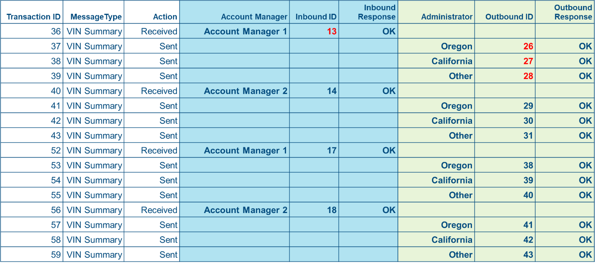

For each message received from an Account Manager, the clearinghouse processes and distributes the relevant information out to the appropriate state Administrators. In this example:

* Inbound message 13 is the VIN Summary message from Account Manager 1, which contained travel data for VINs that belong to programs across all three of these Administrators.
* The clearinghouse created three outbound messages: 26, 27, and 28 for delivery to each Administrator containing only the travel details for VINs belonging to their programs.

This allows the Account Mangers to create a single message with data for all of their accounts, as opposed to creating three different customized messages, one for each state’s Administrator. That level of complexity resides in the clearinghouse, making it easy for the private sector business partners to establish services in a RUC landscape using this interoperable model.

*Illustration 2*

### Totals by Jurisdiction

The Totals by Jurisdiction report details travel and RUC data across all jurisdictions. The existence of the clearinghouse allows for visibility into this comprehensive travel data that was not possible before. This report is all inclusive, aggregating travel from all VINs across each state’s program. Today each state has visibility to data for only VINs enrolled in their own program.

This level of detail will also be useful when planning and informing decisions regarding the implementation for the national RUC pilot.

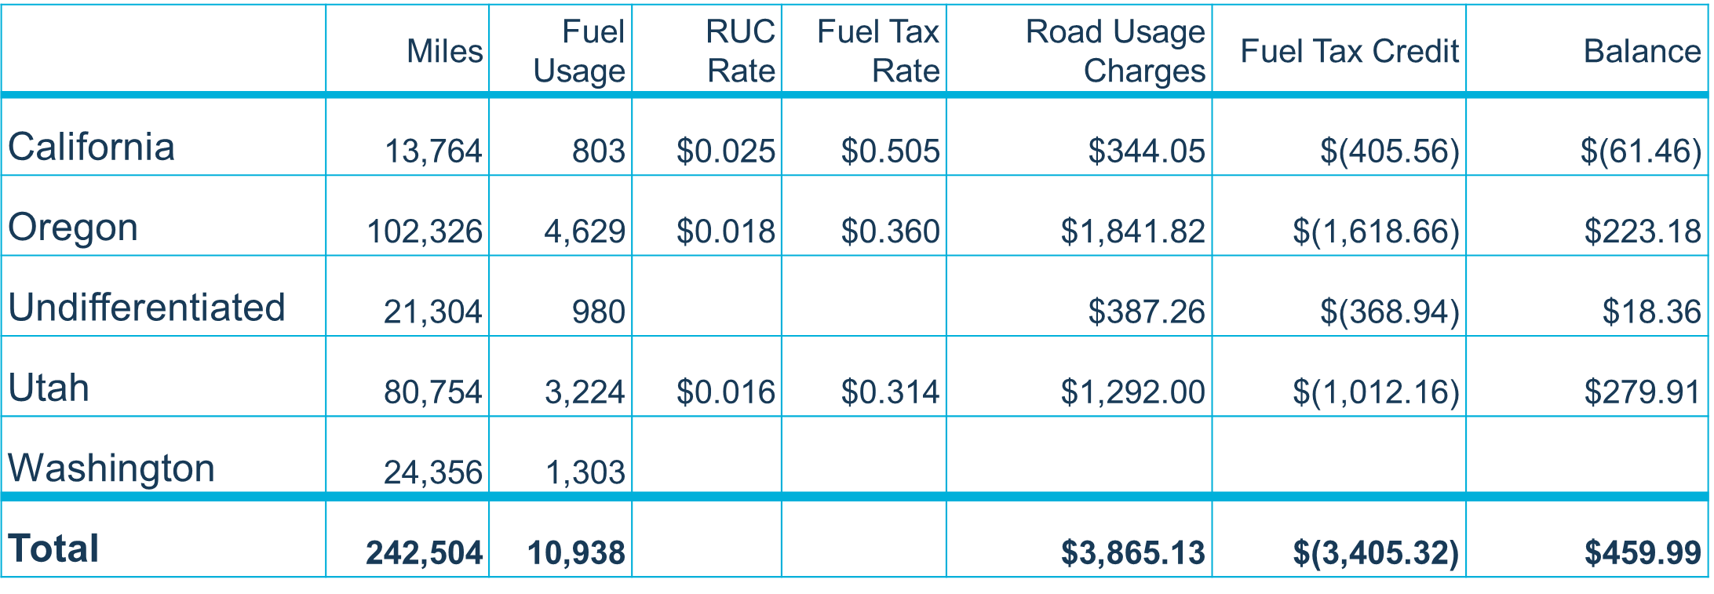

Note that undifferentiated totals are from reported simulated data that was collected without a GPS- enabled reporting option, or the reporting option was unable to determine the vehicle location. This could be due to numerous reasons, such as the vehicle was out of GPS range. Revenue is still generated from that travel and goes to the program the VIN belongs to. The undifferentiated travel revenue is calculated using that specific programs’ business rules and rates.

This structure can also be leveraged to report local layered RUC data. In the same way you can see travel and RUC data by state, you could also view by county, city, or district. These areas need to be identified within a geo-fenced area, and assigned a sub-rule identifier. This is useful for administering RUC for congestion pricing in the future.

*Illustration 3*

### RUC and Fuel Credit Summary

This set of data is the main differentiator for states participating in interoperability. The RUC and Fuel Credit Summary report shows the travel details for the VINs that belong to the Oregon Administrator’s program, as reported by two Account Managers. However, the totals also include travel data from drivers that belong to a different state’s Administrator. Today Oregon has visibility into the travel for drivers only in its program.

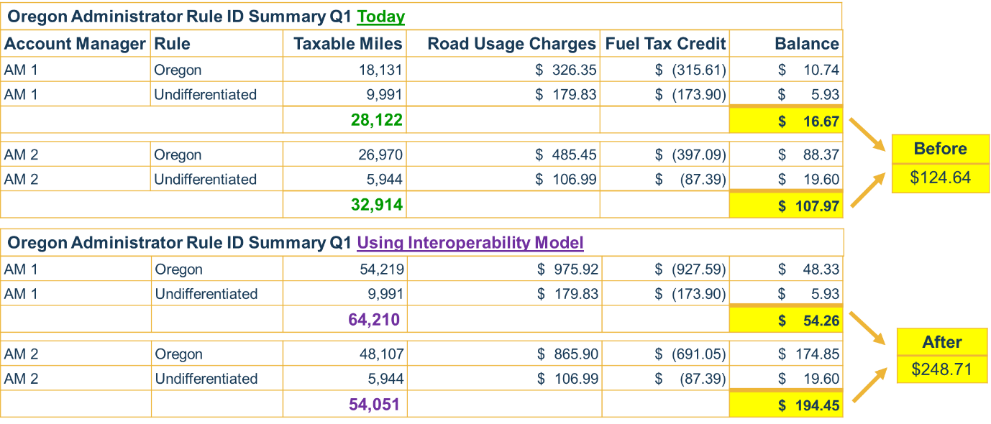

In this example, using today’s RUC model, there are 61,036 taxable miles. With an interoperable model there are 118,261 taxable miles for a **difference of 57,225 miles**. This difference accounts for the travel data reported for VINs that do not belong to Oregon’s program, but are traveling on Oregon roads. In the above example, this additional reporting shows the RUC revenue has doubled from $124 to $248.

*Illustration 4*

### Statement of Deposit

The Statement of Deposit report will allow state administrators to reconcile the totals from the Mileage and RUC Revenue report with what the account managers have reported and the amount that has been deposited into their account.

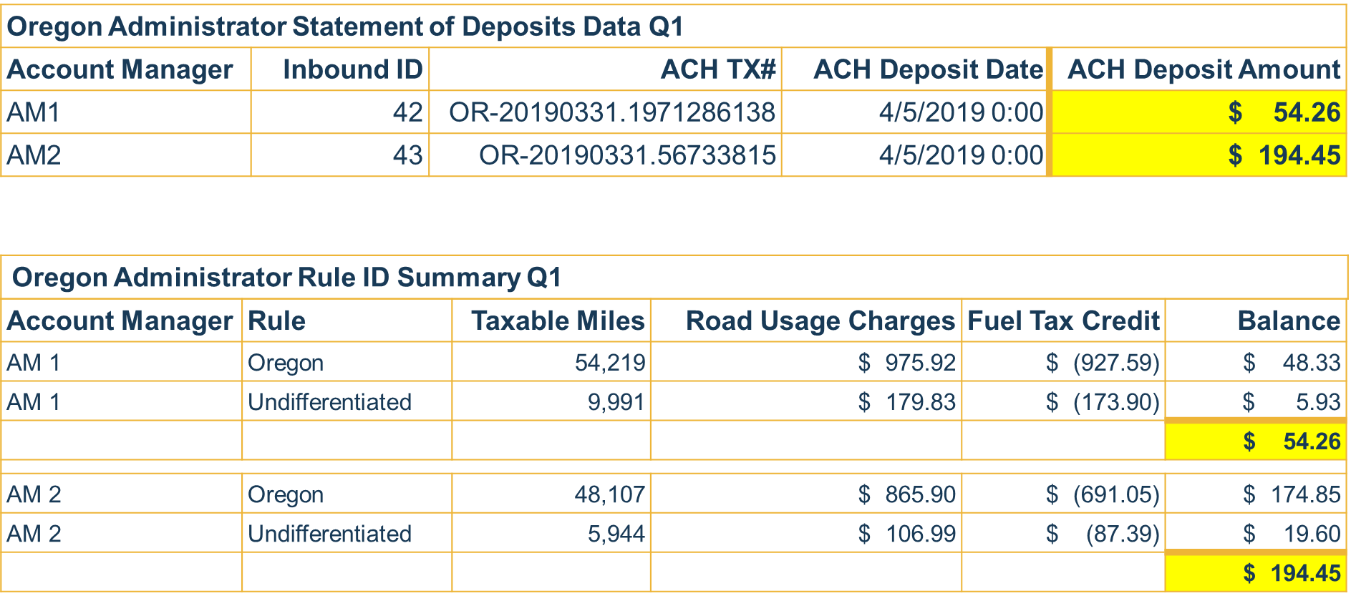

As illustrated in these simple examples this interoperable model has compelling benefits for each participating state. Interoperability enables robust reporting that provides visibility to the full picture of road usage, not just from in-state travel but also state to state. For more evidence, reference the Appendix for additional examples of RUC revenues foregone due to the limited nature of today’s model that does not include reporting miles driven by out of state drivers.

# Learnings & Observations

## Data Conformance and Open Architecture

As interoperability becomes integrated into the RUC ecosystem, more partners will be collecting and sending travel data to the clearinghouse and then on to multiple Administrators. For RUC data to be readable and useful to all parties, all data messages must be standardized, conforming to the same format and definitions. Aligning with agreed upon standards for electronic communication across individual RUC programs is critical to support an open architecture. This allows private sector partners, large and small, to provide their services seamlessly within the established RUC system. The premise is that no matter which partner is sending the message, the receiving subsystem can read the message, thus allowing for healthy competition in an open market.

## Prototype System Performance

The project experienced problems processing large volumes of data when load testing with the clearinghouse “prototype” system. The prototype leveraged a pre-exiting platform that was not positioned for scaling, which was necessary to process this large amount of data. This was a known risk. In future pilots where large volumes of pre-existing RUC data may be used, it is recommended to conduct an in-depth analysis of the dataset and the existing system performance limitations. This enables the project team to consider the effort necessary to conform and prepare the system with the performance specifications needed to support large datasets as a risk mitigation strategy. The challenge and subsequent solutions have bolstered OReGO’s justification for a more scalable RUC architecture.

## Sharing RUC Data

The project reached out to neighboring RUC West States, requesting RUC data to use in this demonstration. Although the specific reasons varied, the general observation is a hesitancy to share RUC data remains high. Several months of meetings transpired with partner states resulting in offers to share data that were later rescinded. Eventually the project did successfully receive a dataset with which to work from. For pilots of this nature to leverage from interstate travel pattern data, clearly defined protocols should be established pertaining to releasing PII (Personally Identifiable Information).

# Recommendations

As we contemplate the future of RUC interoperability there is more research and analysis work to be done in specifically in these areas:

1. Expanding the role of the Clearinghouse to include functions and capabilities such as
   * Reporting and/or publishing tools
   * Auditing
   * Business Partner certification
   * Distributing business rules to service providers
2. Defining the process, procedures and standards for handling common events such as
   * Participants changing Account Managers
   * Participants moving across state lines
   * AM reporting late or correcting a submission

Including interstate policies and procedures relating to

* + Enforcement and compliance
  + Reciprocity (including handling revenues of a state that is not under contract with the collecting Business Partner)

1. Conducting a demonstration to simulate the end-to-end RUC transaction processing. This is currently being planned with a project to demonstrate the use of blockchain technology with a clearinghouse. The clearinghouse will handle the collection and aggregation of the data. Blockchain will handle recording the financial transactions and maintaining the ledger.
   * Anonymizing transactions to protect privacy while ensuring that the data is secure
   * Reducing transactional errors and inefficiencies
   * Improving the data processing times

# Next Steps

The Project Team recommends the following core elements in RUC West’s near term planning:

1. More quantitative analysis on the jurisdictional RUC revenue opportunities with inclusion of out of state miles to help build a business case for interoperability.
2. Prepare a Business Case for states and FHWA to educate and build support within their communities of interest
3. Pilot test and assess blockchain functionality with clearinghouse
4. Establish data standards and conformance agreements with strict adherence to interface communication standards
5. Continue to advocate and test an open architecture model that support interoperability
6. Build systems that scale to support increasing data demands, evolving technology and processing power
7. Embrace an open market approach that supports partnership fluidity in this expanding ecosystem of Administrators, Account Managers, Data Collectors and Transaction Processors
8. Define enforcement policies that will be necessary to implement interoperability
9. Advance efforts of educate the public to address the RUC privacy perception.

# Conclusion

The clearinghouse solution is a compelling business proposition in support of interoperability. States will have a mechanism to receive more RUC revenue than is being collected and distributed today by incorporating additional reporting of data for travel by out-of-state drivers. Based on the Caltrans pilot data representing 9 months of data (July 2016 – March 2017), Oregon alone would have the benefit of collecting RUC for 222,066 miles from only 67 California drivers driving in the state of Oregon (reference Appendix Illustration A-2). Based on the very limited dataset to work with, it was not practical to do a financial analysis. Further financial analysis of RUC interoperability coupled with the outcomes from the Blockchain pilot (in progress), will paint a clearer picture of the business proposition and path forward.

# Appendix

## Additional Reports

California Administration System:

*Illustration A-1*

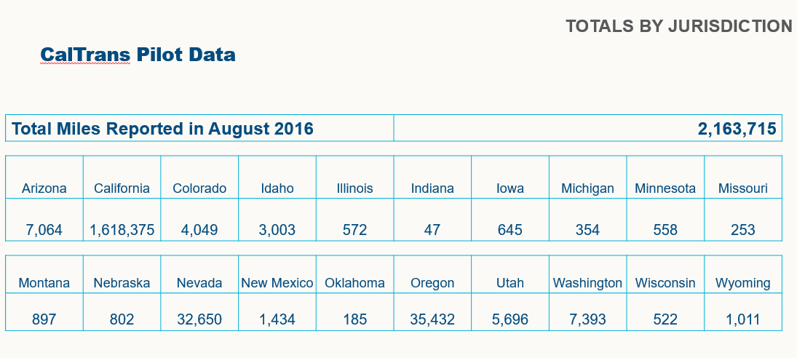

This is from the Caltrans pilot, from a single month – August 2016. In that one month alone, pilot participants drove in 20 different states.

*Illustration A-2*

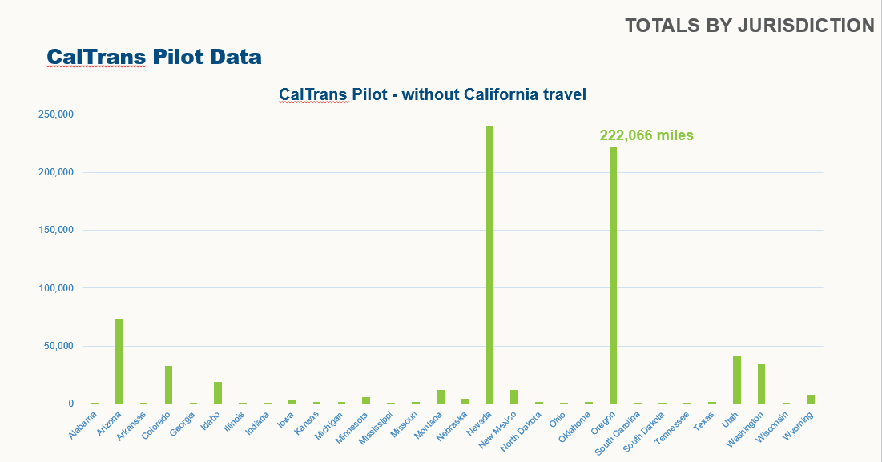

The boarder states realize the highest travel from California drivers (according to this sample data). Oregon would have benefited from 222,066 RUC miles.

*Illustration A-3*

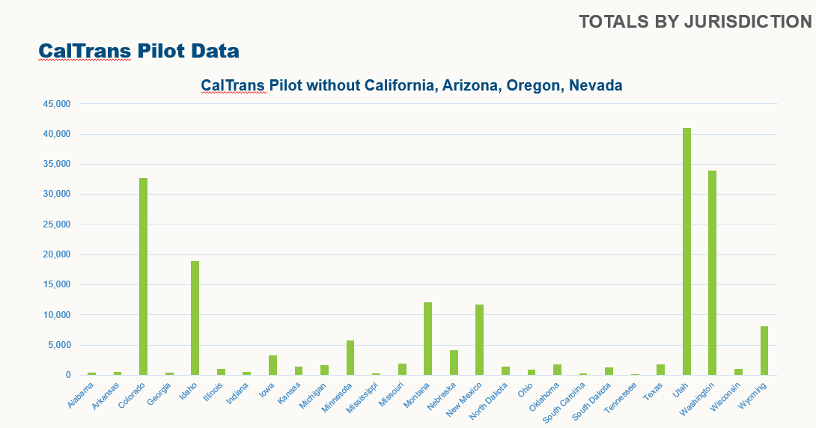

Looking at the same sample data, and honing in on the none-boarder states, clearly several states would have benefited from these unaccounted RUC miles.