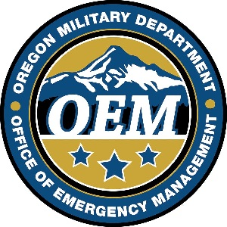
FUEL STORAGE FACILITY COMPATIBILITY FUND
GRANT PROGRAM

Facility Data Sheet

Legal Name:

Doing Business As:

Facility Contact Name:

Facility Contact Phone Number:

Facility Address:

Is this facility currently licensed by Oregon Office of State Fire Marshall: YES NO

Facility has been continuously licensed since:

Fuel storage capacity (all applicable fuel types):

Number of commercial pumps:

Proximity to Oregon Department of Transportation critical lifelines:

How many locations, in addition to the location for which this data sheet is prepared, will allow customers to pump fuel using your card? :

Do you have contracts with government agencies? :

Is this facility in the tsunami inundation zone :

Are there other commercial fueling facilities within a ten mile radius of this facility:

Is this facility a dual (retail) operation: YES NO

