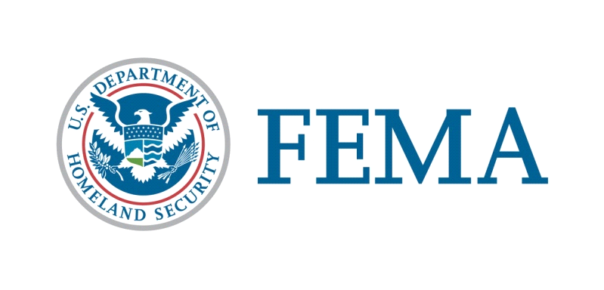

Congressional Affairs Division
202-646-4500

State of Oregon

Federal Disaster Declaration Fact Sheet

July 9, 2019

Today, July 9, 2019, President Donald J. Trump granted a Major Disaster Declaration for the State of Oregon triggering the release of Federal funds to help communities recover from the Severe Storms, Flooding, Landslides, and Mudslides that occurred April 6-21, 2019. Details of the disaster declaration and assistance programs are as follows:

Declaration Number: FEMA-4452-DR

Incident: Severe Storms, Flooding, Landslides, and Mudslides

Incident Period: April 6-21, 2019

Federal Coordinating Officer: Rosalyn L. Cole
National FCO Program

Public Assistance (PA): (Assistance for emergency work and the repair or replacement of disaster-damaged facilities):

PA-Designated Counties: Curry, Douglas, Grant, Linn, Umatilla, and Wheeler Counties.

Hazard Mitigation (HM): (Assistance for actions taken to prevent or reduce long term risk to life and property from natural hazards):

HM-Designated Areas: All areas in the State of Oregon are eligible for assistance under the Hazard Mitigation Grant Program.

OTHER: additional designations may be made at a later date if requested by the State and warranted by the results of further damage assessments.

###

