
Round Two
State and Local Cybersecurity Grant Program
Project Application

Overview

This project application is for jurisdictions applying for Round Two of the State and Local Cybersecurity Grant Program (SLCGP). Every project submitted by a county, city, special district, or tribe must complete this application. No more than two project applications may be turned in per Applicant Agency.

- General Project Information
Applicant Agency (agencies) | Project Title
Federal Funds Requested  $ | SLCGP Service Catalog
SLCGP Strategy GOAL # | SLCGP Strategy OBJECTIVE #
Project Budget Defined by POETE

Planning $
Organization $
Equipment $
Training $
Exercises $
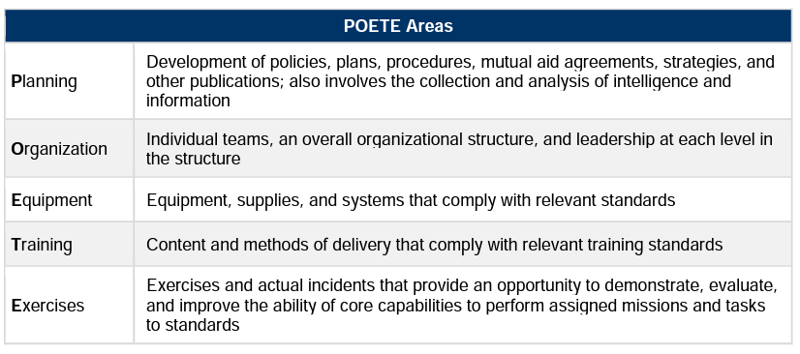

- Requirements
Clearly describe how this project will address a cybersecurity gap/gaps, and how that will allow you to improve your current cyber capability.

Clearly describe how the project ties to Oregon’s SLCGP Cybersecurity Plan.

- Specific Requirements

Cyber Security

Has the jurisdiction performed a formal cyber assessment?

If the jurisdiction has not performed a formal cyber assessment, does the jurisdiction have a formal cyber security plan/strategy?

- Project Details | 25pts
Describe the project. What will this project do? Please be as clear and direct as possible in your first paragraph. Supporting details may be provided in 2nd or 3rd paragraphs.

Have you received quotes for the costs of the items, training, or services described above?

- Project Impact | 30pts
Describe who in the community will be directly impacted by this project and how.

Describe what impact this project will have on the whole community.

Describe how the project will enhance the cyber capability for the jurisdiction.

- Capability History | 5pts
Describe the jurisdiction’s current functionality in the chosen cyber capability.

- Gap Information | 15pts
Describe the current gap in the cyber capability.

Describe how the gap was identified (real event, exercise, assessment).

Describe what the agency/community has done to fill the gap so far.

Describe how the proposed project will fill the gap.

- Sustainment | 15pts
Describe the jurisdiction’s plan to sustain the cyber capabilities built by this project.

- Milestones |  | 10pts
Quarter 1
Quarter 2
Quarter 3
Quarter 4
Quarter 5
Quarter 6
Quarter 7
Quarter 8

