NEW: Instructions for the Sub-applicant Coversheet through MS-Forms

A new feature of the Combined Coversheet is a hyperlink to the Sub-applicant Coversheet questionnaire.

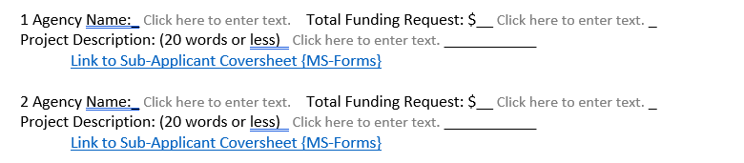
For each project listed in your Combined Coversheet, use the corresponding link to access an online questionnaire to complete the Sub-Applicant Coversheet. You may need to press Ctrl on your keyboard when clicking on the link to access the hyperlink.

The MS-Forms document will send data to OEM, but you must also print and save a copy to be updated into Basecamp.

NEWS STEP: How to Save and Submit the Sub-applicant Coversheet.
When you have completed the questionnaire, your information will be automatically stored in a database, however you will also need to print a copy BEFORE you click submit on the web-tool.

To save your work, Right-click on the questionnaire and select Print to save as a PDF.

You will need to save a copy for your records as well as upload it with your application in Basecamp.

You can also access the Sub-applicant Coversheet questionnaire here: https://forms.office.com/g/xzjMzsGnBX

If you have any questions, please contact:

Kevin Jeffries
Grant Program Coordinator
Oregon Office of Emergency Management
Office (503) 378-3661
kevin.jeffries@state.or.us

