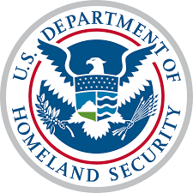
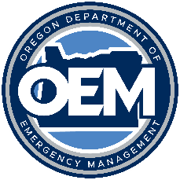
2023 State Homeland Security
Grant Program

FY23 NIMS process Update:

OEM NIMS Assessment- You are required, based on your application for a State Homeland Security Grant or Emergency Management Performance Grant through OEM or are a OERS Council participating agency, to attest each year that you are in compliance with the National Incident Management System.

This is an annual NIMS assessment to assure us we are all meeting the federal requirements for grant funding. OEM utilizes the annual NIMS Assessment to gather information on the extent and success of NIMS implementation throughout the state. If you are a state agency participating in OERS Council, you have adopted NIMS. You are covered under the State EOP and Recovery plan. The rest of the questions should be answered according to how you apply NIMS in your agency. We want to know what else your agency is doing for NIMS, who the POC is, and any other information you can share.

This survey will alert you when an answer may not be in compliance. If you have questions about compliance please remember, if you are working towards compliance, you are in compliance, please reach out to OEM NIMS Point of Contact (POC) Sarah Puls, sarah.puls@oem.oregon.gov for any questions on compliance. If your jurisdiction is not in compliance, the OEM NIMS POC will work with you to make a corrective action plan to assure you can receive your grant funding.

Please take the survey now, only one survey per jurisdiction is required. Please collaborate with your coworkers to submit one per jurisdiction per year.

Link to OEM NIMS Assessment

If you have questions, please contact:

Sarah Puls
Preparedness Planner
Oregon Department of Emergency Management
971-345-7255
Sarah.PULS@oem.oregon.gov

