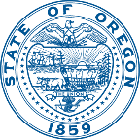 | Office of the Director | 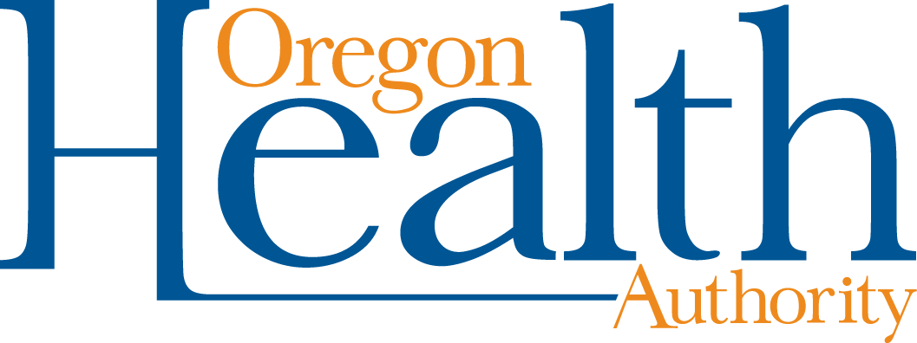
 | Kate Brown, Governor

500 Summer Street NE E20
Salem, OR 97301
Voice: 503-947-2340
Fax: 503-947-2341
TTY: 503-947-5080

August 31, 2017

The Honorable Governor Kate Brown
254 State Capitol
Salem, OR 97301

Dear Governor Kate Brown,

As planned and promised, the Oregon Health Authority (OHA) has completed the 90-day Action Plan and finalized the federally approved clean-up of Medicaid member eligibility by the August 31 deadline you set for us. With the completion of these final 115,233 Oregon Health Plan (OHP) members, OHA has successfully transitioned enrollment eligibility decisions to the new ONE system for nearly 1 million Medicaid members. All Oregonians on Medicaid who are due for an eligibility renewal have been assessed. There are no more Medicaid members pending deferred renewal due to the Cover Oregon failure.

As you know, more than 1 in 4 Oregonians depend on Medicaid and OHP for health coverage. Oregon’s nationally-renowned health system transformation has saved taxpayers $1.3 billion since 2012, improved the health and well-being of OHP members and generated tens of thousands of jobs, especially in rural parts of the state. It has been inspiring to watch the OHA team rally around this Action Plan work to ensure that all Oregonians who are eligible for benefits have access to that critical care.

After Cover Oregon failed, the federal government through the Centers for Medicare and Medicaid Services (CMS), granted Oregon approval in Sept. 2015 to defer Medicaid eligibility renewals until the state could develop and deploy a reliable replacement. Under federal law, every child and adult on Medicaid remains eligible for coverage they complete an administrative renewal. Once OHA replaced Cover Oregon with the ONE technology platform, the agency restarted renewals. Between Mar. 2016 and Mar. 2017, OHA conducted 835,953 eligibility reviews.

OHA identified types of complex member cases which posed significant processing complexity (such as pregnant women, non-respondent children of eligible adults, women with breast or cervical cancer) to resolve at the end of the Cover Oregon clean-up. These members would eventually comprise a total of 115,233 and ultimately became the focus of the Action Plan.

The 115,233 Medicaid renewals completed under the Action Plan do not change the Medicaid forecast for the 2017-2019 biennium or the state budget. Under the Action Plan:
- 52 percent of Medicaid members were found eligible at this initial stage of processing.
- Nearly three in 10 members (28 percent) were closed due to non-response.
- Two in 10 members were found to no longer qualify.

The number of case closures will fall. Federal law provides a standard 90-day due process period in which Medicaid members who fail to respond or have changed circumstances can return to the caseload and qualify for retroactive benefits. As a comparison, OHA found 49 percent of previously processed Cover Oregon member cases were initially qualified for benefits when they were first renewed – at the end of 90 days, the cumulative total of people who were eligible rose to 66 percent.

I want to extend my sincerest thanks to the many dedicated state employees, private sector partners and non-profit organizations who helped complete these challenging member cases on time for your deadline. In addition to OHA Member Services staff, Oregon’s Coordinated Care Organizations (CCOs) made calls to their members and located addresses, and staff across OHA’s seven divisions volunteered to assist in the processing center. Private contractors KPMG provided project management expertise. Private sector partners PH Tech, GALT and Chaves took calls to allow our Member Services staff to focus on the clean-up members.

We have learned a tremendous amount about the renewal system through this process, and we will continue the system improvements we have started to streamline the process for OHP members and increase efficiencies for Oregon taxpayers. As a result of this process OHA is committed to:
- Centralizing Medicaid benefit eligibility with our sister agency, the Department of Human Services, beginning on September 1, when Member Services staff move to DHS.
- Improving transparency with the legislature, stakeholders and community partners to provide more accessible, actionable and real-time data about the Medicaid system.
- Improving partnerships with private contractors and public employee bargaining units to deploy staffing resources more efficiently and address emerging problems with greater nimbleness.
- Strengthening contract management systems to hold vendors more accountable for results.
- Strengthening performance management systems to improve results achieved by OHA staff.
- Improving collaboration and coordination within OHA and across inter-agency partnerships to streamline processes more efficiently, speed problem-solving and spur greater innovation.
Thanks to the hard work of countless OHA employees and partners during these past 17 months, all Oregon Medicaid member cases are now on a regular annual eligibility renewal cycle. The successful completion of the Medicaid clean-up Action Plan enables Oregonians to have as much confidence in the state’s Medicaid eligibility system as they do in Oregon’s innovative, cost-saving health reforms.

Sincerely,

Lynne Saxton
Director

