Search Tips and Technical Notes
This document explains how to interpret search results, followed by examples of search criteria and corresponding returns. Technical notes for consideration can be found near the end of this document. If you have any questions about how to use the Searchable List, please contact HERC.Info@dhsoha.state.or.us and someone will reach out to you within two business days.

How to Interpret Search Returns from the Searchable List
In order to efficiently utilize the searchable list, the following graphic explains key components. The search term “asthma” will serve as an example for returns:
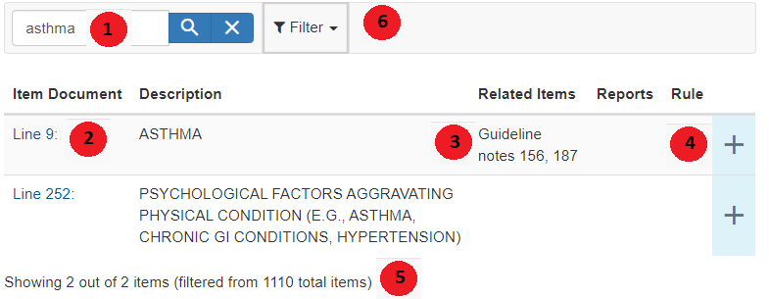

Item 1: This field is the search bar in order to enter one or two keywords or specific guideline or line numbers (e.g., “hernia”, “GN57” or “L56”).
Item 2: The return fields are displayed here. For each item that is displayed, the title contains a link that allows the user to be able to download the content of the displayed Line/Guideline/entry.
Item 3: The “Related Items” column displays associated lines or guideline notes of the entry. In the above example, if the user wanted to learn more about asthma, typing “GN156” or “GN187” into the search bar would return entries that contain linked entries that allow the user to learn about coverage indications for specific asthma treatments.
Item 4: Clicking on the “+” tab will display search tags for the returned field.
Item 5: The number of items that are displayed will be at the bottom of the searchable list. If a search keyword is vague, many entries will return For example, the keyword “pain” has 42 returns--specifying the search criteria as “back pain” will return 7 entries, which can be helpful in narrowing down the scope of the search to only relevant items.
Item 6: The filter can be used to specify which fields to limit the search criteria; available options are to search for keywords in the Description, Related Items, and Search Tags. This tool is helpful for those searches that are very narrow in scope.

Examples of Searches using the Searchable List
Example 1: If one enters the keywords “colorectal cancer” into the search bar, the following returns will appear:
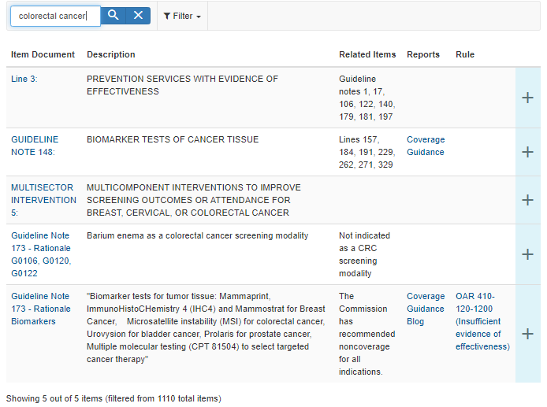
In this search, the returns contain relevant lines that address colorectal cancer (Lines 3), guideline notes (Guidelines 148) and a Multisector Intervention Statement on interventions to improve screening outcomes for certain cancers including colorectal. Additionally, two search items are entries that appear in Guideline 173, a guideline that encompasses all treatments that are not covered under OHP. In this case, both barium enema and microsatellite instability are two interventions that are excluded from coverage.

Example 2: If one wishes to look up a specific guideline note, enter the following into the search bar: “GN” and the guideline note number, with no spaces. For this example, the user entered “GNA5”:
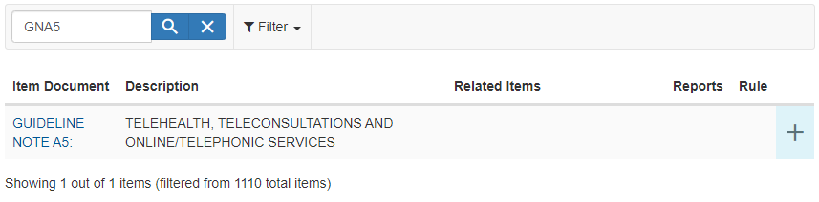
Guideline Note A5 pertains to telehealth and online/telephonic services. If the user does not know the specific guideline number they are looking for, they can alternatively type in keywords, such as “telehealth” or “telemedicine” - Either way, the user will arrive at the same search return of Guideline Note A5.

Example 3: If one wishes to look up any lines or guideline notes that pertain to a certain condition or treatment, one can enter one or two keywords to return all relevant entries. In this example, the user searches for anything relevant to obesity:
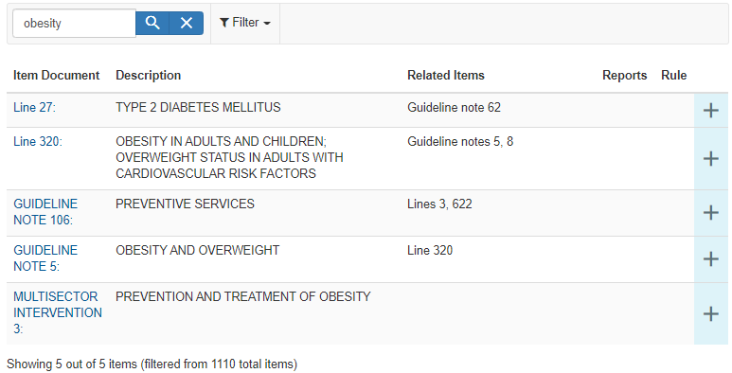
The search returns display the relevant lines that provide treatment services for obesity (Lines 27 and 320) as well as guideline notes that describe indications for obesity treatment and prevention (Guidelines 106 and 5). Finally, the user will find a Multisector Intervention Statement that contains an evidence synthesis of obesity prevention interventions across community and school settings (MSI 3).

Technical Notes
- Searching for multiple words returns only results including ALL the words. To search for an exact phrase, use quotation marks.
- Links open in new windows or tabs depending on your browser setting
- Some links are for Microsoft Word documents and may trigger security warnings
- Open Related Items links: right click and select "open in new window" or "open in new tab"
- This tool is not built for search-by-code functionality, instead see CPT/HCPCS/ICD-10-CM code placement files

