EHRIP Applications in MAPIR:
Patient Volume Reporting Period Options

The EHRIP Team receives many questions around selecting the right 90-day Patient Volume time period for the two options available, as shown in the MAPIR attestation screens:

Calendar Year Preceding Payment Year

or

12 Months Preceding Attestation Date

IMPORTANT: The Patient Volume 90-Day period for an individual practitioner or any member of a Group Patient Volume Definition cannot overlap a previous Program Year 90-Day Patient Volume Period. CMS Rules do not allow recycling eligibility criteria in subsequent Program Years, e.g., re-using all or part of a patient volume period from a previous Program Year attestation.

1. Calendar Year Preceding Payment Year
Using Program Year 2017 as an example, when selecting the option “Calendar Year Preceding Payment Year,” you will be able to put in a Start Date from any date in Calendar Year 2016, as long as the end date of the 90-day period is also contained within Calendar Year 2016. In the example below, the start date of 04/01/2016 was entered:
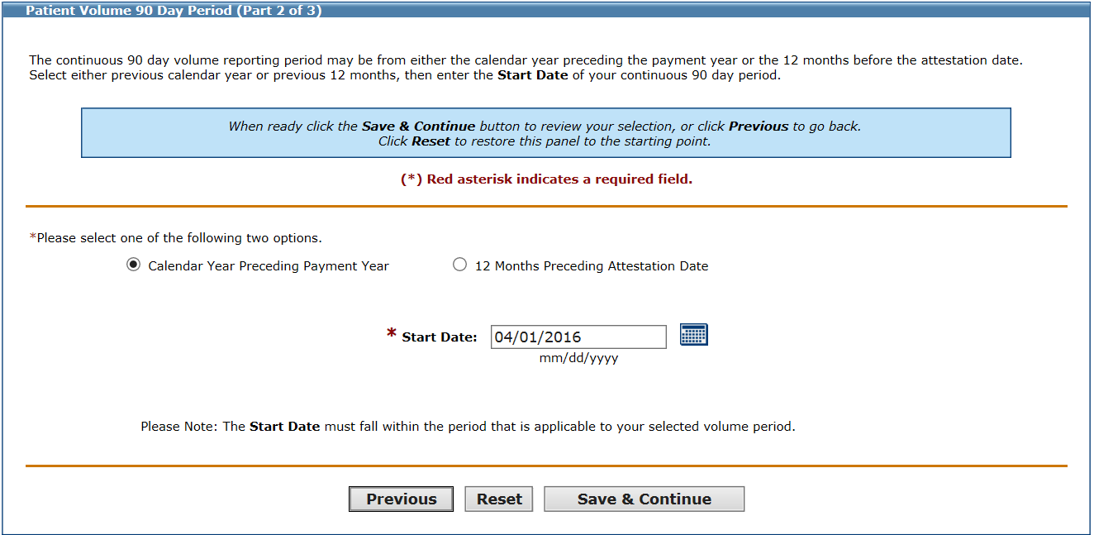
Upon clicking “Save and Continue” MAPIR calculates the correct 90-day period and automatically fills in the end date: 06/29/2016.

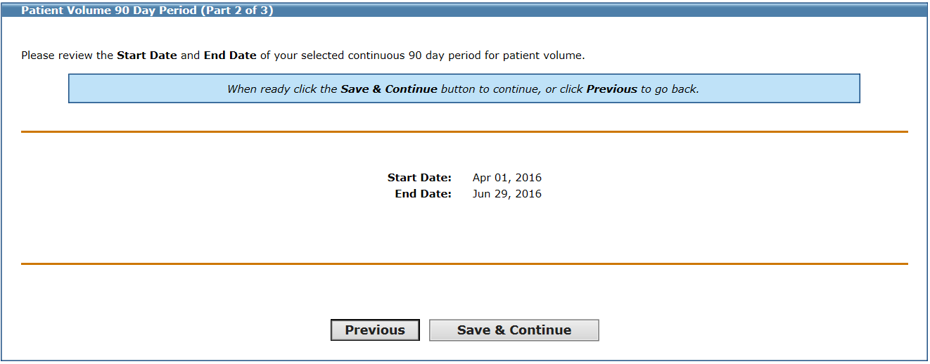
However, if you enter a start date that violates the rules of your 90-day Patient Volume period option, an error message will appear: * The date that you have specified is invalid. You will not be able to proceed with your application. In the example below, the start date entered is 10/04/2016. It is invalid because the end date of the 90- day period would be 01/01/2017, which is NOT in Calendar Year 2016.
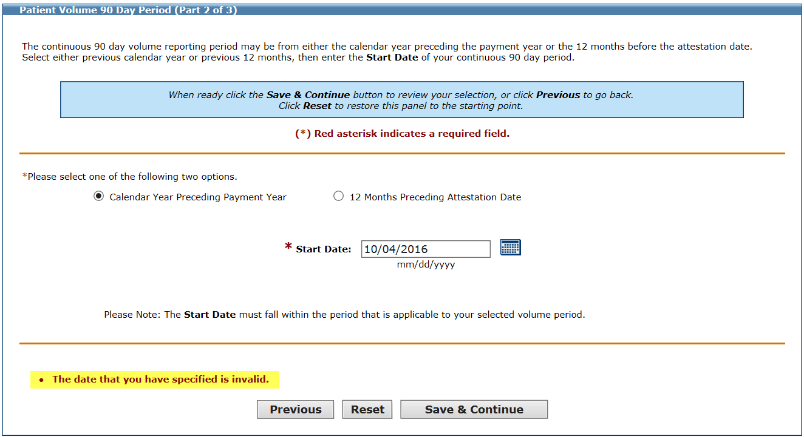

2. 12 Months Preceding Attestation Date
In the example for the option to submit a 90-day period from the “12 Months Preceding Attestation Date” option, pretend we are submitting the attestation on 05/01/2018.
The earliest date you can choose for the 90-day Patient Volume period is 05/01/2017. Here are the screenshots from MAPIR showing the start date and automatically calculated end date of the Patient Volume period:
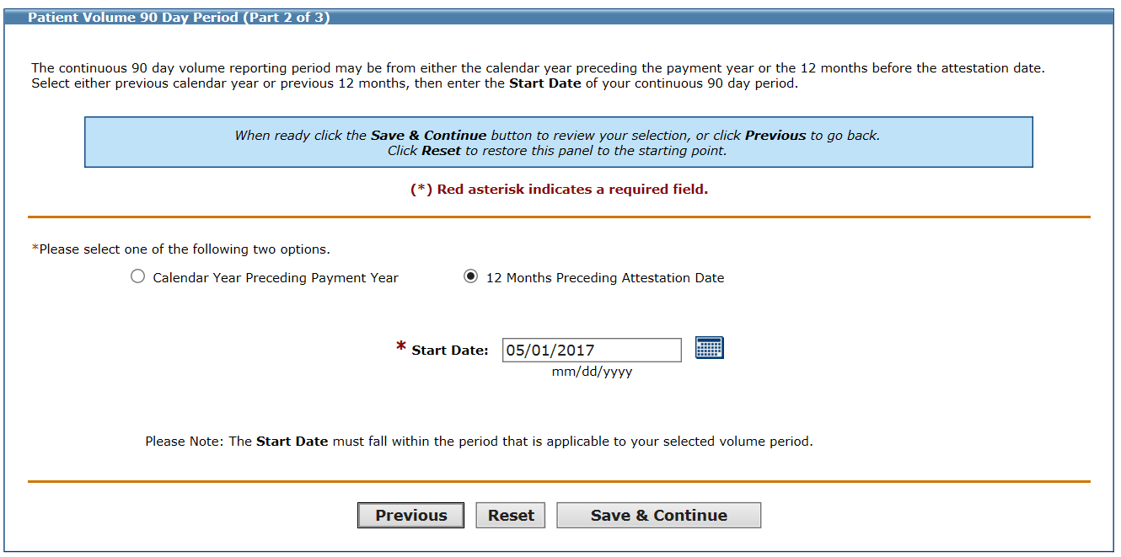
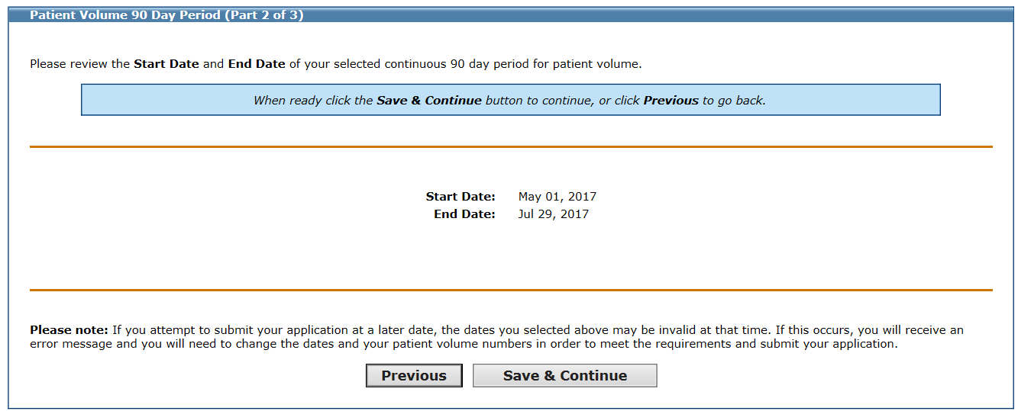

When using 05/01/2018 as the submit date (red circle), the dates highlighted in blue illustrate the EARLIEST start date and time period you can use for the 90-day Patient Volume time period:
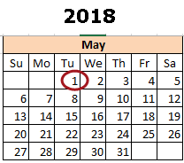
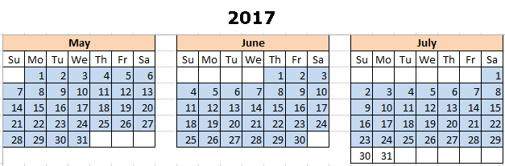
If you are delayed, and are unable to submit your attestation until 05/15/2017, the Patient Volume time period will no longer be valid, and you will receive the error message: * The date that you have specified is invalid.
Stepping forward one day on the submit date, means the EARLIEST start date for your Patient Volume period also moves forward by one day, to keep within the “12 months Preceding Attestation Date” definition. If the submit date is 05/15/2017, the earliest time period for the 90-day Patient Volume period is now 05/15/2017 – 08/12/2017:
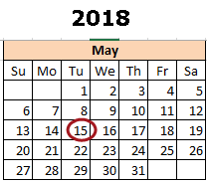
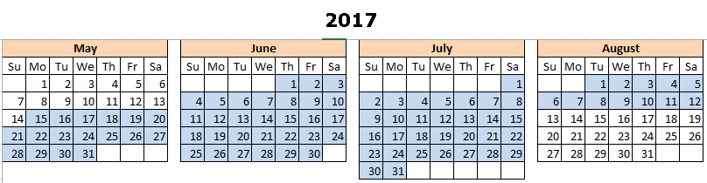
When using the “12 months Preceding Attestation Date” option for the 90-day Patient Volume time period, the start date may expire before you submit your attestation. This is why MAPIR has a warning: “Please note: the dates you have selected above may be invalid if you attempt to submit your application at a later date.”

