Shared Care Plan
for Children and Youth with Special Health Needs
Child/youth name: |  | Necessary releases obtained: ☐ Yes ☐ No
Child/youth likes to be called: |  | Team meeting date:
Date of birth: |  | Meeting location:
Parent(s): |  | Referred by:
Parent phone #: |  | Other:  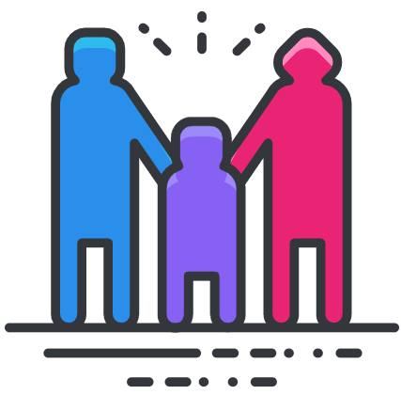
Primary care provider: | Interpreter (if applicable):
Gender identity: ☐ M ☐ F ☐ Other, please specify:

Pronouns: ☐ She/Her ☐ He/Him ☐ Other, please specify:

Child/Family Strengths and Assets

Child/Family Language and Culture

Child/Family Concerns and Goals
For today:
For the longer term:

Brief Medical Summary
Diagnosis:

Medications:

Current Interventions: | Tried Interventions:
Health Care Providers:

Other Important Medical Information (Allergies/Alerts):
Preferred Hospital: | Preferred Pharmacy:

Brief Summary of Involvement with Education/Community-Based Services

Team Members Contact List | Note: Initial next to name to note attendance at meeting. Add rows as needed.
Name | Role/Responsibility | Best way to contact
 | Family member
 | Primary care provider
 | Education
 | Mental/behavioral health
 | Public health
 | Health plan/insurance
 | Interpreter

Action Plan | Note: Add rows as needed.
- The first goal of the team should be one that is identified by the family as a priority.
- If the child/youth is aged 12 or older, include a minimum of one goal focused on the transition to adult healthcare.
Shared goal: | Who? | Is doing what? | By when?
 | This person | Will take this action | By this date  Date completed:
 | This person | Will take this action | By this date  Date completed:
 | This person | Will take this action | By this date  Date completed:
 | This person | Will take this action | By this date  Date completed:
Date identified: | Notes:
Date resolved:

Action Plan | Note: Add rows as needed.
- The first goal of the team should be one that is identified by the family as a priority.
- If the child/youth is aged 12 or older, include a minimum of one goal focused on the transition to adult healthcare.
Shared goal: | Who? | Is doing what? | By when?
 | This person | Will take this action | By this date  Date completed:
 | This person | Will take this action | By this date  Date completed:
 | This person | Will take this action | By this date  Date completed:
 | This person | Will take this action | By this date  Date completed:
Date identified: | Notes:
Date resolved:

Action Plan | Note: Add rows as needed.
- The first goal of the team should be one that is identified by the family as a priority.
- If the child/youth is aged 12 or older, include a minimum of one goal focused on the transition to adult healthcare.
Shared goal: | Who? | Is doing what? | By when?
 | This person | Will take this action | By this date  Date completed:
 | This person | Will take this action | By this date  Date completed:
 | This person | Will take this action | By this date  Date completed:
 | This person | Will take this action | By this date  Date completed:
Date identified: | Notes:
Date resolved:

© 2020, rev. 2021 Oregon Health & Science University
This project is funded by the Health Resources and Services Administration (HRSA) of the U.S. Department of Health and Human Services (HHS) under Oregon's Title V Maternal and Child Health Block Grant (#B04MC28122, in the amount of $1,859,482) and the “Enhancing the System of Services for Oregon’s CYSHCN” grant (#D70MC27548, in the amount of $300,000). The project receives no nongovernmental funding. This information or content and conclusions are those of the author and should not be construed as the official position or policy of, nor should any endorsements be inferred by HRSA, HHS, or the U.S. Government. To request permission to use this template please contact occyshn@ohsu.edu

