CALL FOR NOMINATIONS
Standards Advisory Committee

Purpose
The Oregon Health Authority (OHA) is seeking nominations for the 2019 Patient-Centered Primary Care Home (PCPCH) Standards Advisory Committee (Committee). We are looking for motivated leaders who are committed to advancing health, improving health care and lowering health care costs in Oregon.

A PCPCH is Oregon’s version of the “medical home,” which is a model of primary care delivery that is patient-centered, comprehensive, team-based, coordinated, accessible, and focused on quality and safety. There are over 650 PCPCHs across Oregon – 2/3 of all primary care practices!

The PCPCH Program was created by the Oregon Legislature through House Bill 2009 as part of a comprehensive statewide strategy for health system transformation. After the PCPCH program was established, a committee comprised of volunteer stakeholders from across Oregon convened to develop the core attributes, standards, and measures of the PCPCH model of primary care delivery. OHA periodically re-convenes the Committee to review best practices, clarify existing measures, and refine the model based on lessons learned and current literature.

In 2019, OHA is convening the committee to provide OHA with policy and technical expertise on the PCPCH standards and measures for recognition.

Members
Past advisory committee members have represented a broad range of organizations with an interest in primary care including patient advocates, providers, hospitals, health plans, and coordinated care organizations (CCOs). OHA is committed to ensuring all committees reflect the racial, ethnic, gender, geographic and disability diversity of Oregonians. We are particularly interested in nominations for those representing minority and underrepresented communities.

Commitment
The committee will meet once a month in Portland for three hours from July to December 2019. In-person attendance is preferred, but members can participate remotely. OHA will reimburse travel costs, if needed. All committee meetings are public meetings.

Meeting schedule (tentative):

Meeting date | Time | Meeting Date | Time
Thursday, July 11 | 9:00am – 12:00pm | Wednesday, October 2 | 9:00am – 12:00pm
Wednesday, August 8 | 9:00am – 12:00pm | Wednesday, November 6 | 9:00am – 12:00pm
Thursday, September 12 | 9:00am – 12:00pm | Wednesday, December 4 | 9:00am – 12:00pm

Resources
- Oregon Health Authority Patient Centered Primary Care Home Program 2017 Recognition Criteria Technical Specifications and Reporting Guide. https://www.oregon.gov/oha/HPA/dsi-pcpch/Documents/TA-Guide.pdf
This document describes the PCPCH recognition standards, including requirements for each measure.

- PCPCH Standards Advisory Committee website. https://www.oregon.gov/oha/HPA/dsi-pcpch/Pages/SAC.aspx Includes committee reports, member rosters of previous committees and meeting agendas.

- Patient-Centered Primary Care Home program website. www.PrimaryCareHome.or.gov

Staff contact
Amy Harris, MPH
Manager, Patient-Centered Primary Care Home Program
Oregon Health Authority
amy.harris@state.or.us or 971-344-0875

If you would like to be considered for the Committee please submit a nomination form (see next page) no later than Friday, February 22, 2019.

STANDARDS ADVISORY COMMITTEE
Nomination form

The purpose of this form is to assist the Oregon Health Authority in evaluating the qualifications of an applicant for membership on the Patient-Centered Primary Care Home (PCPCH) Standards Advisory Committee. Please submit this completed form by email along with a current resume (optional) by February 22, 2019 to: Amy Harris, PCPCH Program Manager at amy.harris@state.or.us

PERSONAL INFORMATION

Name: ____________________________________________________________________________

Title: ______________________________________________________________________________

Organization: ________________________________________________________________________

Address: ____________________________________________________________________________

Email: ______________________________________________________________________________

Phone number: _______________________________________________________________________

Please select the stakeholder group you represent (check all that apply):
☐Primary care provider
☐Behavioral health provider
☐Patient/consumer
☐Health plan
☐Hospital or health system
☐CCO
☐Tribes
☐Rural/frontier communities
☐Oral health
☐Social determinants of health and equity
☐Other: _____________________________

Can you commit to attending all six committee meetings and to reviewing materials prior to meeting?
☐Yes
☐No. Please explain why: ______________________________________________________________

INTEREST IN APPOINTMENT
Describe why you are interested in serving on the Patient Centered Primary Care Home Standards Advisory Committee and information about your background that supports your interest. Please limit your answer to this page.
Click or tap here to enter text.

I will accept appointment to the PCPCH Standards Advisory Committee if selected, and I pledge my best efforts to resolve, before assumption of responsibilities, any conflicts of interest that would be inconsistent with my responsibilities as a committee member.

Signature _____________________________________________ Date ______________________________________

OHA is committed to ensuring diverse representation on all committees. To help archive this goal we would appreciate you providing the following information. However, these questions are optional.

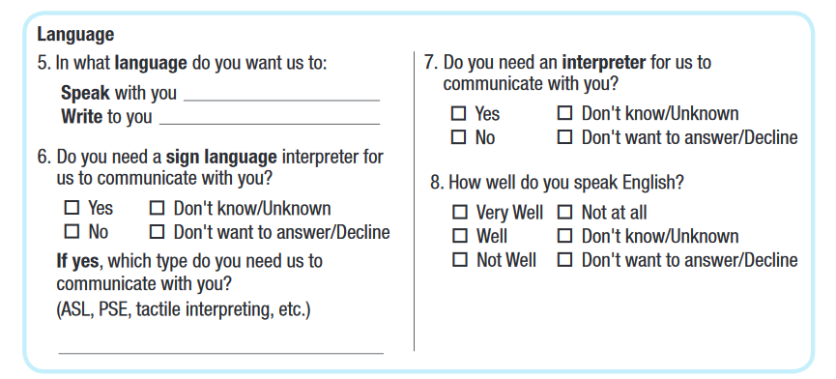
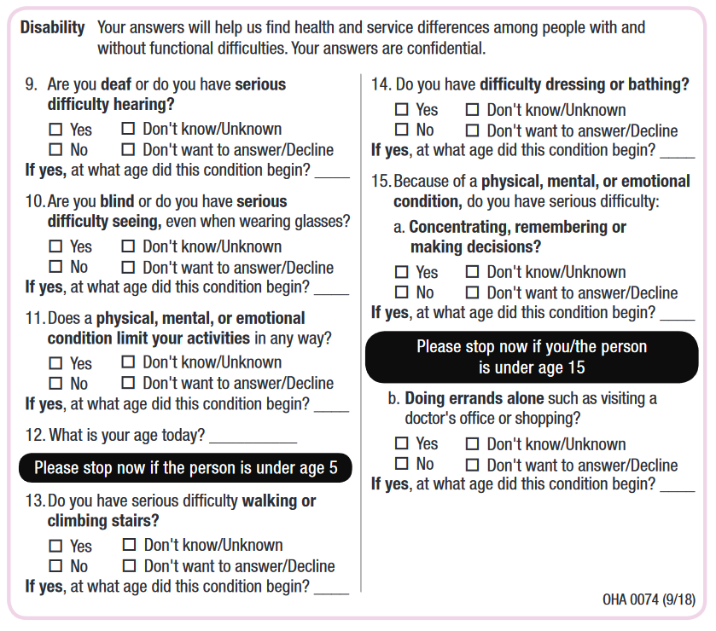

Identity/Orientation
- Decline to answer

- Decline to answer
16. Gender identity: _________________

17. LBGTQ (check if applicable)

