Important things to know about coordinated care organizations (CCOs)

What is a CCO?
Coordinated care crganizations are community-governed organizations that bring together physical, behavioral and dental health providers to coordinate care for people on Medicaid, known as the Oregon Health Plan (OHP).

To qualify for OHP, a student must:
- Live in Oregon;
- Meet income requirements

Other enrollment factors that determine the type of OHP a student may qualify for include citizenship status, other health care resources, and disability status.

CCOs are unique to Oregon. The ultimate goal of CCOs is to achieve the triple aim of:
- Better health;
- Better quality of care;
- Lower costs.

CCOs also have the flexibility to address their members’ health needs outside traditional medical services. This model is designed to improve member care and reduce taxpayer costs.

How do CCOs work?
CCOs are local. There are currently 15 CCOs in the state. Each CCO receives fixed monthly payments from the state to coordinate care and financial incentives that reward outcomes and quality. They have one budget that grows at a fixed rate for mental, physical and dental care.

CCOs are governed by a partnership among health care providers, community members and stakeholders in the health systems that have financial responsibility and risk.

CCOs are accountable for health outcomes, or metrics, of the population they serve. Some of the metrics have incentives if the CCO meets certain set benchmarks. Some particularly relevant metrics for higher education partners are:
- Adolescent well-care visit rate (ages 12-21, but particularly 18-21).
- Effective contraception use among women at risk of unintended pregnancy (age 15-50)
- Substance abuse screening and follow up (SBIRT) (age 15 and over)
- Depression screening and follow up (age 15 and over)
- Cigarette smoking prevalence (age 18 and over)

How do I know what CCO my campus is located in?
Each CCO has a defined service area. You can find a map of current CCO service areas here. Note that your college may have campuses in two different CCO service regions.

How can I connect to my CCO? Who are the right people or groups to reach out to?
Every CCO is unique, but below are some common groups, roles and requirements that could be an opportunity to connect with your CCO.

Community Advisory Councils
Every CCO has at least one community advisory council, or CAC. The CAC is made up of OHP members who are served by the CCO. The CACs provide important lived experience and recommendations on how to improve care in their community (like finding providers, getting appointments, transportation and other health care challenges). Find a contact for each CCO’s CAC at http://oregoncac.com

Innovator Agent
Innovator agents are employed by the Oregon Health Authority, but are assigned to one or more CCO. Innovator agents can be a good initial contact and help direct you to the right person at their CCO. Find out who the Innovator Agent is for your CCO at http://www.oregon.gov/oha/HSD/OHP/Pages/Innovator-Agents.aspx

Quality Improvement Staff
Some CCOs have staff who are responsible for overseeing improvement efforts tied to incentive measures. Knowing what incentive metrics are most relevant for your work (see “How do CCOs work?” section) can help establish a good connection.

Community Health Improvement Plan
CCOs are required by law to complete a community health improvement plan (CHP) based on a community health assessment (CHA) every five years. The CHA and CHP are typically done in partnership with local public health authorities, hospital systems, and many other community partners. Being involved in the CHA/CHP processes is one way to connect the strengths and needs of your campus and student population with the CCO(s) in your area. To learn more about getting involved in the CHA/CHP process, contact your CCO’s CAC coordinator via http://oregoncac.com

What types of information would be helpful to have prior to an initial meeting?

- Types of health services provided on campus (if services are provided on campus).
- Types of health resources available on campus.
- General demographics of student population. Many community colleges do not collect insurance status upon enrollment, but include any proxy measure that might be available, like income.
- Dates of planned events on campus that could be used as a partnership opportunity. (For example: new student orientation, health fairs, vaccine clinics, etc.)
- Current education efforts around health care and health services. Implementing the Health Hack curriculum in health courses is one example.

Important things to know about community colleges

Why are community colleges important partners for CCOs?

Community colleges serve a wide range of community members across Oregon, including CCO members. According to 2016–2017 enrollment data, over 61,000 18–21-year-olds were enrolled in a community college in Oregon (see table below). As programs like Oregon Promise incentivize community college attendance for high school graduates in Oregon, community colleges are an excellent partner in helping CCOs reach their young adult population.

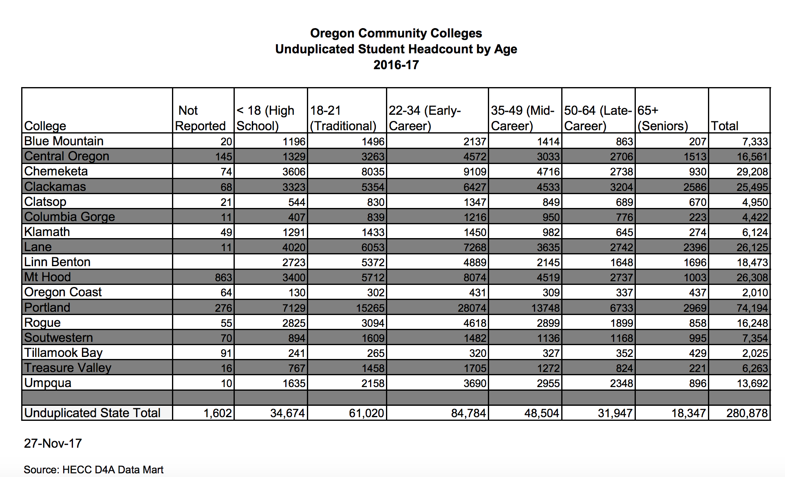

Additionally, community colleges are a key partner in workforce development. Many have training programs for medical assistants, dental assistants and hygienists, community health workers, nurses, peer mentors, addiction specialists and many others.

How do community colleges work?

There are 17 community colleges in Oregon. There is at least one community college in every CCO service area, with many community colleges serving community members at multiple campus locations (which may span multiple CCOs). Like CCOs, every community college is unique. It is important to know that the majority of community colleges do not provide health services on campus, though some may provide counseling services or are working with a community partner to deliver some health care. Most community colleges do provide health resources and may already be working with an OHP enrollment assister to get students enrolled on the Oregon Health Plan.

Additionally, most community colleges do not collect insurance status upon enrollment, which is different than public universities in Oregon. However, they may have access to student income levels that could be used as a proxy to estimate the proportion of Medicaid eligible community college students.

How can I connect to community colleges in my CCO service area?

There are many ways to connect to community colleges in your service area. Each will vary by community, but key roles, offices and programs are listed below. This list is not exhaustive.

Student services
People working in student services are tasked with meeting the needs of students beyond curriculum. There is a student services director at every community college. Find a contact for the community college(s) in your service area at: http://oregoncssa.com/

Programs that support students
The programs listed below may or may not be housed within student services, but may be a good link to engagement with CCO members on campus.

- TRIO: Federal program to help first-generation students, students with low-income and students with documented disabilities be successful in school. Find out more at http://www.oregon-trio.org/OR-TRIO-Projects.html

- SNAP Career Pathways/Training and Employment Programs: Program that supports students receiving SNAP benefits to access education and employment training.

Advising and counseling centers
Community colleges have advisors and/or counselors that offer academic, career and personal counseling. These advisors/counselors may have potential OHP students who could be referred for services and coordinated care.

Resource centers on campus
Many community colleges have resource centers on campus that can help connect CCOs with members including: Women’s Resource Center, Queer Resource Center, and Multicultural Centers. Many programs and resources are targeted to specific student populations, including students of color, Native American students, and Veterans.

Student associations
Connect with the various student associations on campus to conduct direct outreach to student populations for awareness building and recruiting for community advisory council positions.

