
Medicaid
Certified Community Behavioral Health Centers

Certified Community Behavioral Health Centers Wraparound Billing Guidance
Use this billing guide as a supplement to the information available of the Certified Community Behavioral Helath Clinics (CCBHC) web page.
Contents
Certified Community Behavioral Health Centers Wraparound Billing Guidance 1
Overview of Wraparound Payment Process for CCBHC Services 1
Wraparound Data Template 2
Reporting Payments from Other Payers 2
Frequently Asked Wraparound Questions 6

Overview of Wraparound Payment Process for CCBHC Services
OHA will supplement payments received by the CCBHC from CCO/managed care entities, Medicare, private insurance, and other third party sources up to cost (PPS rate). Wraparound payments are only available for CCBHC services provided to CCO enrolled OHP members. Bill the CCO or other payer as you normally would.
- On a quarterly basis, submit all CCBHC Demonstration Service encounters that were paid by the CCO/managed care plan to OHA by completing the CCBHC Wraparound Data Template. Send the completed template to the Medicaid Settlements E-mail.
- Report all payments received from CCOs, other managed care plans, Medicare, and other payers for CCBHC Demonstration Services delivered within the quarter to CCO/managed care enrolled members.
- Capitation payments, risk withholds, global payments, and other lump sums received for CCBHC Demonstration Services are to be reported for the quarter in which they were received.
- Wraparound payments will generally be issued to the CCBHC within 45 days of the date submitted.
- For encounters that OHA is unable to “match” with a paid CCO/managed care claim in the Oregon Medicaid Management Information System (MMIS), OHA will send a report identifying the unmatched encounters. The CCBHC will have 30 days to provide supporting information to qualify for a “follow-up wraparound payment”, such as an explanation of benefits (EOB) or remittance advice (RA) showing payment for the encounter.

Wraparound Data Template
Use the CCBHC Wraparound Data Template when seeking wraparound payments for CCBHC services provided to CCO members during a given calendar quarter. The cover page of this template will estimate the potential wraparound payment within the row labeled “Costs Less Amounts Received”; however this amount is subject to change based on the number of encounters OHA is able to validate as paid by the CCO in the MMIS.

Reporting Payments from Other Payers
Medicaid is the payer of last resort. Oregon Medicaid providers are required to pursue payment from all payer sources prior to billing Oregon Medicaid. For CCBHC wraparound payment requests, CCBHCs must report all payments received for CCBHC services provided to CCO/managed care enrolled members
CCBHCs may receive many different types of payments from other payers for the provision of CCBHC services to CCO/managed care enrolled members. These payments may include, but are not limited to, traditional claims payments (fee-for-service), capitation payments (permember, per-month), case rate payments, risk withhold payments. In the table below, we detail what these payments are and how to report them:
Payment Type | Description | How to Report | Example
Capitation | A fixed, pre-arranged monthly payment received by a physician, clinic or hospital per patient enrolled in a health plan with a capitated contract. | Capitation payments are reported in the quarter they are received. CCBHCs should identify the percentage of capitation received for OHP members AND for the provision of CCBHC services. Report the dollar amount of the applicable percentage in row 30 of the template cover page. Indicate as a comment in the template or separate statement your CCBHC’s method for allocating the capitated amount. | CCBHC A receives $200,000 capitation on 4/1/2017 from the CCO. The CFO at CCBHC A establishes that 100% of the $200,000 is for OHP members, but 30% is for residential treatment (non-CCBHC) services. CCBHC A reports $140,000 in row 30 of the cover page, and reports “PMPM” for zero-paid CCO encounters on the data tab in column L.
Claims (Fee-for-Service) | A method in which health care providers are paid for each service performed, giving an incentive for providers to provide more treatments because payment is dependent on the quantity of care, rather than quality of care. | On the cover page within cells D34-D36, report the total amount received through claims based reimbursements, from each of the payer types: - Coordinated Care Organizations - Medicare/Medicare Advantage Plans - Private Payers, Third Party Resources (TPR) Within the data tab, for each encounter, report the specific claims payment received in columns K & M. | CCBHC B receives $450,000 from the CCO in claims payments for services provided during 4/1/2017 – 6/30/2017. The CCBHC comptroller determines that $400,000 was issued for CCBHC demonstration services. CCBHC B reports $400,000 in row 34 of the cover page, and reports the individual claims payments on the CCBHC C receives a $100,000 risk withhold payment on 4/1/2017 from the CCO. CCBHC C reports $100,000 in row 31 of the cover page.
Risk Withold | A percentage of the clinic’s capitation or fee-for-service payments are withheld for a defined period, and placed at risk depending on the clinic’s ability to achieve quality, access, cost, or other targets. This payment is reported when it is released from withhold and received by the clinic. | Risk withhold payments are reported in the quarter they are received. CCBHCs should identify the percentage of risk withhold received for OHP members AND for the provision of CCBHC services. Report the dollar amount of the applicable percentage in row 31 of the template cover page. Indicate as a comment in the template or separate statement your CCBHC’s method for allocating the | CCBHC C receives a $100,000 risk withhold payment on 4/1/2017 from the CCO. CCBHC C reports $100,000 in row 31 of the cover page.
Case Rate Payment | Also known as episodebased payment or bundled payment, is a pre- determined amount of money paid to a provider organization to cover the average costs of all services needed to achieve a successful outcome for a predefined episode of care. | Case rate payments are reported in the quarter they are received. CCBHCs should identify the percentage of case rate payments received for OHP members AND for the provision of CCBHC services. Report the dollar amount of the applicable percentage in row 33 of the template cover page. Indicate as a comment in the template or separate statement your CCBHC’s method for allocating the case rate amount. On the data tab, report each individual encounter that the case rate payment is intended to support (member ID, procedure code, diagnosis code, date of service, etc.) | CCBHC D receives $40,000 in case rate payments on 5/1/2017 from the CCO for SPMI patients. The accounting manager at CCBHC D establishes that 100% of the $40,000 is for OHP members, but 25% was/will be used for residential treatment (non-CCBHC) services. CCBHC D reports $30,000 in row 33 of the cover page, and reports “Case Rate” for zeropaid CCO encounters on the data tab in column L.

Frequently Asked Wraparound Questions
Should CCBHC wait until encounters have been fully adjudicated by our CCO before submitting to the State?
We are guiding clinics to wait until the CCO has adjudicated 90-95% of the services provided within the quarter, before submitting for the wraparound payment. When you get to the 90-95% marker, you may submit all of the encounters that you are expected payment for, including the additional 5-10% that have not reach final adjudication. OHA will issue a supplemental wraparound payment for the encounters we are able to match against a paid CCO claim in the MMIS. For the encounters we are not able to match, we will report those encounters to you and indicate that you have 30 days to submit additional information to substantiate you received payment for the service. Once we receive the supporting information (explanation of benefits, remittance advice, etc.) on the unmatched encounters, we will issue a follow-up wraparound payment.
After submitting our wraparound encounter data on the template, how long will it take for our CCBHC to receive the wraparound payment?
Less than 45 calendar days. If a claim is denied by the CCO for timely filing, will that also be denied for a WRAP payment as well? Yes, CCBHC encounters will only count when they are adjudicated to a paid status by the managed care plan/CCO.
Are we required to report bonus payments like quality incentives from the CCO?
No, only report payments specifically for the provision of CCBHC Demonstration Services to Oregon Health Plan members. There is a column for "CCBHC Medicaid ID #" on the data tab...and we have three different ones. One for mental health, one for A&D and one for primary care. I have no way in my EHR to pull each ID # per specific claim. What would you like me to put there? You may leave that column on the data tab blank, but list all of your NPI and Medicaid ID numbers used to bill CCOs on the cover page of the template.
You mentioned to include all CCBHC services regardless if they have been paid yet. Do you want that encounter total as the total on the cover page or do you want the cover page encounter total not to include unpaid services?
List the paid encounters along with those 5-10% awaiting payment, but exclude denied encounters from the total.
Do we send only non-open card Medicaid services? Or do you want us to report ALL CCBHC services, even the open card (fee-for-service) encounters that had previously been sent through MMIS to bill OHA directly?
The wraparound payment process is only for CCO/managed care enrolled Oregon Health Plan members. Open card member services can be billed directly to OHA through the MMIS. We sometimes serve out of county Medicaid clients that we bill their CCO for their services, but do not have a contract with their CCO.
Can we report these services for a wraparound payment?
Yes, if the CCO submitted a paid claim to the MMIS for the care your CCBHC provided, you may include the service and payment from the non-contracted CCO in your wraparound submission.
Are CCBHC services performed in the community an eligible PPS event?
Yes, PPS and wraparound reimbursements are available for encounters provided outside the four walls of the clinic (community-based, home visit, nursing facility, etc.).
You mentioned that there was no specific due date, but you wanted us to submit the wraparound report when 90-95% of the CCO payments have been received… Were we correct in understanding that to be the general guideline?
Yes, we will not be able to issue a supplemental wraparound payment for claims that the CCO hasn’t submitted to the MMIS in a paid status; therefore it’s likely in the best interest of your clinic to wait until the overwhelming majority of claims have been adjudicated by the CCO and submitted to the MMIS. The benefit of submitting when 90-95% are paid is that you will not need to wait an unreasonable amount of time for a small number of encounters that the CCO has not adjudicated yet, to get your initial wraparound payment.

Wraparound Reporting Template Example
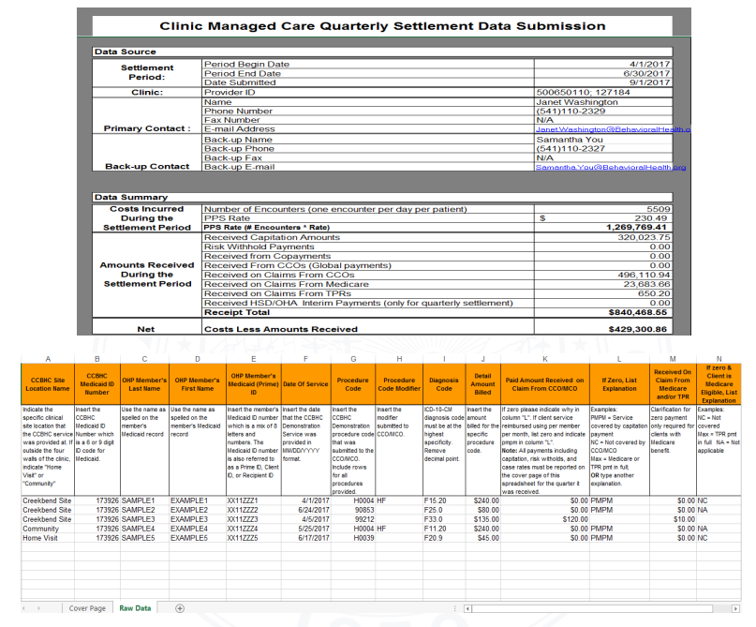
You can get this document in other languages, large print, braille or a format you prefer free of charge. Contact the CCBHC team at CCBHC@oha.oregon.gov.

Medicaid
Certified Community Mental Health Programs
Oregon CCBHC Website

