OHA MEDICAID DIVISION | 

Reminder & Update for CY2025 CCO-LTSS MOU CCO Deliverable
The updated MOU period aligns with the CCO 2.0 contract extension through 2026 set by the Oregon legislature. Any updates for CY2026 will follow the normal contract deliverable date. We are extending the due date for CY2025 CCO-LTSS MOUs. CCOs should be aligning MOUs with feedback from CCO-LTSS MOU reporting and updated CCO care coordination OARS (OAR 410-141-3860, 410-141-3865, 410-141-3870, 410-141-3875, 411-004-0020) released in 2024. Technical assistance is available for any questions.

- CCO-LTSS MOUs must all be updated through meetings with your local APD/AAA districts. Please reach out to schedule conversations to hear your local partner concerns or ideas for improvement.
- For CY2025 CCO-LTSS MOUs we are extending the due date to March 31, 2025, to ensure adequate time for these meetings and conversations,
- Updated MOUs should improve on long-standing expectations where needed. While the CCO-LTSS guidance is largely the same posted guidance-- the following updates were made:
--Updates to align with care coordination rules finalized in 2024
--Updates to reflect new 1115 HRSN waiver services
--Alignment with updated definitions of terms in the glossary to reflect changes in CCO OARS.
- CCOs should use issues identified in annual MOU reports to improve their MOUs and prepare for continued tracking for annual reporting to OHA.
  - Updated MOUs for this two-year period should address weaknesses as noted in feedback such as:
    - Ability to track communication with APD/AAA offices and staff,
    - Use of Hospital Event Notifications (HEN) and Skilled Nursing Facility (SNF) PointClick Collective Platform notifications to trigger communication with APD/AAA offices especially concerning care setting transitions,
    - Ensuring development of care plans for a greater proportion of CCO members with LTSS or needing LTSS.
    - Addressing needs at care-setting transitions for discharge to prevent readmissions or unnecessary hospitalizations.
    - Sharing how referrals and supports for members may be enhanced with new 1115 waiver services.

Guidance and updated template for the CCO-LTSS MOU Report will be released in 2025. Tracking for the fields in CY2024 report template should be continued to prepare for CY2025 reporting.

MOUs will be reviewed as in the past by a review of the completeness of each MOU’s addressing each required domains’ minimum expectations and the listed CCO and APD expectations. Each section should ensure to address each area clearly. Governance sections must also be completed and documents must have obtained required signatures.

Please submit through the CCO portal at via the Contract Deliverables portal located at https://oha-cco.powerappsportals.us/. This report content is subject to public posting and redaction. It will be shared without redaction with the Centers for Medicare and Medicaid Services (CMS) and with the Oregon Department of Human Services.

CY2025 Due Dates:

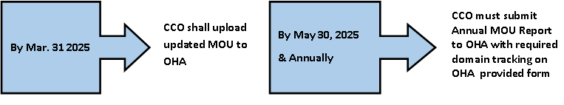

Please contact the Medicaid leads below with questions:
Cheryl Henning | Jennifer Valentine
CCO Contracts Administrator | Medicare-Medicaid/CCO-LTSS Policy Analyst
Cheryl.L.Henning@oha.oregon.gov | Jennifer.B.Valentine@oha.oregon.gov

