DATE

Re: Oregon Medicaid DSH Examinations State Fiscal Year 2017
Surveys Due: 5/29/2020

Dear Hospital Contact:

In order to comply with the federal regulation regarding disproportionate share hospital (DSH) payments issued by CMS on December 19, 2008, December 3, 2014 and April 3, 2017, the Oregon Health Authority has contracted with Myers and Stauffer LC, a certified public accounting firm, to perform the mandated examinations. (See Federal Register Vol. 73, No. 245, December 19, 2008, rules and regulations, Federal Register Vol. 79, No. 232, December 3, 2014, rules and regulations, and Federal Register Vol. 82, No. 62, April 3, 2017, rules and regulations).

The regulation mandates auditing and reporting requirements for DSH payments under state Medicaid programs. The DSH year under review covers the time period from July 1, 2016 through June 30, 2017.

Because your hospital received Medicaid DSH payments during state fiscal year 2017, it is subject to the DSH program examination and must identify its actual Medicaid and uninsured costs incurred during the cost report years that overlap the DSH year. Completing the surveys for all cost reporting periods within the state rate year 2017 will ensure that the hospital’s uncompensated care costs are captured in the DSH calculation and in accordance with the final DSH rule. To fulfill the other reporting requirements, several additional data elements will need to be reported by your hospital. These additional data elements will be used as a tool to determine the completeness of and accuracy of uncompensated costs and charges.

Note: For the 2017 DSH examination, prior year submitted surveys that overlap the current state plan year will be used and do not need to be resubmitted. DSH Survey Part II (and supporting Exhibits A-C) only needs to be completed for the cost report year(s) noted on your survey forms.

For instructions on completing the surveys, refer to Attachment A enclosed with this letter, as well as the instructions included within the DSH surveys. For guidance on uninsured and Medicaid definitions refer to the CMS DSH rules and policy. Please note there are no significant changes to submission requirements or submission format from the prior year.
The hospital-specific DSH Surveys (with HCRIS data populated) have been uploaded to the hospital’s primary user’s Myers and Stauffer SFTP account. Along with the DSH surveys, Myers and Stauffer has uploaded (to the primary user’s Myers and Stauffer SFTP account) state Medicaid FFS revenue code summaries to be mapped by Medicare cost report cost center and entered into DSH Survey Part II, Section H, In-State Medicaid Fee for Service Primary columns. Detail state Medicaid FFS data has also been uploaded if needed. State Medicaid Crossover data is available upon request but we encourage hospitals to use hospital generated Exhibit C Crossover reports instead to ensure completeness.
Oregon Health Authority (OHA) is planning to obtain Medicaid managed care data for hospitals or they may use their own data to include on the DSH surveys. The state will provide the information to the hospital association and the hospital association plans to provide the information to hospitals (upon request) once available for hospitals to submit the Medicaid managed care data. Please note if the hospital uses this information, the hospital will be responsible for the accuracy of the data.
Your hospital was determined to have met the Medicaid shortfall during the 2016 examination. As a result, your hospital is not required to submit and Exhibit A or B at this time but are required to submit an uninsured confirmation letter. However, if after completion of review of 2017 data your hospital is determined to have not met the Medicaid shortfall with current year data, MSLC will request that an Exhibit A and B will be submitted.
All documentation should be submitted in electronic format using the Myers and Stauffer SFTP site as much of this documentation contains confidential protected health information. See Attachment B for instructions on accessing and using the SFTP site. If you require additional assistance accessing the SFTP site, please contact Diane Kovar (dkovar@mslc.com).

Completed DSH surveys and supporting documentation must be submitted by 5/29/2020.

You may request an extension of time for good cause to submit this documentation. If you need to request an extension of time to submit this documentation, please submit your request to the following (carbon copy dkovar@mslc.com)

Ms. Angel Wynia
Hospital Policy and Program Manager
500 Summer St. NE E-35
Salem, Oregon 97301
Angel.WYNIA@dhsoha.state.or.us

Once your completed surveys (and other required documents) are received by Myers and Stauffer, we will contact you to address any questions we may have and request additional documentation if expanded review and/or testing of your survey responses is considered necessary.

It is important to the Oregon Medicaid program that all hospitals receiving DSH payments during this time period provide the information needed in order to complete the required federal examination. Failure to provide this information may result in the recoupment of the DSH payments made to your hospital.

If you have questions or concerns please contact us at (800) 505-1698 or e-mail dkovar@mslc.com. We appreciate your cooperation with this initiative.

Sincerely,

Diane Kovar
Diane Kovar, CPA
Myers and Stauffer LC
Attachment A
This attachment includes additional instructions to complete the DSH Surveys. Each DSH Survey also includes an instructions tab. If you have questions regarding the DSH Surveys after reviewing this attachment and the instructions in the survey, please contact Myers and Stauffer.

DSH Survey, Part I – DSH Year Data
Begin with the DSH Survey Part I – DSH Year Data. All of the information in this survey relates specifically to the state DSH year under examination (7/1/2016-6/30/2017). (DSH Survey Part I – DSH Year Data.xls)
- See the “Instructions” tab for information on how to complete this survey.
- This file includes a Checklist to assist you with gathering the supporting documentation to submit with the surveys.

DSH Survey, Part II – Cost Report Year Data
The DSH Survey Part II includes all data related to your hospital’s cost reporting period. Submit one copy for each cost report year that overlaps the DSH year. (DSH Survey Part II – Cost Report Data.xls)

- Sections D, E and F – General Information
  - See the “Instructions” tab for information on how to complete these sections.

- Section G Cost Report Data
  - Section G is pre-populated using data from the HCRIS database. All information in this section comes directly from the cost report. The data will be used to calculate the per diems and cost to charge ratios.
  - A copy of your cost reports overlapping the 2017 DSH year must be submitted with the DSH surveys. If you have a newer version of the applicable cost report (audited, settled, reopened…), please use it to complete the survey and include a copy with your survey submission. You are required to use the audited cost report, if it is available.

- Section H - In-State Paid Claims Data
  - In-State Medicaid FFS Primary
    - A paid claims summary report with all Medicaid claims for each applicable cost reporting period will be provided to you to assist in completing the survey.
    - Please note that Title XXI CHIP paid claims are removed from the totals on the paid claims report provided. These must be excluded from the survey.
  - In-State Medicaid Managed Care
    - If reporting Managed Care claims on the DSH Survey, hospital patient detail or a paid claims summary from the MCO must be provided. Oregon Health Authority (OHA) is planning to obtain Medicaid managed care data for hospitals or they may use their own data to include on the DSH Surveys. The state will provide the information to the hospital association and the hospital association plans to provide the information to hospitals (upon request) once available for hospitals to submit the Medicaid managed care data. Please note if the hospital uses this information the hospital will be responsible for the accuracy of the data. If submitting hospital patient detail, it must be submitted using the Exhibit C format. (DSH Survey Exhibit A-C Hospital-Provided Claims Data.xlsx) (tab Exhibit C)
    - Hospitals must submit the data in the Exhibit C format. The above referenced Excel file is included with the survey request.
    - This population would typically represent accounts (with admit dates within the cost report period) with In-State Medicaid MCO as the primary payor. Payments would reflect all payments received on the account (regardless of when the payment was received) from all payors.
  - In-State Medicaid FFS Cross-Overs (with Medicare Primary)
    - If submitting internally-generated cross-over data, patient level detail must be submitted using the Exhibit C format. (DSH Survey Exhibit A-C Hospital-Provided Claims Data.xlsx) (tab Exhibit C)
    - Hospitals must submit the data in the Exhibit C. The above reference Excel file is included with the survey request.
    - This population would typically represent accounts (with admit dates within the cost report period) with Medicare FFS as the primary payor and Medicaid/Medicaid MCO as the secondary (tertiary, etc.) payor. Payments would reflect all payments received on the account (regardless of when the payment was received) from all payors.
    - State Medicaid Crossover data is available upon request if a hospital is unable to provide internally-generated Exhibit C cross-over data.

  - Other Medicaid Eligibles
    - If reporting Other Medicaid Eligible claims on the DSH Survey, patient detail must be submitted using the Exhibit C format. (DSH Survey Exhibit A-C Hospital-Provided Claims Data.xlsx) (tab Exhibit C)
    - Hospitals must submit the data in the Exhibit C format. The above reference Excel file is included with the survey request.
    - Other Medicaid Eligibles should include any other Medicaid-Eligible patients accounts (with admit dates within the cost report period) that have not been reported anywhere else in the survey. The patients must be Medicaid-eligible for the dates of service and they must be supported by Exhibit C and include the patient's Medicaid ID number. This would include Medicare Part C/Medicaid cross-overs not reported elsewhere on the survey, Private Insurance primary/Medicaid secondary cross-overs not reported elsewhere on the survey and any other Medicaid eligible accounts not reported elsewhere on the survey. Payments would reflect all payments received on the account (regardless of when the payment was received) from all payors.

  - Uninsured
    - Exhibit A – All Uninsured Charges / Days (DSH Survey Exhibit A-C Hospital-Provided Claims Data.xlsx) (tab Exhibit A – Uninsured Charges)
      - Hospitals must submit the data in the Exhibit A format. An example of the format is included in the DSH Survey and the above referenced Excel file which was included with the survey request.
      - Total days and charges in Exhibit A must agree to the data entered on the survey.
      - Exhibit A must include patient level detail and list charges/routine days by revenue code for each patient. Exhibit A accounts should represent uninsured accounts with admit dates within the cost report period.

    - Exhibit B – ALL Patient Payments on a Cash Basis (DSH Survey Exhibit A-C Hospital-Provided Claims Data.xlsx) (tab Exhibit B – Self-Pay Pmt (CASH))
      - Hospitals must submit the data in the Exhibit B format. An example of the format is included in the DSH Survey and the above referenced Excel file which was included with the survey request.
      - Exhibit B should include all cash basis insured and uninsured patient payments and clearly indicate each patient’s insurance status at the time of service. Exhibit B payments should represent all self-pay payments received during the cost report period (regardless of date of service).
      - Report all uninsured payments for hospital services in the uninsured column, see example to calculate payments for hospital services.

- Section I - Out-of-State Paid Claims Data
  - Report all out-of-state claims in the appropriate column of this tab (Medicaid FFS, Medicaid Cross-Overs…).
  - Use out-of-state paid claims reports (PS&Rs), if available, to report Medicaid claims. If out-of-state paid claims reports are not available, use hospital records to submit data. Please see the example of Exhibit C – OOS Data for the format required. (DSH Survey Exhibit A-C Hospital-Provided Claims Data.xlsx) (tab Exhibit C – OOS …)

- Section J and K Organ Acquisition
  - Report the charges and number of useable organs for each cost center for each payor type.
  - Submit patient level detail to support the number of useable organs and charges claimed.

- Section L Provider Tax Assessment Reconciliation/Adjustment
  - Report the Hospital Gross Provider Tax Assessment and how it was reported on the cost report.
  - Submit supporting documentation as necessary regarding whether filed on the cost report.

After completion of all surveys, review checklist in DSH Survey Part I and submit all support, surveys and exhibits.

Attachment B

This attachment includes instructions to the Myers and Stauffer Secure File Transfer Protocol (SFTP). All documentation should be submitted in electronic format using the Myers and Stauffer SFTP site as much of this documentation contains confidential protected health information. If you require assistance while using the Myers and Stauffer SFTP site, please send an email to ftpsupport@mslc.com. Please note: All files uploaded to the Myers and Stauffer SFTP site will only remain on the site for 14 days after which they will be automatically deleted.

- Logging On
  - Input the following URL into the Internet Explorer address bar: https://transfer.mslc.com.
  - Enter your username
  - Enter your password (Note: Password is case sensitive)
  - Click the “Sign On” button

- Password Change
  - Password change requests are now self-service.
  - Navigate to the FTP site: https://transfer.mslc.com
  - Select “Request a password change” at login screen. Clicking this link opens the Password Change Request page.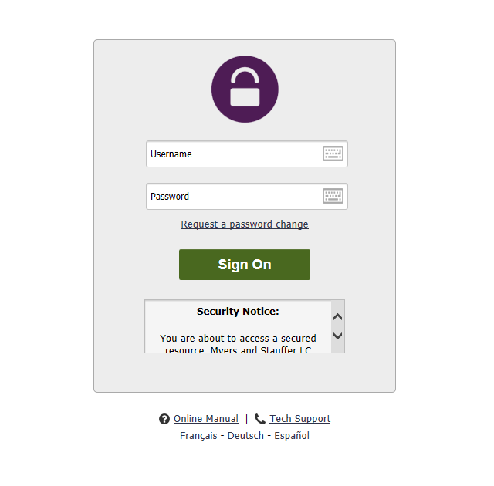
  - Enter the username in the box provided
  - Select “Request Password Change”
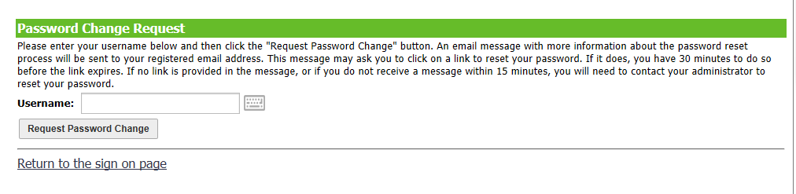
  - An email from Myers and Stauffer LC is emailed to the user. This email contains a link that allows the user to set a new password. Please note, the link provided is available for 30 minutes. After the time has expired, the user will receive an error message at the sign in page and will need to request another emailed link.
  - Users with expired FTP accounts will be denied password change requests. Please contact FTP support (ftpsupport@mslc.com) or Diane Kovar (dkovar@mslc.com) for assistance having the password reset.

- SFTP Online Manual
  - An online manual can be accessed from the home screen.
  - Select Online Manual while holding the Ctrl key. The online user manual will open in a new window.

- Logging Out
  - When you have finished uploading/downloading files, click the “Sign Out” link positioned in the top right of the web page.
  - Clicking the “Sign Out” link will prompt the user to the sign in screen. A message will appear at the top of the screen “Signed off successfully”.
  - Close the browser tab or browser window.

