MCE Letterhead (required)
(include name, address
phone number; can add
subcontractor)
Important: Results of your appeal request
You asked us to change our decision about a denial. This letter has our appeal decision. Please call us right away at XXX-XXX-XXXX or TTY ### if you do not understand this letter. You can get this letter in large print, another language or any way that is best for you. You can ask for help from an interpreter. This help is free.

<< NOTICE DATE>>

MEMBER NAME
ADDRESS
CITY, STATE ZIP

<<OHP Client ID, DOB>>
<<PCP/PCD/BHP, CLINIC/NOT YET ASSIGNED>>
Results of your request to change our decision
(Also called Notice of Appeal Resolution)
Dear <<Member name>>,
On <<request date>>, we got your appeal request to change the decision we made. We looked at your records again. We also looked at what you told us in your appeal request. We requested any new records that were sent about you and this service. This letter explains our decision and what you can do next.
Appeal (decision) results: | <<Decision in plain language. Denied, terminated reduced, suspended. We have decided to overturn (reverse) our denial decision. / We have decided to uphold (not change) our denial.>>
Date decision is effective: | <<Effective date>>
Service that was <<denied, approved, partially approved>>: | <<Plain language description of denied service and procedure codes>>
Service was to help treat: | <<Diagnosis in plain language, diagnosis codes. Diagnoses submitted in request (when service is being denied as diagnosis is not funded or diagnosis and procedure do not pair on the Prioritized List)>>>
Provider who requested it: | <<Provider name>>
Reason for appeal results: | <<Member-specific reasons why coverage criteria was not fully met>>.
We based our decision on: | <<List of all applicable OARs, Guideline Notes, HERC Clinical Guidance, medical policies or criteria, etc. OARs are listed with only the specific sections and subsections that apply to this member-specific decision.>>
A copy of this letter has been sent to your provider.
When we looked at your records, we checked to see if you have a different medical issue that would let us cover this. There are rules we have to meet in order to do this. We had a health care professional review your case to see if you met those rules. Unfortunately, you did not meet those rules.
<<Did you get a bill?
If you get a bill for this service, call our Customer Service at <<XXX-XXX-XXXX / the number listed below>>. Do not pay the bill until you talk to us. We will see why you got a bill.
Providers should not bill you if a service is covered. If a service is not covered and you signed a valid Oregon Health Plan Financial Waiver, you have to pay for it. You can see the waiver form at https://bit.ly/OHPwaiver. If you do not know if you signed a waiver form, ask your provider’s office.>>
You can ask for a hearing to change our decision
If you disagree with our decision, you have the right to ask for a hearing with a judge to change it.

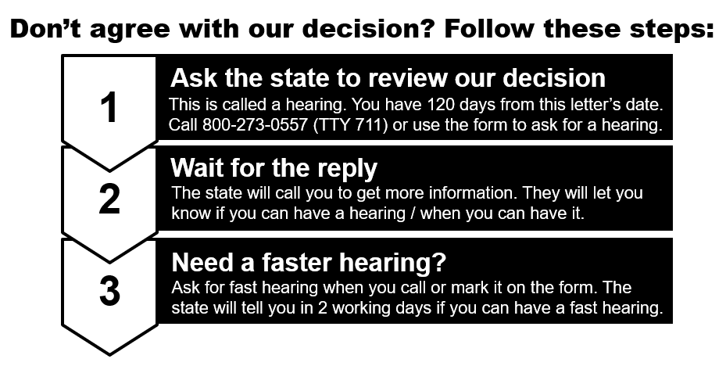
Hearings - Call the state at:
800-273-0557 (TTY 711)
Use the request form
Scan the QR code to
get the form. Or go to https://bit.ly/request2review

More about hearings
How do I ask for a hearing? | If you do not agree with the appeal decision, ask the state to review it. The review is called a hearing.  Choose one of these ways to ask for a hearing:  - Submit a request online at https://bit.ly/ohp-hearing-form  - Use the request form that was sent with this letter or you can print the request form at https://bit.ly/request2review  - Call the state at 800-273-0557 (TTY 711)
How much time do I have to ask for a hearing? | You must ask for a hearing within 120 days of the date of the appeal decision letter. The letter is called a Notice of Appeal Resolution.
What if I need a faster hearing? | You can ask for a fast hearing. This is also called an expedited hearing. Call the state at 800-273-0557 (TTY 711) or use the request form that was sent with this letter. Get the form at https://bit.ly/request2review  Fast hearings are for services that you have not had yet. Services already provided will not get a fast hearing.
When will I know if I can get a fast hearing? | The state will call to follow up within 2 working days after getting your request. You will also get a letter if your request is denied.
Who can ask for a hearing? | You or someone with written permission to speak for you. That could be your doctor or an authorized representative.
Other things you can do
- You can ask your doctor about other ways to treat your condition.
- You can ask us for the information used to make this decision.

In the middle of treatment?
If you have been getting this service and we have stopped providing it, you can ask us to continue it.
You need to ask for this within 10 days of the date of this letter or by the date this decision is effective, whichever is later.
- You can ask by phone, letter, or fax.
- You can also use the enclosed Request to Review a Health Care Decision form. Please answer “yes” to the question about continuing services in box 8 on page 4 of the form.

Payment for This Service
If you choose to still get this service, you may have to pay for it. If the judge agrees with you at the hearing, you will not have to pay.
Get help or copies of paperwork
If you need help or have questions, please call Customer Service at <<XXX-XXX-XXXX>> or <<TTY number>>, Monday to Friday, 8 a.m. - 5 p.m. All members have a right to know about and use our programs and services. We give these kinds of free help:
- Sign language
- Spoken language interpreters
- Materials in other languages
- Braille, large print, audio, and any way that works better for you
You can ask us for a free copy of all paperwork used to make this decision.
For information on certified Health Care Interpreters call <<XXX-XXX-XXXX>>.

CC: <<Professional Name>>
<<Requesting Provider Name (if different from Professional Name)>>
Enclosures:
- Non-Discrimination Policy
- Request to review a health care decision (OHP 3302)
- COVID-19 hearing extension

Important: Results of your appeal request
You asked us to change our decision about a denial. This letter has our appeal decision. Please call us right away at XXX-XXX-XXXX or TTY ## if you do not understand this letter. You can get this letter in large print, another language or any way that is best for you. You can ask for help from an interpreter. This help is free.
Language Access - Spanish
Language Access - Russian
Language Access - Vietnamese
Language Access - Arabic
Language Access - Simplified Chinese, Traditional
Language Access - Somali

