THIS IS NOT A BILL
Important: Denial of payment for service
This is not a bill. We have denied a request from your provider to pay for a service or treatment. Please call us right away at ###-###-### if you do not understand this letter. You can get this letter in large print, another language or any way that is best for you. You can ask for help from an interpreter. Help is free.

<<MCE Letterhead required
(include name, address
phone number; can add
subcontractor)>>

<< NOTICE DATE>>

<<MEMBER NAME
ADDRESS
CITY, STATE ZIP>>

<<OHP Client ID, DOB, PCP/PCD/BHP>>
Reason for Payment Denial
(Also called Notice of Adverse Benefit Determination)
Dear <<Member name>>,
This is not a bill. You do not need to do anything. We have to send this to you so you have the information.
We were asked to pay for a service you received. We are not able to pay for it. This letter says why the request was not approved and what you can do next.
On <<claim date>>, <<Name of requesting/ performing/ billing provider/facility>> asked us to pay for a <<medical or pharmacy>> service you got <<on service date, if different from claim date>>. They asked us to cover <<description of the service or item provided>>. This service was to help treat your <<plain language: diagnosis or diagnoses submitted in request (when service is being denied as diagnosis is not funded or diagnosis and procedure do not pair on the Prioritized List)>>. Unfortunately, we are not able to pay for it. This letter says why the request was not approved and what you can do next.
Reason for payment denial
<<Reason for denial>>. <<Member specific info related to criteria that was not met. This is why we were unable to pay for the service. The Oregon Health Plan (OHP) does not cover all services and supplies.>>
These are the OHP rules that we used when we made this decision:
<<List of all applicable OARs, Guideline Notes, HERC Clinical Guidance, medical policies or criteria, etc. OARs are listed with only the specific sections and subsections that apply to this member-specific decision.>>
This decision is effective <<effective date>>.

<<We looked at other medical issues
When we looked at your records, we checked to see if you have a different medical issue that would let us cover this. There are rules we have to meet in order to do this. We had a health care professional review your case to see if you met those rules. Unfortunately, you did not meet those rules.
If your provider thinks another medical issue will let us cover this, they can submit the request again.>>

<<We did not look at other medical issues
You may have other medical issues that would let us cover this service. There are rules we have to meet in order to do this. Your provider can ask us to review your case to see if you meet those rules.
You can ask your provider to submit the request again.>>

Did you get a bill? Call us right away.
If you get a bill for this service, call our Customer Service at <<XXX-XXX-XXXX / the number listed below>>. Do not pay the bill until you talk to us. We will see why you got a bill.
Providers should not bill you if a service is covered. If a service is not covered and you signed a valid Oregon Health Plan Financial Waiver, you have to pay for it. You can see the waiver form at https://bit.ly/OHPwaiver. If you do not know if you signed a waiver form, ask your provider’s office.
You can ask us to change our decision.
If you disagree with our decision, you have the right to ask us to change it.
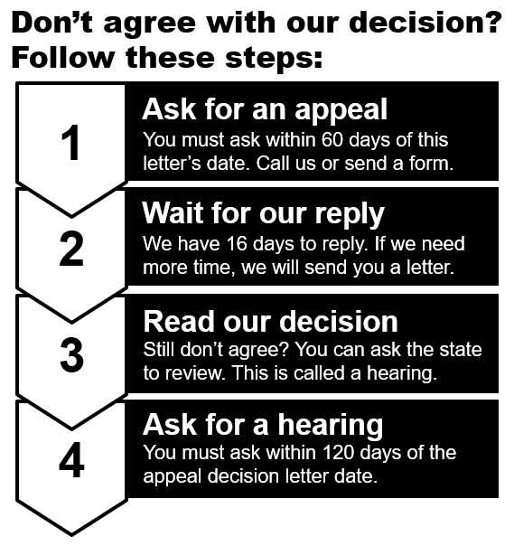
Appeals - Call us at:
XXX-XXX-XXXX (TTY 711)
Hearings - Call the state at:
800-273-0557 (TTY 711)
Use the request form
Scan the QR code to
get the form. Or go to https://bit.ly/request2review

More about appeals and hearings
How much time do I have? | You have 60 days to ask for an appeal. We must get your request within 60 days of <<Date of Notice>>.
How can I ask for an appeal? | Call us at XXX-XXX-XXXX or use the Request to Review a Health Care Decision form. The form was sent with this letter. You can also get it at https://bit.ly/request2review  You can also fax the form to XXX-XXX-XXXX.
How long do you get to review my appeal? | We get 16 calendar days to send you a reply. If we need more time, we will send you a letter. We have up to 14 more days.
What if you don’t meet the timeline? | If we take longer than 30 days to reply, you can ask the state for a review. This is called a hearing.
What if I need a faster reply? | Fast appeals are for services you did not get yet. If you already got the service, a fast appeal request will not be approved.
Who can ask for an appeal? | You or someone with written permission to speak for you. That could be your doctor or an authorized representative.
How do I ask for a hearing? | You have to ask for an appeal before you can ask for a hearing. If you do not agree with the appeal decision, ask the state to review it. The review is called a hearing.  Call the state at 800-273-0557 (TTY 711) or use the request form that was sent with this letter. Get the form at https://bit.ly/request2review
How much time do I have to ask for a hearing? | You have 120 days after you get the appeal decision letter. You must ask for a hearing within 120 days of the date of the appeal decision letter. The letter is called a Notice of Appeal Resolution.
What if I need a fast hearing? | Fast hearings are for services you did not get yet. If you already got the service, a fast hearing request will not be approved.
Who can ask for a hearing? | You or someone with permission to speak for you. That could be your doctor or an authorized representative. They don’t need permission in writing.

Other things you can do
You can do other things besides requesting an appeal or hearing. See page 2 of the enclosed Request to Review a Health Care Decision form for more information. You can also get the form at https://bit.ly/request2review.
In the middle of treatment?
If you are in the middle of this treatment, you can ask us to continue it. If you choose to get this service in the future, you may have to pay for it. If we change our decision during the appeal, or if the judge agrees with you at the hearing, you will not have to pay.
You need to:
- Ask for this within 10 days of the date of this letter or by the date this decision is effective, whichever is later. Use the contact information <<below>>.
- Answer “yes” to the question about continuing services on box 8 on page 4 on the Request to Review a Health Care Decision form.
Payment for this service
If you choose to still get this service, you may have to pay for it. If we change our decision during the appeal, or if the judge agrees with you at the hearing, you will not have to pay.
Get help
If you need help or have questions, please call Customer Service at XXX-XXX-XXXX or TTY number, Monday to Friday, 8 a.m. - 5 p.m.
All members have a right to know about and use our programs and services. We give these kinds of free help:
- Sign language interpreters
- Spoken language interpreters
- Materials in other languages
- Braille, large print, audio, and any way that works better for you
- Copies of all paperwork used to make this decision
For information on certified Health Care Interpreters call XXX-XXX-XXXX or TTY number.
CC: <<Requesting Provider Name>>
Enclosures:
- Non-Discrimination Policy
- Request to review a health care decision (OHP 3302)
- COVID-19 hearing extension

Language Access - English
Important: Denial of payment for service
This is not a bill. We have denied a request from your provider to pay for a service or treatment. Please call us right away at ###-###-#### if you do not understand this letter. You can get this letter in large print, another language or any way that is best for you. You can ask for help from an interpreter. Help is free.
Language Access - Spanish
Importante: Negación del pago de servicio
No es una factura. Hemos rechazado una solicitud de su proveedor para que paguemos un servicio o tratamiento. Si no comprende esta carta, comuníquese con nosotros de inmediato llamando al ###-###-####. Puede recibir la carta en letra grande, otro idioma o bien de cualquier modo que sea más adecuado para usted. Puede solicitar la ayuda de un intérprete. La ayuda es gratuita.
Language Access - Russian
Важное примечание: Отказ в оплате счета
Этот документ не является счетом. Мы отклонили запрос вашего поставщика услуг на оплату услуги или лечения. Если вы не понимаете сути этого письма, срочно позвоните нам по телефону ###-###-####. Вы можете получить это письмо, напечатанное крупным шрифтом, на другом языке или в предпочитаемом вами формате. Вы можете сделать запрос на услуги устного переводчика. Помощь предоставляется бесплатно.
Language Access - Vietnamese
Quan trọng: Từ chối thanh toán dịch vụ
Đây không phải là hóa đơn. Chúng tôi đã từ chối yêu cầu từ bác sĩ của quý vị để thanh toán cho một dịch vụ chăm sóc sức khỏe hoặc điều trị. Vui lòng gọi ngay cho chúng tôi theo số ###-###-#### nếu quý vị không hiểu nội dung của lá thư này. Quý vị có thể nhận lá thư này theo dạng chữ in lớn, bằng một ngôn ngữ khác hoặc theo bất kỳ định dạng nào tốt nhất cho quý vị. Quý vị có thể nhờ thông dịch viên giúp đỡ. Chúng tôi sẽ trợ giúp quý vị miễn phí.

Language Access - Arabic
مهم: رفض للدفع مقابل خدمة
هذه ليست فاتورة. لقد رفضنا طلب من مُقَدِّم/ة الخدمة التابع لك لدفع تكاليف خدمة أو علاج. يُرجى الاتصال بنا فورًا على الرقم ###-###-### إذا لا تفهم هذه الرسالة. يمكنك الحصول على هذه الرسالة في لغة أخرى، أو بخط كبير، أو بأي طريقة تفضلها. بإمكانك طلب المساعدة من مترجم شفوي. وتكون المساعدة مجانية.

Language Access - Simplified Chinese
重要须知：拒绝为服务付款
这不是账单。我们否决了您的提供者提交的为服务或治疗付款的申请。若您不理解本函件的内容，请立即拨打 ###-###-#### 联系我们。您可获取本函件的大字版、其他语言版或最适合您的版本。您可要求口语翻译人员提供帮助。您可获得免费帮助。
Language Access - Traditional
重要資訊：拒絕給付服務
本文件並非帳單。我們已拒絕由您醫療服務提供者所提出的服務或治療給付申請。如果您不瞭解本信函的內容，請立即致電 ###-###-#### 與我們聯絡。您可獲得本信函的大字版、其他語言版本或最適合您閱讀的任何格式。您可申請口譯員協助。協助為免費提供。
Language Access - Somali
Muhiim ah: Diidmada lacag bixinta adeega
Tani ma aha biil. Waanu diidnay codsigii ka socday daryeel bixiyahaaga ee bixinta lacagta loogu talagalay adeega ama daaweynta. Fadlan isla markiiba naga soo wac ###-###-#### haddii aad fahmi waydo warqadan. Waxaad heli kartaa warqadan oo ku qoran far waaweyn, luqad kale ama hab kale oo adiga kuu fiican. Waxaad codsan kartaa caawimaad ka socota turjubaan. Caawimaadu waa mid lacag la’aan ah.

