MCE Letterhead (required)
(include name, address
phone number; can add
subcontractor)
Important: Results of your appeal request
You asked us to change our decision about a denial. This letter has our appeal decision. Please call us right away at XXX-XXX-XXXX if you do not understand this letter. You can get this letter in large print, another language or any way that is best for you. You can ask for help from an interpreter. This help is free.

<< NOTICE DATE>>

MEMBER NAME
ADDRESS
CITY, STATE ZIP

<<OHP Client ID, DOB, PCP/PCD/BHP>>
Results of your request to change our decision
(Also called Notice of Appeal Resolution)
Dear <<Member name>>,
On <<request date>>, we got your appeal request to change the decision we made. We looked at your records again. We also looked at what you told us in your appeal request. We requested any new records that were sent about you and this service. This letter explains our decision and what you can do next.
Appeal decision
<<REVERSAL: We have decided to overturn (reverse) our denial decision. Your request for <<plain language description of the denied service>> is now approved. We will cover this service. Please contact your doctor to find out what you need to do next.>>

<<PARTIAL: We have decided to overturn (reverse) part of our denial decision, but not all of it. We are able to cover <<description of what part of the denied service is being overturned>>. But we still can’t cover <<description of what part of the denied service is being upheld>>. We told your provider about next steps needed/You need to:>>

<<UPHOLD: We have decided to uphold (not change) our denial. Your request for <<description of the denied service>> is still not covered.>>

The reason we were not able to <<cover / cover all of>> the service is <<member-specific reasons why coverage criteria was not fully met>>. The Oregon Health Plan does not cover all services and supplies.
These are the OHP rules that we used when we made this decision:
<<List of all applicable OARs, Guideline Notes, HERC Clinical Guidance, medical policies or criteria, etc. OARs are listed with only the specific sections and subsections that apply to this member-specific decision.>>
This action is effective on <<effective date>>. A copy of this letter has been sent to your provider.
When we looked at your records, we checked to see if you have a different medical issue that would let us cover this. There are rules we have to meet in order to do this. We had a health care professional review your case to see if you met those rules. Unfortunately, you did not meet those rules.
<<Did you get a bill?
If you get a bill for this service, call our Customer Service at <<XXX-XXX-XXXX / the number listed below>>. Do not pay the bill until you talk to us. We will see why you got a bill.
Providers should not bill you if a service is covered. If a service is not covered and you signed a valid Oregon Health Plan Financial Waiver, you have to pay for it. You can see the waiver form at https://bit.ly/OHPwaiver. If you do not know if you signed a waiver form, ask your provider’s office.>>
You can ask for a hearing to change our decision
If you disagree with our decision, you have the right to ask for a hearing with a judge to change it.
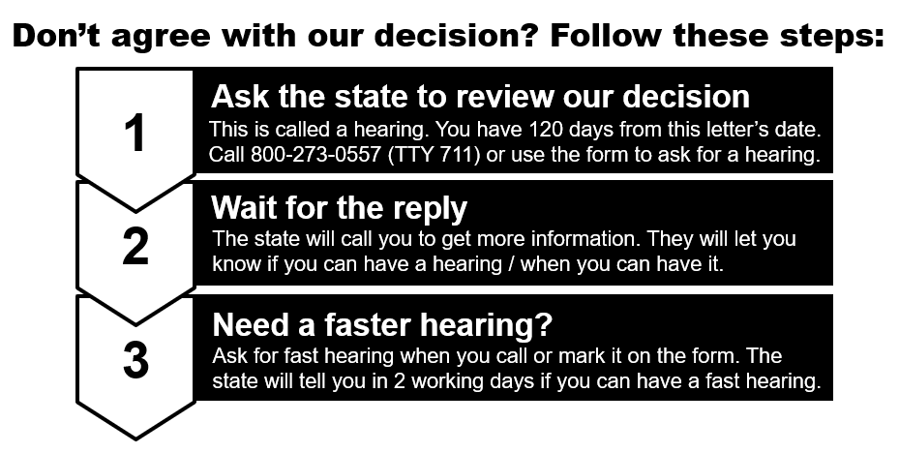
Hearings - Call the state at:
800-273-0557 (TTY 711)
Use the request form
Scan the QR code to
get the form. Or go to https://bit.ly/request2review

More about hearings
How do I ask for a hearing? | You have to ask for an appeal before you can ask for a hearing. If you do not agree with the appeal decision, ask the state to review it. The review is called a hearing.  Call the state at 800-273-0557 (TTY 711) or use the request form that was sent with this letter. Get the form at https://bit.ly/request2review
How much time do I have to ask for a hearing? | You have 120 days after you get the appeal decision letter. You must ask for a hearing within 120 days of the date of the appeal decision letter. The letter is called a Notice of Appeal Resolution.
What if I need a faster hearing? | You can ask for a fast hearing. This is also called an expedited hearing. Call the state at 800-273-0557 (TTY 711) or use the request form that was sent with this letter. Get the form at https://bit.ly/request2review
When will I know if I can get a fast hearing? | The state will decide if you can have a fast hearing 2 working days after getting your request.
Who can ask for a hearing? | You or someone with permission to speak for you. That could be your doctor or an authorized representative. They don’t need permission in writing.

Other things you can do
You can do other things besides requesting an appeal or hearing. See page 2 of the enclosed Request to Review a Health Care Decision form for more information.
In the middle of treatment?
If you have been getting this service and we have stopped providing it, you can ask us to continue it.
You need to:
- Ask for this within 10 days of the date of this letter or by the date the decision is effective, whichever is later. Use the contact information <<below>>.
- Answer “yes” to the question about continuing services on box 8 on page 4 on the Request to Review a Health Care Decision form.
Payment for This Service
If you choose to still get this service, you may have to pay for it. If the judge agrees with you at the hearing, you will not have to pay.
Get help or copies of paperwork
If you need help or have questions, please call Customer Service at <<XXX-XXX-XXXX>> or <<TTY number>>, Monday to Friday, 8 a.m. - 5 p.m.
All members have a right to know about and use our programs and services. We give these kinds of free help:
- Sign language
- Spoken language interpreters
- Materials in other languages
- Braille, large print, audio, and any way that works better for you
You can ask us for a free copy of all paperwork used to make this decision.
For information on certified Health Care Interpreters call <<XXX-XXX-XXXX>>.

CC: <<Professional Name>>
<<Requesting Provider Name (if different from Professional Name)>>
Enclosures:
- Non-Discrimination Policy
- COVID-19 hearing extension
- Request to review a health care decision (OHP 3302)

Language Access - English
Important: Results of your appeal request
You asked us to change our decision about a denial. This letter has our appeal decision. Please call us right away at XXX-XXX-XXXX if you do not understand this letter. You can get this letter in large print, another language or any way that is best for you. You can ask for help from an interpreter. This help is free.

Language Access - Spanish
Importante: Resultados de una solicitud de apelación
Nos solicitó que cambiáramos nuestra decisión sobre una negación. Esta carta incluye nuestra decisión sobre su apelación. Si no comprende esta carta, comuníquese con nosotros de inmediato llamando al XXX-XXX-XXXX. Puede recibir la carta en letra grande, otro idioma o bien de cualquier modo que sea más adecuado para usted. Puede solicitar la ayuda de un intérprete. Esta ayuda es gratuita.
Language Access - Russian
Важное примечание: Результаты вашего запроса на проведение апелляции
Вы просили нас изменить наше решение об отказе. В этом письме содержится наше решение по апелляции. Пожалуйста, позвоните нам незамедлительно по тел. XXX-XXX-XXXX, если вы не понимаете сути этого письма. Вы можете получить это письмо, напечатанное крупным шрифтом, на другом языке или в предпочитаемом вами формате. Вы можете сделать запрос на услуги устного переводчика. Эта помощь предоставляется бесплатно.

Language Access - Vietnamese
Quan trọng: Kết quả giải quyết yêu cầu khiếu nại của quý vị
Quý vị đã đề nghị chúng tôi thay đổi quyết định từ chối của chúng tôi. Thư này cho biết chúng tôi đã giải quyết khiếu nại của quý vị như thế nào. Vui lòng gọi ngay cho chúng tôi theo số XXX-XXX-XXXX nếu quý vị không hiểu nội dung của lá thư này. Quý vị có thể nhận lá thư này theo dạng chữ in lớn, bằng một ngôn ngữ khác hoặc theo bất kỳ định dạng nào tốt nhất cho quý vị. Quý vị có thể nhờ thông dịch viên giúp đỡ. Sự trợ giúp này hoàn toàn miễn phí.
Language Access - Arabic
مهم: نتائج التماسك للاستئناف
لقد طلبت منا تغيير قرارنا المتعلق برفض. تحتوي هذه الرسالة على قرارنا للاستئناف. يُرجى الاتصال بنا فورًا على الرقم ###-###-#### إذا لا تفهم هذه الرسالة. يمكنك الحصول على هذه الرسالة في لغة أخرى، أو بخط كبير، أو بأي طريقة تفضلها. بإمكانك طلب المساعدة من مترجم شفوي. إن هذه المساعدة مجانية.

Language Access - Simplified Chinese
重要须知：申诉申请的结果
您要求我们更改对您的拒绝决定。本函件载有我们的申诉决定。若您不理解本函件的内容，请立即拨打 XXX-XXX-XXXX 联系我们。您可获取本函件的大字版、其他语言版或最适合您的版本。您可要求口语翻译人员提供帮助。这一帮助是免费的。
Language Access - Traditional
重要資訊：您的上訴申請結果
您要求我們變更我們所作的某項拒絕決定。本信函包含了我們的上訴決定。如果您不瞭解本信函的內容，請立即致電 XXX-XXX-XXXX 與我們聯絡。您可獲得本信函的大字版、其他語言版本或最適合您閱讀的任何格式。您可申請口譯員協助。協助均為免費提供。
Language Access - Somali
Muhiim ah: Natiijooyinka codsigaaga rafcaanka
Waxaad naga codsatay in aanu beddelno go’aankayaga ku saabsan diidmada. Warqadan ayaa leh go’aankayaga rafcaanka. Fadlan isla markiiba naga soo wac XXX-XXX-XXXX haddii aad fahmi waydo warqadan. Waxaad heli kartaa warqadan oo ku qoran far waaweyn, luqad kale ama hab kale oo adiga kuu fiican. Waxaad codsan kartaa caawimaad ka socota turjubaan. Taageeradani waa lacag la'aan.

