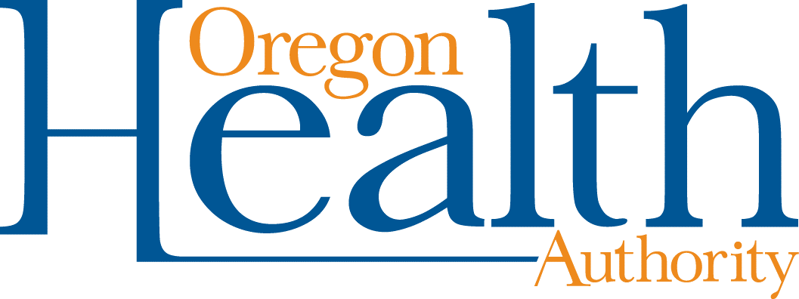
HSD Business Systems Request
Please fill out the form below to request a P# for a new user, to request a reinstatement of a current user that is disabled, or to deactivate a current user that should no longer have access to MOTS.
For new access and reinstatement, expect for this process to take 10 business days to complete. Both the requestor and the user will receive an email when the process is complete. The end user will need to log in as soon as they receive notification from MOTS Support. This is a time sensitive process.
Name of Agency or Facility
Agency or Facility Street Address
City | State |  | Postal Code |  | County of Agency or Facility |  |  |  | Phone Number with Area Code/ Ext
User’s Legal First Name |  | M.I. |  | User’s Legal Last Name |  |  |  | User’s Email
End User Position/Title
Account Access Information
Account type? New Reinstate Deactivate |  |  |  |  |  | To Reinstate/Deactivate Provide existing P#, if known |  |  |  | P#

If your agency has more than one facility in MOTS, do you want this user to have access at the agency level – meaning that they will have the same rights for all facilities? Yes No N/A

If No, which facilities should they have access to?

Does the agency have an existing access agreement number? Yes No Not Sure
Please provide 6-digit Access Agreement number, if known |  |  |  |  |  |  | AA #
Program and User Roles – Please check the appropriate boxes and choose from the drop-down menus.
ACR MOTS
Please note: If choosing PG Net, all requests will be placed on a wait list until program is deployed.
PG Net/ GAMBLING

Once this form is completed, please have your manager send it to: mots.support@dhsoha.state.or.us.
The body of the email should state: “I am the manager and approve assigning/reactivating/deactivating) a P# for (INSERT NAME OF USER).”

