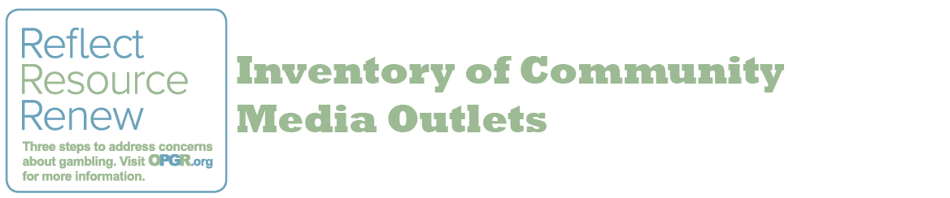
Each community has a unique variety of media outlets, events, venues, and other media placement opportunities where problem gambling prevention resources can be distributed. Using this tool, identify the media placement opportunities that exist in your community, so you can make strategic decisions about ways to share media.
Video
Television Stations
Local Access TV
Other
Audio
Radio Stations
PA Systems
Other
Print
Newspaper
Town/Organizational Newsletters
Bulletin Boards/Billboards
Brochure/Card Rack
Event to Distribute
Other
Electronic
Social Media
Websites
Other
Events
Fairs or Celebrations
Other

