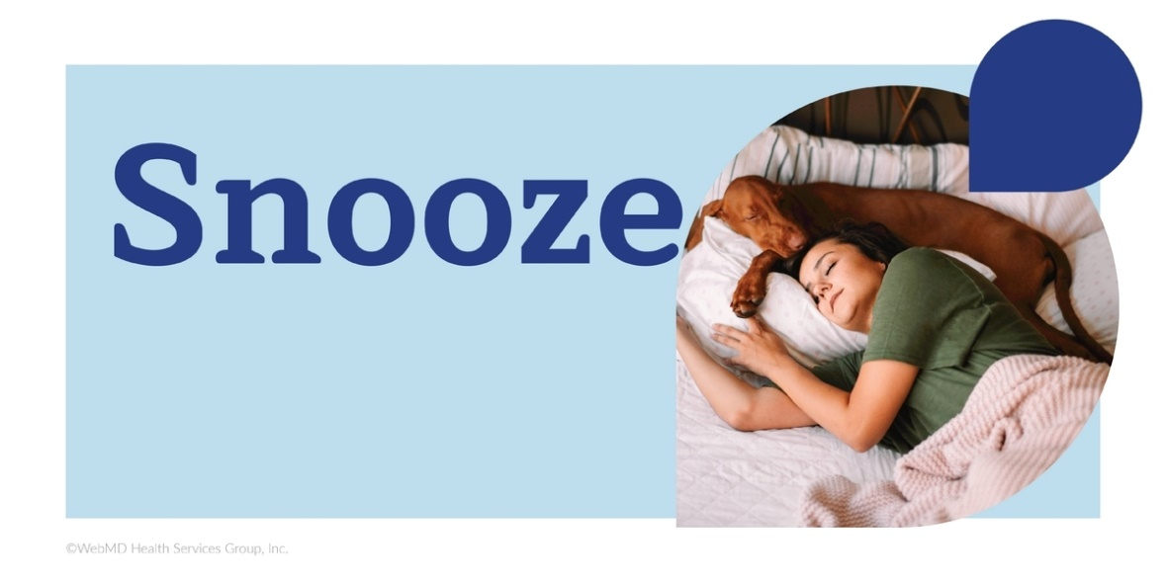
Seize the Zzzz Challenge
February 6 – March 5, 2023

The Seize the Zzzz Challenge Toolkit
This toolkit can help you create excitement and encourage ongoing participation in the 4-week Seize the Zzzz Challenge. Learn tips, tricks and best practices that can help you successfully reach your colleagues and keep them engaged from start to finish. You’ll find materials to help your colleagues register for the challenge, record their progress and keep the challenge top of mind.

What is the Seize the Zzzz Challenge?
This 4-week individual challenge is designed to encourage participants to take steps to get a good night’s rest on a regular basis by starting better bedtime habits and keeping track of their sleep. Participants track their sleep for at least 21 of 28 days and reporting “Yes” to getting a good night’s sleep for at least 14 of 28 days.

Key dates
- Registration opens Monday, January 23, 2023, and ends Monday, February 13, 2023.
- Challenge starts Monday, February 6, 2023.
- Challenge ends Sunday, March 5, 2023.
- Last day to enter data is Sunday, March 12, 2023.

In this toolkit you’ll find flyers, social media posts, and a series of emails that you can send to your colleagues.

HealthyYou Portal Resource: The NEW Community Feature

Connect with people who inspire you to be better using the new Community feature, available at www.webmdhealth.com/oebb. Find like-minded people who will help lift you up. As you work toward your personal well-being goals, the new Community feature from HealthyYou can help you connect with others through fun and motivating group chats. Share helpful tips, discuss your experiences, offer encouragement and join conversations that will help you stay engaged in different health goals, including sleep.

The Sleep Tight group is a space to talk with other OEBB members about sleep struggles and find support to help get a good night’s rest. You can find the Community flyer at the end of this toolkit.

I. Kick-Off Event Ideas

Host a kick-off event to get the Seize the Zzzz Challenge off to an exciting start! During the event, promote the challenge and describe how it works. This is also a great opportunity to hand out the Seize the Zzzz flyer and challenge materials. Some other event ideas include:

- Host a meditation session – Meditation can be a powerful sleep tool. To help your colleagues learn how to meditate, reserve a quiet room, find an outdoor space or hold a virtual meditation session each day. It can last just five minutes! You can send an email to colleagues asking if anyone is experienced with meditation and would like to help teach others. There are also on-demand guided meditations by WebMD Health Services on the HealthyYou portal at www.webmdhealth.com/oebb.

- Create a hashtag - Encourage people to use a hashtag to create buzz for the Seize the Zzzz Challenge! You can promote it through your social media channels or by sending an email.
Tip: Keep your hashtag short! To be effective, it should be simple and easy to understand at-a-glance.
Examples: #SeizetheZzzz, #Snooze, #Refreshed, #RiseAndShine, #SoundSleeper, #HealthyYou, #SleepOn

- Encourage people to share their sleep journey - Encourage colleagues to send success stories, or relaxation and sleep techniques. You can tell participants to post their techniques and stories through social media along with your chosen hashtag! And you can also utilize the NEW Community feature available on the HealthyYou portal (www.webmdhealth.com/oebb). This is an online support system where participants can share helpful tips, discuss experiences, offer encouragement, and join conversations that will help them stay engaged.

Tip: Take advantage of team meetings to share what your colleagues send you. It can be a great way to promote the challenge and demonstrate its success.

II. Get Leadership Involved

Ask leaders to help promote the Seize the Zzzz Challenge. Encourage them to show support by joining the challenge themselves and talking about the challenge in meetings. To make it as simple as possible, provide talking points they can use to get the message across quickly and clearly.

Talking point examples:
- “Getting a good night’s rest can help you be your best, at work, at home and everywhere in-between. That’s why I’m excited to announce Seize the Zzzz, a fun sleeping challenge from HealthyYou.”

- “I’d like to mention that I’ve been really impressed by the commitment to well-being that I’ve seen during the Seize the Zzzz Challenge. Our colleagues are putting sleep first and prioritizing their well-being – which is more important than anything.”

- “If you haven’t already, make sure to sign up for the upcoming Seize the Zzzz Challenge. All you have to do during the challenge is spend more time getting quality sleep!”

III. Activity Ideas Throughout the 4-Week Challenge

Keep participants engaged and excited throughout the challenge! These creative events will help reinforce the Seize the Zzzz campaign and add fun elements that help make the challenge memorable.

Start a book club – Most of us spend time in front of screens before bed, which can harm the quality of sleep. To help your colleagues reduce their screen time at night, start a book club to encourage them to read before bed instead.

Offer on-site exercise classes – Staying active during the day can help your colleagues sleep better at night. To help set them up for some high-quality Zzzz, offer on-site physical activity classes or start a run/walk club.

Seize the Zzzz Week – During the first week of Seize the Zzzz, hold a challenge week to get your audience excited to get more sleep! Throughout the week, send emails encouraging participation and have leadership promote the challenge.

IV. Challenge Materials

In this section, you’ll find out how to utilize the Seize the Zzzz Challenge materials. Included promotional materials include:

- Flyers
- Newsletters
- Emails
- Social media

FLYER
The Seize the Zzzz flyer provides useful tools while reminding participants to register. It includes sleeping tips and a list of natural sleep aides, which can be used throughout the challenge.

Be sure to pass out flyers at campus/department events. They’re an effective way to promote the challenge and provide participants with a tangible resource they can hold in their hands and take home.

If you prefer, the flyer is designed to be used electronically as well. You can link to it from a web page or newsletter article or email it to your colleagues.

Timing: Display the flyers at events and post them electronically before the challenge begins. Flyer can be found at the end of this toolkit.

NEWSLETTER CONTENT
Keep participants informed on all the details of Seize the Zzzz. This long-form content provides all the information they need to register and get started. Plus, it’s flexible and can be used in newsletters, blogs or anywhere else you see fit.

Timing: Use these a few weeks before registration for the challenge begins.

Tip: Whether digital or in print, publish your newsletter content when registration for the Seize the Zzzz Challenge begins.

Content:

Headline: Sleep Your Way to Well-Being
Body Copy: Did you know you may be able to improve your well-being from bed? By getting enough quality sleep, you can help manage stress, maintain a healthy weight and prevent many health conditions. To get help sleeping more soundly, register for HealthyYou’s Seize the Zzzz Challenge by February 13, at www.webmdhealth.com/oebb.
Protect your health
An estimated 50 to 70 million Americans have a chronic sleep disorder, which can lead to health problems like heart disease, diabetes, obesity and more. The good news is, there are steps you can take to improve your sleep habits and overall well-being.
During the Seize the Zzzz Challenge, you’ll track your sleep for 21 of 28 days between February 6 and March 5. Report getting a good night’s rest for at least 14 days and enjoy better well-being!
Wake up feeling renewed
Your best days start with a good night’s sleep. While you’re snoozing, your body is getting the rest it needs to help you feel happier, think clearer and stay focused for longer.
Ready to get started? Register for the Seize the Zzzz Challenge and record your progress today at www.webmdhealth.com/oebb!
SOURCES
Centers for Disease Control and Prevention: “Sleep and Sleep Disorders”
WebMD: “Surprising Reasons to Get More Sleep”

Reviewed by Melinda Ratini, DO MS
September 2021

EMAILS

1. Registration Email
Get your participants signed up and engaged in Seize the Zzzz. Send emails one and two to all eligible participants to encourage them to register as soon as possible.

Timing: Two weeks before registration for the challenge begins, send the first registration email. After a week, give another push and send the second registration email.

Subject line: Get Ready for the Seize the Zzzz Challenge!

Email Body: Did you know you may be able to improve your well-being from bed? By getting enough quality sleep, you can help manage stress, maintain a healthy weight and prevent many health conditions. To get help sleeping more soundly, register for HealthyYou’s Seize the Zzzz Challenge by February 13, 2023.

During the Seize the Zzzz Challenge, track your sleep for 21 of 28 days between February 6 and March 5. Get a good night’s rest for at least 14 days and enjoy better well-being!

SOURCE
WebMD: “Surprising Reasons to Get More Sleep”
Reviewed by Melinda Ratini, DO MS
September 2021

2. Challenge Launch
Announce the start of Seize the Zzzz to encourage participants to start the challenge and provide them with helpful tools they can use along the way.
Timing: Send this email on the first day of Seize the Zzzz.

Subject line: Seize the Zzzz Starts Now!

Email Body: The HealthyYou Seize the Zzzz Challenge starts today!

Better sleep can lead to a better you. Besides helping to protect you from many health conditions, a good night’s rest can help boost your memory, improve your ability to learn and help you be your best every single day.

How it works
During the Seize the Zzzz Challenge, track your sleep for 21 of 28 days between February 6 and March 5. Get a good night’s rest for at least 14 days and enjoy better well-being!

SOURCE
The University of North Carolina at Chapel Hill: “Sleeping to Succeed”
Reviewed by Melinda Ratini, DO MS
September 2021

3. Challenge Complete Email
Let participants know that the challenge is complete and point them to resources that can help them continue their well-being journey.

Timing: Send this email after the final day of Seize the Zzzz.

Subject line: That’s a Wrap! Congrats, Seize the Zzzz is Done!

Email Body: Congratulations, you made it to the end of the HealthyYou Seize the Zzzz Challenge! If you got a good night’s rest for at least 14 days, make sure you record your progress by March 12!

Sleep on
Getting seven to eight hours of high-quality sleep helps you stay on the path to well-being. Even though the challenge has ended, continue to snooze, slumber and set yourself up for successful days. Need help staying on track? Visit www.webmdhealth.com/oebb to find tools that can help you keep up your healthy habits and work toward any well-being goal.

Social Media Posts
Using your campus or department internal social media channels can help you build an online presence and encourage more people to sign up for Seize the Zzzz. Use these social media posts to create buzz for Seize the Zzzz and remind participants to record their progress.

Timing: Use the first social media post the first week that registration for Seize the Zzzz begins. Post the second one any time you’d like to encourage participation in the challenge.

Tip: You can also use these to start conversations in the new Community feature available in the HealthyYou portal (www.webmdhealth.com/oebb). Your HealthyYou Program Manager will also be utilizing this feature to encourage participants throughout the challenge. Let’s build a community together!

SOCIAL POST 1: REGISTRATION
Headline: Snooze
Body Copy: You may be able to improve your well-being from your own bed. By getting enough quality sleep, you can help manage stress, maintain a healthy weight and prevent many health conditions. To get help sleeping more soundly, register for HealthYou’s Seize the Zzzz Challenge today at www.webmdhealth.com/oebb.
SOCIAL POST 2: TIP 1
Headline: Refresh
Body Copy: Sticking to a schedule can help you fall asleep faster and stay asleep longer. To learn more and start your own healthy sleep habits, keep up with HealthyYou’s Seize the Zzzz Challenge and record your progress at www.webmdhealth.com/oebb if you’re participating!
SOCIAL POST 3: TIP 2
Headline: Less Stress Means More Sleep
Body Copy: Need help managing stress and easing your mind before bed during HealthyYou’s Seize the Zzzz Challenge? Write your worries and concerns down and try not to think about them until the next day. Then record your sleep at www.webmdhealth.com/oebb if you’re participating.
SOCIAL POST 4: DEADLINE
Headline: A Challenge Wake Up Call!
Body Copy: The Seize the Zzzz Challenge ends March 5! If you’re participating, get a good night’s rest for 14 days and enjoy better well-being. Record your sleep today at www.webmdhealth.com/oebb!
V. The Seize the Zzzz Challenge - FAQ
What is the Seize the Zzzz Challenge?
This 4-week individual challenge is designed to encourage participants to take steps to get a good night’s rest on a regular basis by starting better bedtime habits and keeping track of their sleep. Participants track their sleep for at least 21 of 28 days and reporting “Yes” to getting a good night’s sleep for at least 14 of 28 days.

How long does the Seize the Zzzz Challenge last?
This is a 4-week challenge, starting February 6, 2023, and ending March 5, 2023.

What are the key dates of the Seize the Zzzz Challenge?
January 23-February 13: Registration period
February 6: Start of the Challenge
March 5: Last day of the Challenge
March 12: Last day to enter data in the HealthyYou portal or app

How does someone participate?
A participant must register on the WebMD ONE HealthyYou portal (www.webmdhealth.com/OEBB) or the Wellness at Your Side App during the registration period (January 23-February 13). There will be a challenge notification on the homepage starting January 23. The participant will track “Yes” or “No” daily to getting a good night’s rest.

When is the last day someone can enter data for this challenge?
The last day to enter data is one week after the challenge ends (March 12).

Who can participate in the challenge?
OEBB Members and their dependents who are at least 18 years and older.

How do I access the portal from my mobile device/smart phone?
Download Wellness at Your Side application and enter connection code OEBB.

How does one access the challenge from the portal or app?
The app and desktop site offer a similar user experience. Once a person downloads the app, they will see the challenge card from the homepage during the registration period.

What is the goal?
The goal is to participate (by tracking) a minimum of 21 days and track at least 14 days of “Yes,” meaning a participant has gotten a good night’s rest.

If I have questions during the challenge, who do I direct them to?
Contact WebMD Customer Service at 1-888-388-8256 or the HealthyYou Program Manager for OEBB, Fancy Flores, at faflores@webmd.net.

