OFFICE OF THE DIRECTOR  Office of the State Public Health Director | 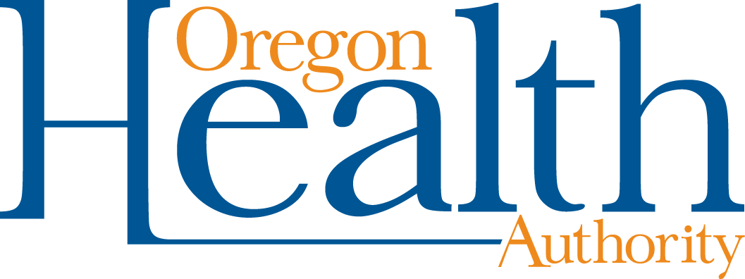

Community Based Organization (CBO)
Consent and attestation for COVID-19 Wraparound Assistance
Instructions
- The CBO and the person requesting services should complete
Sections 1 and 2.
- If the person requesting services is a COVID-19 close contact (has been within six feet of a COVID-19 case for 15 minutes or longer during the period of time that person may have been contagious COVID-19), fill out Section 3. Skip section 4.
- If the person requesting services is a COVID-19 case, skip Section 3 and fill out Section 4.
Section 1. Community Based Organization (CBO) information
CBO name: | CBO staff name:
Section 2. Person requesting services information
Name (first, middle, last): | Date of birth: | Phone number:
Address: |  | Date of services:

Section 3. Attestation — COVID-19 close contact
A close contact is someone who was within six feet of a confirmed or presumptive positive case for 15 minutes or more while that person may have been contagious and met the public health guidelines for isolation. Please complete this section if you believe you are a close contact of a COVID-19 positive case.
Date I was within six feet of a COVID-19 case for a total of 15 minutes or more:
Known COVID-19 case information
Please complete as much information as you are able about the person who is known to have exposed you to COVID-19.
Name (first, middle, last): |  | Date of birth: |  | Phone number:
Address: |  |  |  | County of residence:
 | Confirm and attest that the information above is true and correct with your initials.
(initial)

Section 4. Attestation – COVID-19 case
A COVID-19 case is someone who received positive test result OR has two or more COVID-19 symptoms within the last 10 days and was a close contact of a confirmed COVID-19 positive case. Please complete this section if you believe you are a COVID-19 positive or presumptive positive case. You may be asked to verify your testing information with your results.

Confirmed positive – testing information
Date I received a positive COVID-19 test:
Presumptive positive – symptom and exposure information
Date I began having two or more of the following symptoms: shortness of breath, cough, fever, new loss of smell or taste (if no symptoms, write N/A):
AND
Date I was within six feet of a COVID-19 case for a total of 15 minutes or more:
 |  | Confirm and attest that the information above is true and correct with your initials.
(initial)
PERSON REQUESTING SERVICES:
I agree to let the Community Based Organization (CBO) and staff person listed above see and use my personal information to help me receive short-term wraparound supports during my COVID-19 isolation and quarantine period. I agree to let the CBO listed above share my information with the Local Public Health Authority (LPHA) if needed. The CBO and LPHA are required to protect and keep any signed information private.
 | I have not/am not receiving wraparound services for isolation or quarantine from another organization.
Signature |  |  |  |  |  |  | Date

For CBO administrative use:
This person has met criteria to receive wraparound services
(check at least one):
 | Close contact: This person has been within six feet of a known case for a total of 15 minutes during the time they would have been in isolation.
 | Confirmed case: This person has provided a positive test result.
 | Presumptive case: This person has been within six feet of a known case for a total of 15 minutes during the period they would have been in isolation AND has two or more symptoms of COVID-19.
CBO approval |  | Date:
Start date for services:
Estimated end date for services:
CBO denial: |  | Date:

Document accessibility: For individuals with disabilities or individuals who speak a language other than English, OHA can provide information in alternate formats such as translations, large print, or braille. Contact Mavel Morales at 1-844-882-7889, 711 TTY or OHA.ADAModifications@dhsoha.state.or.us.

