2021-23 TPEP Success Story Template
The 2021-23 TPEP RFA requires that TPEP Coordinators develop and share at least one success story per year for HPCDP’s story bank. Programs can use their success story to showcase local accomplishments, increase awareness about the TPEP program, and obtain support for TPEP activities. In addition, HPCDP uses the success story bank to illustrate what tobacco prevention looks like across Oregon in social media, legislatively mandated reports, and other communications materials.
A success story describes strategies that are making a real, sustainable difference in the health and well-being of communities. It provides an emotional connection that engages participants, partners, potential funders, and other stakeholders.

Success Story Guidance
To get people to pay attention, we need to speak to both their head (with facts) and their heart (with stories that make the facts relatable). And in a time when digital marketing experts estimate that most Americans are exposed to around 4,000 to 10,000 ads each day, we also need a striking visual to engage viewers.
This guidance describes how to create a bite-sized success story that operates on all three of these: a statistic, a story, and an image. This tool can help you capture these into an ongoing story bank which can be used in various outreach efforts as appropriate.

EXAMPLE
Fact | More than nine out of every ten tobacco retailers in Our County sell flavored tobacco products like cigarillos and e-cigarettes that appeal to youth. (In the state overall, this percentage is only 21%.) [Source: 2018 Tobacco and Alcohol Retail Assessment Summary Report]
Story | In our work during the retail assessment, we talked with store owners about how tobacco industry sales reps pressure them to carry flavored products and discount them at kid-accessible prices.
Image | Something like this:  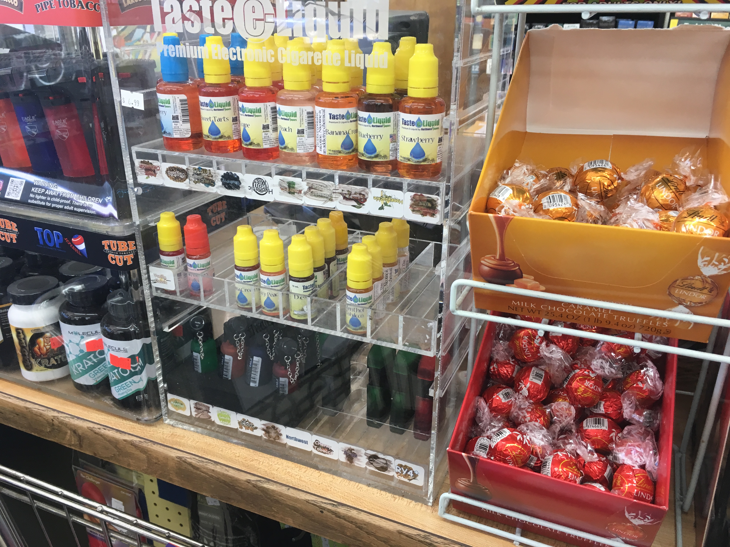  [Source: Oregon 2018 Tobacco and Alcohol Retail Assessment]  Note: Only use images with the appropriate permissions.
Action | When our Parent Teacher Association heard a presentation from our TPEP Coordinator, they were especially worried about how to protect kids from those flavored products. Five parents showed up to testify in support of a flavor ban when our County Commissioners were considering a tobacco retail license – and our Public Health Administrator heard later that’s why the flavor ban was included in the final ordinance.
Pulling it all together | Did you know that tobacco companies put tremendous pressure on store owners to sell flavored products at cheap, kid-friendly prices? More than nine out of every ten tobacco retailers in Our County sell flavored tobacco products like cigarillos and e-cigarettes that appeal to youth. (In the state overall, this percentage is only 21%.) When our Parent Teacher Association heard a presentation from our TPEP Coordinator, they were especially worried about how to protect kids from those flavored products. Five parents showed up to testify in support of a flavor ban when our County Commissioners were considering a tobacco retail license – and our Public Health Administrator heard later that’s why the flavor ban was included in the final ordinance. We’ll be working to implement the ordinance in the coming year.

YOUR STORY
Fact
Story
Image
Action

Pulling it all together

