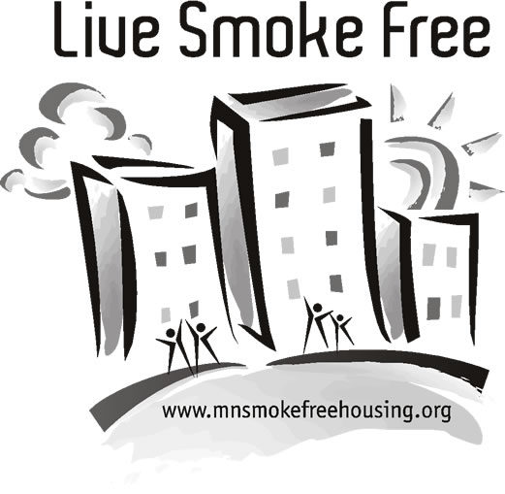
Housing Industry Glossary
This list graciously shared by Association for Nonsmokers - Minnesota

Affordable Housing: Commonly understood as housing that costs no more than 30% of a household's annual income. May also be understood as housing that costs no more than 30- 40% of a household's annual income. (Source: HousingLink.org)

ADR – Alternative dispute resolution: A procedure for settling a dispute by means other than litigation; such as arbitration or mediation. (Source: Black’s Law Dictionary)

ADA – Americans with Disabilities Act of 1990: Prohibits discrimination based on disability. Disability is defined as “a physical or mental impairment that substantially limits a major life activity.” (Source: Wikipedia.org)

CIC – Common Interest Community: See Owner-Occupied Units.

CDA – Community Development Agency: Combines the powers of an HRA (Housing Redevelopment Authority) with an EDA (Economic Development Authority).

Covenant of Quiet Enjoyment: An express or implied term of a lease, by the landlord to the tenant, which insures that the dwelling unit will be suitable for the purpose for which it is leased and that the there will be no serious interference with the tenant’s enjoyment of the unit. (Source: Jesse Dukeminier and James E. Krier, “Property” (1998))

EDA – Economic Development Authority: Works to enhance economic condition of a community. May focus on commercial and industrial development, job opportunities, and tax bases for citizens.

Eviction Action: See Unlawful Detainer Action (UDA).

FHA – Fair Housing Act: Title VIII of the Civil Rights Act of 1968. Protects against discrimination in housing based on protected classes such as race, religion, national origin, sex, handicap, and family status. (Source: Wikipedia.org)

Fixed-Term Lease: A rental agreement that has specific start date and end date, usually for a period of six months or one year. When the lease expires and the property manager or owner accepts rent for the next month without making a new lease agreement, the renter automatically begins a month-to-month tenancy. (Source: HousingLink.org)

HRA – Housing and Redevelopment Authority: Provides (may own and/or manage) affordable multi-housing to residents through federal, state, or local resources. HRA buildings may accept residents based on income levels, housing vouchers, or other qualifications. HRAs often serve a particular geographic region such as a county or city. Also known as a Public Housing Authority.

Housing Cooperative (Co-Op): In a housing cooperative, residents either own shares reflecting their equity in the co-operative's real estate, or have membership and occupancy rights in a not-for-profit co-operative, and they underwrite their housing through paying subscriptions or rent (Source: International Co-operative Alliance & Wikipedia.org).

Housing Voucher: Provides low income renters a means to find their own housing (market rate or public housing). Many vouchers are issued by HUD. Renters can use the vouchers at any building that participates in the voucher program. A housing subsidy is paid to the landlord directly by the local Public Housing Authority on behalf of the renter. The renter pays the difference of the rent charged and what has been subsidized. (Source: HUD)

HUD – U.S. Department of Housing and Urban Development: Offers programs to assist renters, landlords, and communities in areas of housing. HUD’s five core missions are: Increase homeownership; assist low-income renters; improve the physical, social, and economic health of cities; fight discrimination in housing markets; and assist homeless persons with housing and support services. HUD administers many housing vouchers and public housing programs. (Source: “A History of HUD” by Larry Thompson, former senior HUD employee)

Market-Rate Housing: Also known as privately-owned housing. These buildings do not receive state, federal, or local funding (although some may accept housing vouchers) and are owned by a private party. These buildings generally charge rent based on what the unit is worth on the average rental housing market rather than charging rent based on the renter’s income.

Month-to-Month Tenancy/Periodic Lease: A tenancy without a specific ending date. The tenancy usually continues from month-to-month until the property owner/manager or renter gives proper notice. (Source: HousingLink.org)

NAHRO – National Association for Housing and Redevelopment Officials: A professional membership organization comprised of 21,227 housing and community development agencies and officials throughout the United States who administer a variety of affordable housing and community development programs at the local level. (Source: Nahro.org)

Nuisance: A condition or situation (such as loud noise or foul odor) that interferes with the use or enjoyment of property.
(Source: Black’s Law Dictionary)

Owner-Occupied Units: Multi-housing units that are owned rather than rented. Includes town homes, condominiums, housing cooperatives (co-op), and other homeowner associations. Many owner-occupied communities have an association or board that is made up of several residents that discuss issues related to the property and its maintenance. Since each resident owns their own unit and one person does not make decisions for the entire building, policy changes (such as creating a smoke-free building) are usually done by a resident vote. Also known as a Common Interest Community.

Public Housing: Owned by a government authority (PHA, HRA, EDA, CDA). The goal of public housing is to provide affordable housing for low-income renters. Qualified individuals usually pay 30% of their adjusted gross income for the combination of rent and utilities. (Source: HousingLink.org)

Reasonable Accommodation: Legal requirement that ensures that housing features, procedures, etc., are adjusted to the needs of persons with a disability. (Source: HousingLink.org)

Rent Escrow Action: A simplified procedure available in Minnesota courts that permits a tenant to seek relief for housing violations on their own without the assistance of an attorney. Tenant deposits rent with the court pending the outcome of a hearing on housing violation. (Source: “Landlords and Tenants: Rights and Responsibilities” by the Office of the Minnesota Attorney General)

Section 8 Housing: Provided by HUD. The two main Section 8 programs are tenant-based vouchers and project-based vouchers.
- Under the tenant-based program, eligible families with a certificate or voucher lease a unit in the private sector and pay a portion of the rent (usually around 30% of their income). The local housing authority pays the owner the remaining rent. (Source: Wikipedia.org)
- A public housing authority can choose to project-base up to 25% of its total vouchers, meaning that the vouchers are linked to a particular building. Eligible families pay 30% of their income while living in the building, but cannot take that voucher with them to another residence. (Source: Wikipedia.org)

Section 42 Housing/Low Income Housing Tax Credit: A federal tax code that benefits individuals or groups that invest in low-income rental housing. Residents at tax-credit properties whose income qualifies pay a less than market-rate rent for units.
(Source: HousingLink.org)

Section 202 Housing (Seniors): A HUD-funded rental housing program that provides housing for seniors. Applicants at Section 202 properties must meet age and income requirements. (Source: HousingLink.org)

Section 236 Housing: A HUD-funded program that provides rental housing for families, elderly, disabled, handicapped, and individuals under age 62. Eligible residents pay the greater of contract rent or 30% of adjusted gross income, but not more than market rent. (Source: HousingLink.org)

Section 811 Program (Disabilities): Provides rental housing for persons with disabilities. Funded by HUD and administered by a nonprofit agency. Eligible residents will pay 30% of his/her adjusted gross income. At least one member of the household must be at least 18 years old and have a disability, such as a physical or developmental disability or chronic mental illness. (Source: HousingLink.org)

Tenant Remedies Act: The law which provides for a court action allowing a group of tenants, an individual tenant or a governmental body to take the property manager/owner to court for issues of non-repair. (Source: HousingLink.org)

UDA – Unlawful Detainer Action or Proceeding: An action to return a wrongfully-held tenancy (as one held by a tenant after the lease has expired) to its owner; also referred to as an eviction action. (Source: Black’s Law Dictionary)

Warranty of Habitability: In a residential lease, a warranty from the landlord to the tenant that the leased property is fit to live in and that it will remain so during the term of the lease; also termed covenant of habitability. (Source: Black’s Law Dictionary)

