SAMPLE SOCIAL POSTS TO CUSTOMIZE AND USE

Helpful tips
Social media can be a powerful communication and engagement tool, and having fresh, original data is a prime opportunity. Smokefree Oregon’s Facebook page will use the Tobacco and Alcohol Retail Assessment data over the next month. Please like and repost our posts, and consider posting your own, too, using the suggestions below.

Sample post 1:
Local health department staff and volunteers visited nearly 2,000 Oregon tobacco retailers to see how Big Tobacco markets to people—including kids. Bottom line: The industry is aggressively pushing its deadly products. Learn more in this new report from @SFO.

80-character version: Find out how Big Tobacco markets to Oregon adults and kids. Learn more @SFO

Potential image 1:

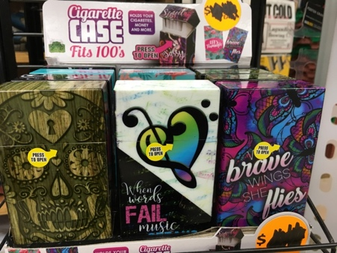

Sample post 2:
When you hear “Pebbles Donuts,” do you think of a children’s cereal? It’s actually a flavor of vape, or e-cigarette. A recent statewide assessment found that nearly 9 out of 10 tobacco retail locations sold fruit- or candy-flavored e-cigarettes or cigarillos. Learn more in this new report from @SFO about how the tobacco industry targets Oregon kids.

80-character version: OHA finds nearly 9 out of 10 retailers sell candy-flavored e-cigarettes or cigarillos targeted to kids @SFO

Potential image 2:

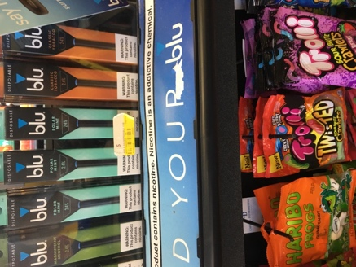

Sample post 3:
The tobacco industry spends more than $100 million per year to market its products in Oregon, pouring the bulk of this money into convenience stores, grocery stores and other locations where we shop daily. Learn how Oregon communities can fight back in this new report from @SFO.

80-character version: Big Tobacco pours $ into the stores we shop daily. Learn how Oregonians push back @SFO

Potential image 3:
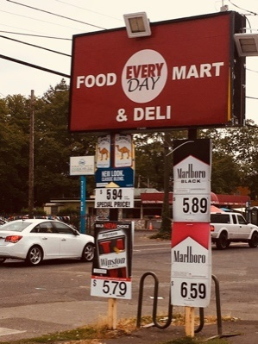

Sample post 4:
Big Tobacco makes sure retailers keep tobacco cheap for people on a limited budget, including low income communities and youth. Think Oregon is exempt? 64 percent of tobacco retailers were found to have a price discount on at least one tobacco product. Learn more in this new report from @SFO about how the tobacco industry targets us.

80-character version: Big Tobacco keeps tobacco cheap for low income people & kids. Learn how they target @SFO

Potential image 4:

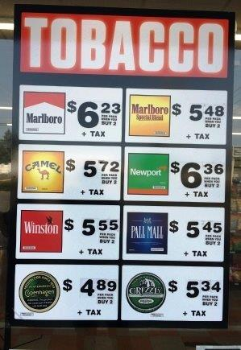

Content considerations:
Literacy level: Public health best practice is to write at a sixth-grade reading level, which means short words, simple and clear sentences, and no jargon.

Tone: Consider the tone of voice you’d like to use on social media. Is it warm? Urgent? Health care focused?

Length: Shorter posts that are concise and to the point usually receive more audience engagement (likes, comments and shares). Aim for no more than 80 characters. Facebook cuts off longer posts and forces followers to click “See More” to read the rest of the text. This extra step causes audiences to lose interest and reduces engagement.

Words/terms to avoid: Facebook uses algorithms to determine what posts show up in your followers’ news feeds. There are some words that prevent your content from being shared widely. Here are some words and terms to avoid using in Facebook posts:
- Free
- Like
- Love
- Comment
- Share
- Buy
- Sale
- Follow

Sharing links: Sharing links to relevant articles, videos or other online sources creates a drumbeat of interesting content, provides followers with more information about the issue, and demonstrates that you are actively engaged in the work. The statewide report link is great to share.

Sharing photos/images: Photos and graphic images are a great way not only to keep people interested and involved but also to show compelling pictures and the real faces of your organization, supporters and volunteers.

Posting and replying: Post (or repost) discussion-worthy questions or topics, official statements, and information on your Facebook page. When people leave comments, reply to them, both to show that you value their engagement and to keep the conversation going!

Re-share: Share content from people and organizations working on tobacco prevention locally and nationally, but add your own voice/commentary to it!

