Oregon Health Promotion and Chronic Disease Prevention



**Change Agent Training Series**

**SAMPLE Tobacco Free Properties Observational Assessment**

**Evaluation of a County Tobacco-Free Properties Policy**

Building/Campus/Park Name: ___________________________________________________

Department(s): ______________________________________________________________

Address: ____________________________________________________________________

Date: _______ /_______ /_______

Briefly describe weather conditions: ________________________________________­_

Time of Observation: Start _____: _____am / pm End: _____: ______ am / pm

* Conduct a separate observational assessment for each location.
* Consider conducting observations at multiple times during the day/evening.

It may be helpful to obtain information by walking into the building you are assessing and asking the front desk staff, security guards, or other staff that work in the building property questions such as:

1. If somebody asks, where do you suggest they go to smoke?
2. Where did people smoke before the policy was in place?
3. Have you seen changes after the policy has been in place?

Macintosh HD:Users:analyst:Dropbox (Rede Group):REDE Marketing (1):Logo-New:Redegroup-Logo-new-w-back-no-shadow.eps

**Preparation:**

1. **In Google Maps, get a screenshot of the area you are assessing and include ½ inch surrounding the perimeter of the property. Be sure that the cross streets are shown, this will help orient yourself throughout the study.**

* **Get a screenshot of the area**
* **Paste the screenshot onto an 8½ x 11in page**
  + - **Expand the screenshot to full-page and print for marking**
  1. **Paste a screenshot of the Google Earth map on page 10 for reference.**
  2. **Paste a screenshot of the Google Map on page 10 for reference.**

1. **Draw the perimeter of the parking lots on both Google Maps by referring to the Google Earth map.**

**Assessment:**

**During your assessment, take pictures of any problem areas or other interesting findings (e.g., lack of signage, ashtrays on the property). Do not take pictures of people who are smoking.**

**S=Signage, indicate the quantity you observed (if there were four seen: S4)  
A=Ashtray**

**B=Cigarette butts, indicate the quantity you observed (if there were 2 seen: B2)**

**U=Tobacco Users, indicate if they are an employee, visitor, or unknown**

**As you are walking around the property, look for entrances, common/sitting areas, parking lots, and other areas of tobacco use. Keep a tally of the overall amount of ashtrays, cigarette butts, and signs you see on the property. Read below for more specifics.**

1. **Entrances: An entrance is the area starting at the doorway and extending 10ft in any direction.**
   1. **Mark each entrance with an E on the map and number the entrances (E1, E2, E3…)**
2. **Common/sitting areas: The common sitting areas’ boundaries should be extending 10ft in any direction. Be sure to draw the perimeter of the sitting area. Common areas may overlap with other areas. The drawn perimeter will help identify the boundaries between the two areas. (e.g., a sitting area next to an entrance)**
   1. **Mark each common/sitting area with a C on the map and number the areas (C1, C2, C3…)**
   2. **Indicate on the table (page 7) whether the common area is covered or has seating**
3. **Parking Lots: Walk around each parking lot and make sure the outline of the parking lot is on your map.**
   1. **Mark each parking lot with a P on the map and number the parking lots (P1, P2, P3…)**
   2. **If you saw smokers, indicate on the table (page 6) if they were in their car or not**
4. **Other Areas of Tobacco Use: These areas extend 10ft in any direction. These can be cigarette butts, ashtrays, dip cans, or any other indication of tobacco use in areas that do not fit within the previously stated areas.** 
   1. **Mark each of these other areas with a T and number the areas (T1, T2, T3…)**
5. **Property Perimeter: After you have walked and documented the entire property, walk around the property’s perimeter to observe any smoking that is near the property, but not on the property. These areas extend 10ft in any direction.**
   1. **Mark each of these smoking areas outside the property with an OT and number the areas (OT1, OT2, OT3…)**

**After your observations are complete, fill out pages 4-10 with the information you placed on your map.**

**Map Key**

**E = Entrance**

**P = Parking Lot**

**C = Common Area**

**T = Other Area of Tobacco Use**

**OT = Off Campus Smoking Area**

**S = Signage**

**A = Ashtray**

**B = Cigarette Butts**

**U = Tobacco Users**

**Entrances (area within 10ft of an entrance)**

**Mark the entrances with an “E” and a number (E1, E2, E3, etc.) on the map. If you saw signs of smoking, indicate which entrance (e.g., E1, E5, and E14) and input the data into the table.**

|  |  |  |  |  |
| --- | --- | --- | --- | --- |
| **E #** | Ashtrays | Cigarette Butts | Tobacco Users | Signage |
| E__ | * Yes # _______ * No | * Yes # _______ * No | * Yes # _______ * No | * Yes # _______ * No |
| E__ | * Yes # _______ * No | * Yes # _______ * No | * Yes # _______ * No | * Yes # _______ * No |
| E__ | * Yes # _______ * No | * Yes # _______ * No | * Yes # _______ * No | * Yes # _______ * No |
| E__ | * Yes # _______ * No | * Yes # _______ * No | * Yes # _______ * No | * Yes # _______ * No |
| E__ | * Yes # _______ * No | * Yes # _______ * No | * Yes # _______ * No | * Yes # _______ * No |
| E__ | * Yes # _______ * No | * Yes # _______ * No | * Yes # _______ * No | * Yes # _______ * No |
| E__ | * Yes # _______ * No | * Yes # _______ * No | * Yes # _______ * No | * Yes # _______ * No |
| E__ | * Yes # _______ * No | * Yes # _______ * No | * Yes # _______ * No | * Yes # _______ * No |
| E__ | * Yes # _______ * No | * Yes # _______ * No | * Yes # _______ * No | * Yes # _______ * No |
| E__ | * Yes # _______ * No | * Yes # _______ * No | * Yes # _______ * No | * Yes # _______ * No |

If you saw people smoking, were they:

* Employees # _____
* Clients # ______
* Visitors #______
* Unknown #______
* No one was smoking

Notes: ___________________________________________________________________________________________________________

___________________________________________________________________________________________________________________

___________________________________________________________________________________________________________________

___________________________________________________________________________________________________________________

**Parking Lots**

**Mark the parking lots with a “P” and a number (P1, P2, P3, etc.) on the map. If you saw signs of smoking, indicate which parking lot (e.g., P1, P5, and P14) and input the data into the table.**

|  |  |  |  |  |
| --- | --- | --- | --- | --- |
| **P#** | Ashtrays | Cigarette Butts | Tobacco Users | Signage |
| P__ | * Yes # _______ * No | * Yes # _______ * No | * Yes # _______ * No | * Yes # _______ * No |
| P__ | * Yes # _______ * No | * Yes # _______ * No | * Yes # _______ * No | * Yes # _______ * No |
| P__ | * Yes # _______ * No | * Yes # _______ * No | * Yes # _______ * No | * Yes # _______ * No |
| P__ | * Yes # _______ * No | * Yes # _______ * No | * Yes # _______ * No | * Yes # _______ * No |
| P__ | * Yes # _______ * No | * Yes # _______ * No | * Yes # _______ * No | * Yes # _______ * No |

If you saw people smoking, were they:

* Employees # _____
* Clients # ______
* Visitors #______
* Unknown #______
* No one was smoking

If you saw people smoking, were they:

* In their Car # _____
* Not in their Car # ______

Notes: ___________________________________________________________________________________________________________

___________________________________________________________________________________________________________________

___________________________________________________________________________________________________________________

___________________________________________________________________________________________________________________

___________________________________________________________________________________________________________________

**Common/Sitting Areas**

**Mark every common/sitting area with a “C” and a number (C1, C2, C3, etc.) on the map. If you saw signs of smoking, indicate which common/sitting area (e.g., C1, C5, and C14) and input the data into the table.**

|  |  |  |  |  |
| --- | --- | --- | --- | --- |
| **C #** | Ashtrays | Cigarette Butts | Tobacco Users | Signage |
| C__ | * Yes # _______ * No | * Yes # _______ * No | * Yes # _______ * No | * Yes # _______ * No |
| C__ | * Yes # _______ * No | * Yes # _______ * No | * Yes # _______ * No | * Yes # _______ * No |
| C__ | * Yes # _______ * No | * Yes # _______ * No | * Yes # _______ * No | * Yes # _______ * No |
| C__ | * Yes # _______ * No | * Yes # _______ * No | * Yes # _______ * No | * Yes # _______ * No |

If you saw people smoking, were they:

* Employees # _____
* Clients # ______
* Visitors #______
* Unknown #______
* No one was smoking

**Additional information for common/sitting areas**

|  |  |  |
| --- | --- | --- |
| **C #** | Covered | Seating |
| C__ | * Yes * No | * Yes * No |
| C__ | * Yes * No | * Yes * No |
| C__ | * Yes * No | * Yes * No |
| C__ | * Yes * No | * Yes * No |

Notes: ___________________________________________________________________________________________________________

___________________________________________________________________________________________________________________

___________________________________________________________________________________________________________________

___________________________________________________________________________________________________________________

**Other areas where there are indications of tobacco use**

**Mark every other area that had indications of tobacco use with a “T” and a number (T1, T2, etc.) on the map. Indicate in the table if there were any ashtrays, cigarette butts, tobacco users, or signage in each of these areas.**

|  |  |  |  |  |
| --- | --- | --- | --- | --- |
|  | Ashtrays | Cigarette Butts | Tobacco Users | Signage |
| T1 | * Yes # _______ * No | * Yes # _______ * No | * Yes # _______ * No | * Yes # _______ * No |
| T2 | * Yes # _______ * No | * Yes # _______ * No | * Yes # _______ * No | * Yes # _______ * No |
| T3 | * Yes # _______ * No | * Yes # _______ * No | * Yes # _______ * No | * Yes # _______ * No |
| T4 | * Yes # _______ * No | * Yes # _______ * No | * Yes # _______ * No | * Yes # _______ * No |
| T5 | * Yes # _______ * No | * Yes # _______ * No | * Yes # _______ * No | * Yes # _______ * No |
| T6 | * Yes # _______ * No | * Yes # _______ * No | * Yes # _______ * No | * Yes # _______ * No |

If you saw people smoking, were they:

* Employees # _____
* Clients # ______
* Visitors #______
* Unknown #______
* No one was smoking

Notes: ___________________________________________________________________________________________________________

___________________________________________________________________________________________________________________

___________________________________________________________________________________________________________________

___________________________________________________________________________________________________________________

___________________________________________________________________________________________________________________

___________________________________________________________________________________________________________________

___________________________________________________________________________________________________________________

___________________________________________________________________________________________________________________

___________________________________________________________________________________________________________________

**Off-Campus Smoking (near the perimeter of the county property)**

**Mark every off-campus smoking area with an “OT” and a number (OT1, OT2, etc.) on the map. Indicate in the table if there were any ashtrays, cigarette butts, tobacco users, or signage in each parking lot.**

|  |  |  |  |  |
| --- | --- | --- | --- | --- |
|  | Ashtrays | Cigarette Butts | Tobacco Users | Signage |
| OT1 | * Yes # _______ * No | * Yes # _______ * No | * Yes # _______ * No | * Yes # _______ * No |
| OT2 | * Yes # _______ * No | * Yes # _______ * No | * Yes # _______ * No | * Yes # _______ * No |
| OT3 | * Yes # _______ * No | * Yes # _______ * No | * Yes # _______ * No | * Yes # _______ * No |
| OT4 | * Yes # _______ * No | * Yes # _______ * No | * Yes # _______ * No | * Yes # _______ * No |
| OT5 | * Yes # _______ * No | * Yes # _______ * No | * Yes # _______ * No | * Yes # _______ * No |
| OT6 | * Yes # _______ * No | * Yes # _______ * No | * Yes # _______ * No | * Yes # _______ * No |

In the area below, please include information about the area that had off-campus smoking, such as the buildings in the surrounding areas (e.g., schools, stores), whether the smokers were employees, clients, or visitors, or anything else that could be helpful.

___________________________________________________________________________________________________________________

___________________________________________________________________________________________________________________

___________________________________________________________________________________________________________________

___________________________________________________________________________________________________________________

___________________________________________________________________________________________________________________

___________________________________________________________________________________________________________________

___________________________________________________________________________________________________________________

___________________________________________________________________________________________________________________

___________________________________________________________________________________________________________________

___________________________________________________________________________________________________________________

___________________________________________________________________________________________________________________

___________________________________________________________________________________________________________________

**Final Questions**

1) Did you approach a person using tobacco and ask him/her to stop?

* Yes
* No

If yes, please briefly describe the situation:

___________________________________________________________________________________________________

___________________________________________________________________________________________________

___________________________________________________________________________________________________

___________________________________________________________________________________________________

___________________________________________________________________________________________________

**Final Tallies:**

-How many signs were there on the entire property? #______

-How many cigarette butts were on the entire property? #______

-How many smokers/tobacco users on the entire property? #______

-How many ashtrays were on the entire property? #______

Reference Screenshots:

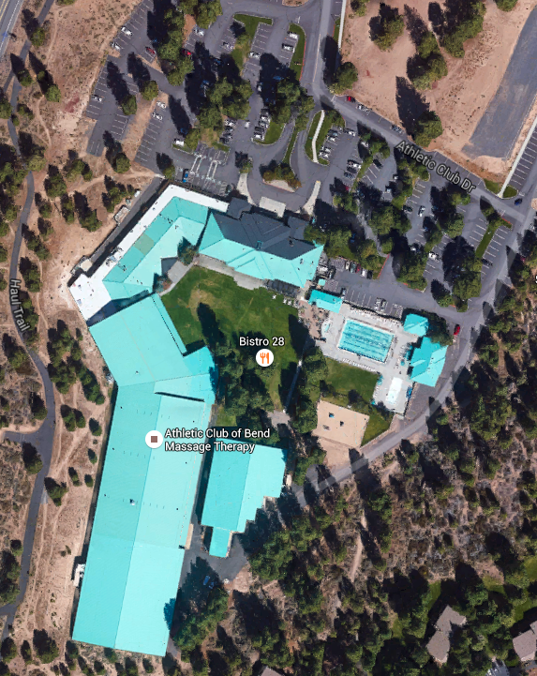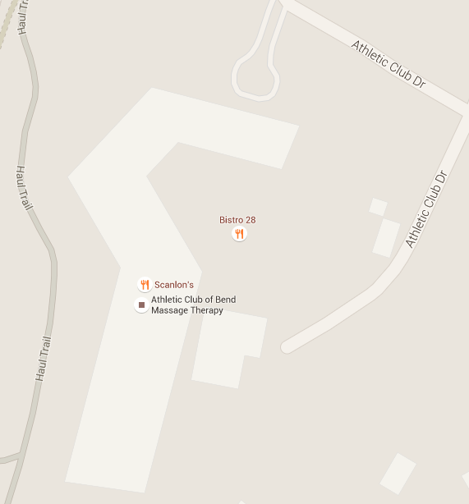

**Google Earth Map** **Google Maps**