- Open the Source Water Assessment Report and turn to Table 2. Inventory Result, near the end of the report, located in Appendix (see below for example).
- Select a high relative risk PCS in the 2 year Time of Travel (TOT), see example below. Select a lower risk PCS if none in the 2 yr TOT and/or move out to the next TOT if no PCSs in the 2 yr TOT.
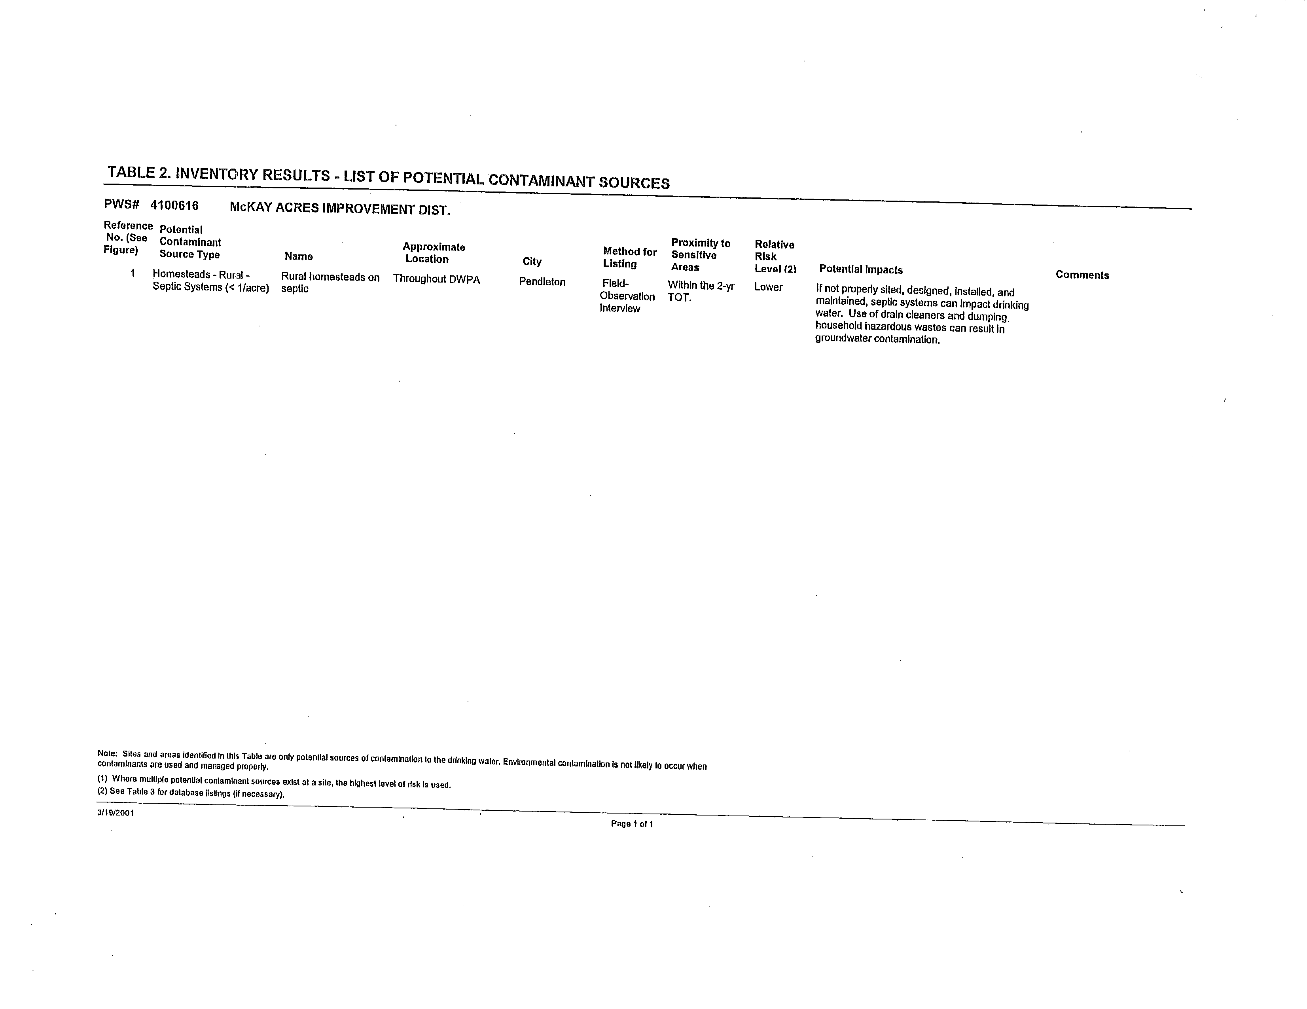
- Example of the Potential Contaminate Source Map showing TOT zones, PCSs and well locations
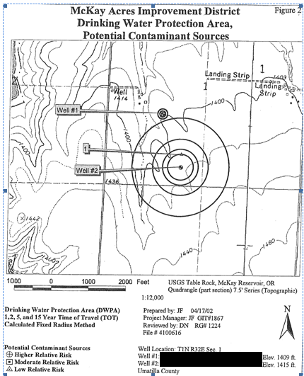
- Using handout, review initial/substantial implementation Best Management Practices (BMPs) for each PCS identified in Table 2.
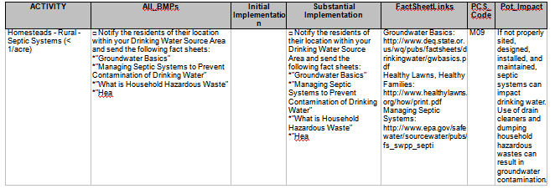
- Complete Best Management Practices (BMPs) Implementation Matrix for each of the PCSs listed in Table 2 (see above for example).
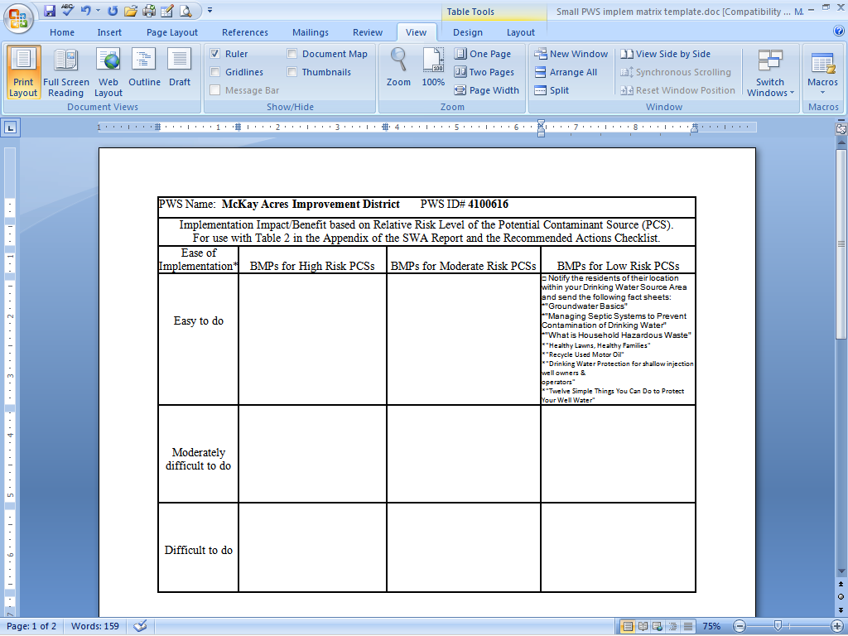

- Discuss completion of the matrix.
    - Are there any BMPs that are “easy to do” that would have a “High” impact?
    - Are there any BMPs that are “difficult to do” that would have a “Low” impact?
    - Which BMPs would you try to implement first? Which ones last or not at all?
- Post Class Implementation: Repeat the exercise above for the remaining PCSs listed in the Source Water Assessment and after the PCSs have been addressed and BMPs implemented (that means provided to the owner of the PCS and used by the owner of the PCS), please send a completed copy of the Checklist to OHA (see example below and included in the handouts).
Address to:
Russell Kazmierczak
Drinking Water Program
444 A Street
Springfield, OR 97477

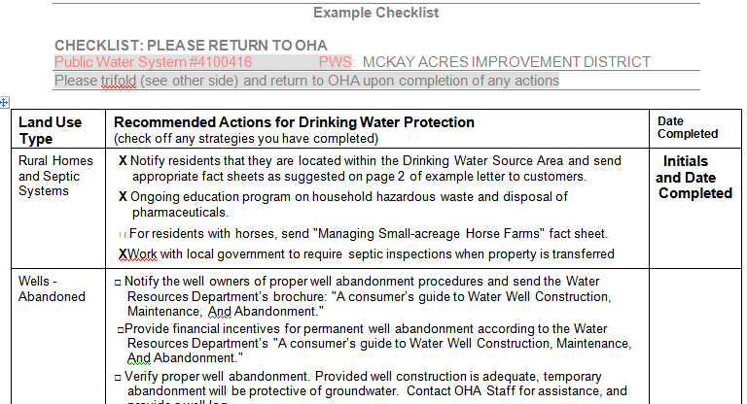

If you’re not able to mail the checklist, you can call or email the information to the Drinking Water Program (Russ Kazmierczak at 541-726-2785 ext. 26 or email russell.a.kazmierczak@state.or.us). Just list the PCS that were addressed and how the protection strategies, such as the issuance of BMPs, were implemented. If you do call and talk to a person other than the one of the regional geologists, such as Russ Kazmierczak (Eastern Region Geologist), please provide your full name, water system name, water system number, county location of the water and a return phone number. If you are having difficulties in implementing source water protection, you can also call to schedule a meeting and we can meet with you at your water system and help you come up with strategies on how to address the potential contaminate sources.

