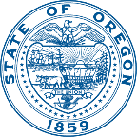 | PUBLIC HEALTH DIVISON  Center for Health Protection, Environmental Public Health | 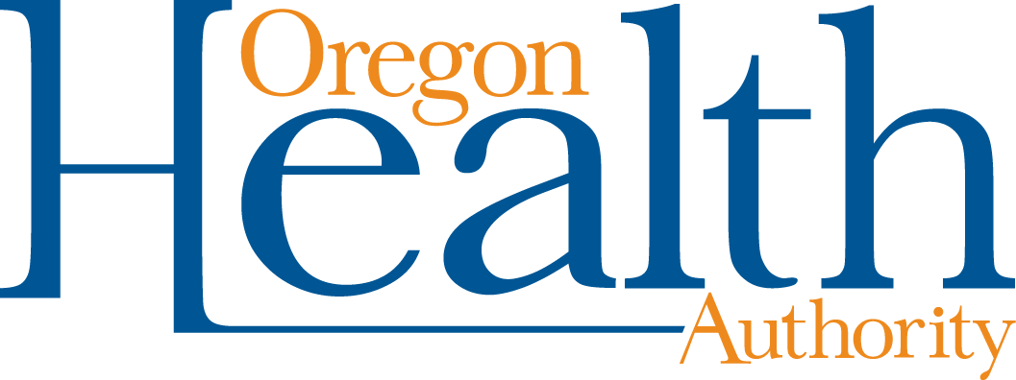
 | Kate Brown, Governor

800 NE Oregon St Ste 640
Portland OR 97232
971-673-3284
FAX: 971-673-0979
TTY: 711

Date: July 16, 2018

TO: Interested Parties

FROM: Brett Sherry, Program Manager
Toxic Free Kids Program

RE: Notice of Proposed Rulemaking – OAR 333-016
“Toxic Free Kids Rule Revision”
________________________________________________________________
The Oregon Health Authority (Authority), Public Health Division is proposing to permanently amend administrative rules in chapter 333, division 16 related to the Toxic Free Kids Act.

ORS 431A.250 requires manufacturers of children’s products to disclose high priority chemicals of concern for children’s health used in children’s products that are sold or offered for sale in Oregon. To improve the law’s implementation and in accordance with its provisions, the Authority proposes to amend Oregon Administrative Rules pertaining to the following: the list of Chemicals of High Concern for Children’s Health; Notification Requirements; Enforcement and Civil Penalties; and Fees.

Proposed amendments to OAR chapter 333, division 16 include:
- The addition of five high priority chemicals to (and three removed from) the Chemicals of High Concern for Children’s Health list (OAR 333-016-2020);
- A priority order of those entities responsible for providing product notifications, per OAR 333-016-2060, is specified. The same priority order will be used for enforcement purposes, per OAR 333-016-2090;
- A requirement that product notifications include the number of children’s products containing high priority chemicals either sold or offered for sale in Oregon in the notice period;
- Clarification that only one entity that meets the definition of manufacturer is required to report a particular children’s product, per OAR 333-016-2060;
- Alignment of the Exemption Request Review Fee in OAR 333-016-2080 (increments of $12,000) with the fee resulting from the passage of HB 5027 in 2017 of ($200 per hour).

You are invited to review and comment on the proposed rules. If you wish to present oral testimony, a public hearing will be held on August 16, 2018 at 9:00 a.m. at the Portland State Office Building, 800 NE Oregon St., Room 1D, Portland, OR 97232.

You may also file written comments before 5:00 p.m. on August 22, 2018, by submitting them to the Public Health Division Rules Coordinator at the following address:
OHA, Public Health Division
Brittany Hall, Administrative Rules Coordinator
800 NE Oregon Street, Suite 930
Portland, Oregon 97232

E-mail comments to: publichealth.rules@state.or.us
You may also send comments by fax to (971) 673-1299.

Final rules will be filed after consideration of all comments.

For more details, please see the Notice of Proposed Rulemaking Hearing, Statement of Need and Fiscal Impact, and the full text of the proposed rules at the following website: http://www.healthoregon.org/toxicfreekids.

If you have questions or would like a paper copy of these rule changes, please contact Justin Waltz at 971-673-1217 or justin.waltz@state.or.us. Thank you for your continued support.

