PRECAUTION

Name of Water Body is not Routinely monitored

But CYaNOBACTERIA blooms and Toxins can be present

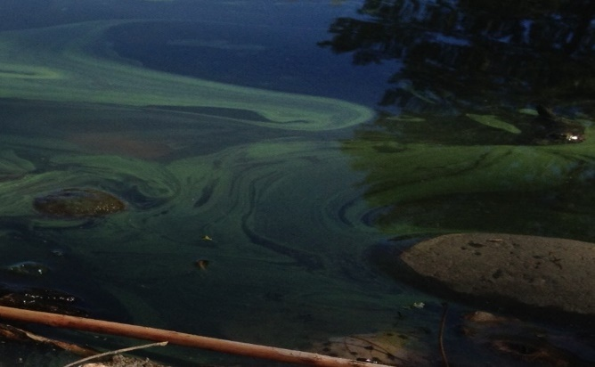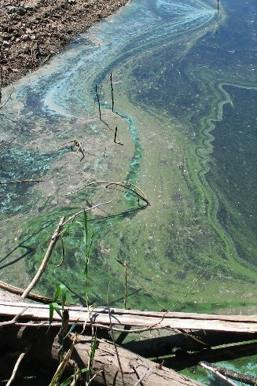

Some species of cyanobacteria (known as harmful or blue-green algae) can produce cyanotoxins that can make people, pets and other animals sick.

- Be aware of water conditions. When in doubt, stay out. Avoid water that is foamy, scummy, thick like paint, bright pea-green, blue-green or where brownish red mats can be seen.
- Avoid activities that cause water to be swallowed.
- Children and pets are at greatest risk: Keep them away from suspicious looking water and scummy algae mats.

For health information or to report human or pet illnesses due to blooms, contact the Oregon Health Authority at 971-673-0440 or hab.health@odhsoha.oregon.gov, or visit www.healthoregon.org/HAB. For local waterbody information contact (customize for local waterbody/park/campground manager)

Insert local partner logo here

