Participant Centered Group Session Guide, Washington County WIC

BABY PREP CLASSES 1-5

Location Considerations: Beaverton and Hillsboro classrooms

Materials Needed and Their Location:
- Tables and chairs for about 5- 10 couples
- White board
- White board markers
- Laptop with loaded PowerPoint presentations
- Projector
- Speakers
- Extension cord
- Name table tents
- Markers for name tags and group activities
- pens, enough for each couple
- Business cards

Preparation Needed:
Organize tables and chairs however they fit best in the room, set up PowerPoint and projector, make sure sound and DVDs work for video, set out nametags and markers on the tables, set out business cards near exit.

Time needed: approximately 60 minutes

Facilitator Considerations or Expertise Needed: A Breastfeeding Peer Counselor, a WIC counselor with advanced breastfeeding training or an IBCLC will have the expertise necessary to facilitate.

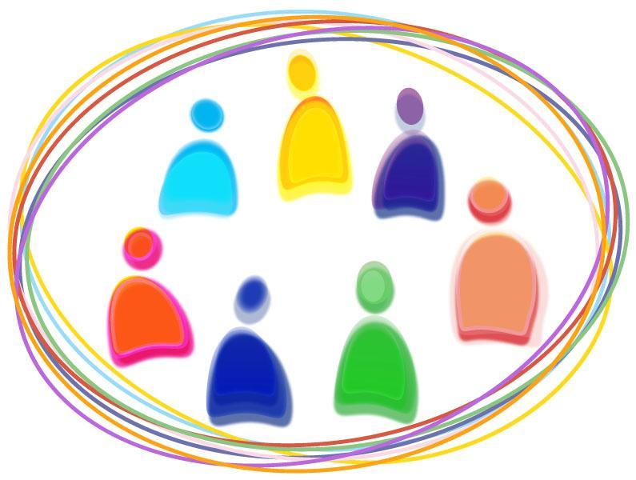
Session Title: BABY PREP # 1
Session 1 Focus

Target Audience: Pregnant women and their partners/support people

Session Goal: General introduction to Baby Prep classes and basic information about risks of formula feeding and benefits of breastfeeding.

Key Content Points:
- Point 1: Benefits and risks of breastfeeding and formula feeding
- Point 2: Differences between breast milk composition and formula
- Point 3: Breastfeeding duration and anticipated barriers

Session Objectives: By the end of the session, participants should be able to
- Objective 1: Identify two benefits of breastfeeding and two risks of formula feeding
- Objective 2: Identify two components that can be found in breastmilk, but not formula
- Objective 3: State the AAP recommended breastfeeding duration

Session 1 Outline

Facilitator notes: Provide a general overview of PC Breastfeeding Services and expectations for participation.

Time | Learning activity (Supports participant centered content/instruction) – Key Open Ended Questions - Important concepts to cover | Objective covered
 | Leave blank
2min | Opening the session:  Welcome and review agenda
20 min | Activity 1  Video: Inspirational clip from Breastmilkcounts.com  Discussion: Benefits/risks  Manipulative: Journaling. Pg. 3, Q 1. | 1
20 min | Activity 2  Manipulative: Lego activity & review  Discussion: Breastfeeding duration  Video: “You know you’re breastfeeding when…” | 2,3
10 min | Closing  Manipulative: Baby Prep card  Discussion: summary  Feedback: survey

Participant Centered Group Session Guide, Washington County WIC
Session Title: BABY PREP # 2 (Also known as “Tips for Partners”)
Session 2 Focus

Target Audience: Partners/support people of pregnant participants, and pregnant participants

Session Goal: To provide practical, anticipatory guidance on how partners can support a breastfeeding parent

Key Content Points:
- Point 1: Identify ways partners can support the breastfeeding parent
- Point 2: Explore myths that can undermine breastfeeding confidence

Session Objectives: By the end of the session, participants should be able to
- Objective 1: State two ways a partner can support breastfeeding
- Objective 2: Identify two myths that can interfere with breastfeeding success
- Objective 3: Describe one event which is supportive and one event which is unsupportive of breastfeeding

Session 2 Outline

Facilitator notes:

Time | Learning activity (Supports participant centered content/instruction) – Key Open Ended Questions - Important concepts to cover | Objective covered
 | Leave blank
2min | Opening the session:  Welcome and review agenda
15 min | Activity 1  Discussion: define “partner”.  Slideshow: 8 tips to support your breastfeeding partner  Manipulative: truths & myths activity
30 min | Activity 2  Manipulative, group work: supportive board activity  Video: Dads and breastfeeding  Journaling: Pages 19. 20, Q1.
10 min | Closing  Manipulative: Baby Prep card  Discussion: summary  Feedback: survey

Participant Centered Group Session Guide, Washington County WIC
Session Title: BABY PREP # 3
Session 3 Focus

Target Audience: Pregnant women and their partners/support people

Session Goal: Introduction of resources to prepare for childbirth

Key Content Points:
- Point 1: Know how to access community resources for childbirth
- Point 2: Exploring feelings around childbirth
- Point 3: Exploring importance and benefits of skin to skin contact

Session Objectives: By the end of the session, participants should be able to
- Objective 1: Give two benefits of skin-to-skin
- Objective 2: State one community resource for accessing birth doulas
- Objective 3: Describe personal feelings around childbirth

Session 3 Outline

Facilitator notes:

Time | Learning activity (Supports participant centered content/instruction) – Key Open Ended Questions - Important concepts to cover | Objective covered
 | Leave blank
2min | Opening the session:  Welcome and review agenda
10 min | Activity 1  Manipulative: Picture activity. Ask participants to choose 2-3 pictures that best represent how they currently feel about childbirth. Then discuss. | 3
15 min | Activity 2  Discussion & offer handouts: Doula resources, childbirth education resources  Video: Labor and positioning from Babycenter.com | 2
23 min | Activity 3  Discussion: Skin-to-skin important points  Manipulative: Journaling Pg. 32- both Qs  Demonstration and video - Biological nurturing: Nina, DVD, slides, handout | 1,3
10 min | Closing  Manipulative: Baby Prep card  Discussion: summary  Feedback: survey

Participant Centered Group Session Guide, Washington County WIC
Session Title: BABY PREP # 4
Session 4 Focus

Target Audience: Pregnant women and their partners/support people

Session Goal: Increase confidence in breastfeeding skills such as latch and positioning, hand expression and skin to skin contact

Key Content Points:
- Point 1: Introducing practical skills for successful breastfeeding
- Point 2: Offering anticipatory guidance for common breastfeeding concerns

Session Objectives: By the end of the session, participants should be able to
- Objective 1: Demonstrate skills for hand expression
- Objective 2: Identify normal infant stool patterns
- Objective 3: Describe the process of lactogenesis

Session 4 Outline

Facilitator notes:

Time | Learning activity (Supports participant centered content/instruction) – Key Open Ended Questions - Important concepts to cover | Objective covered
 | Leave blank
2min | Opening the session:  Welcome and review agenda
10 min | Activity 1  Discussion: Percent duration  Manipulative: Journaling Pg 10, Q2 | 3
10 min | Activity 2  Discussion: Colostrum, milk production - supply/demand fundamentals.  Video: Stanford hand expression. Begin at 2’11” | 3
28 min | Activity  Manipulative, group work: Timeline activity.  Each participant will receive an “event”. The group will work together to place each event on the correct place on the timeline.  Journal: Pg 21, Q1 | 2,3
10 min | Closing  Manipulative: Baby Prep card  Discussion: summary  Feedback: survey
Participant Centered Group Session Guide, Washington County WIC
Session Title: BABY PREP # 5
Session 5 Focus

Target Audience: Pregnant women and their partners/support people

Session Goal: Review of previous classes and understanding baby behaviors

Key Content Points:
- Point 1: Materials from previous sessions (Summaries)
- Point 2: Understanding of baby behaviors

Session Objectives: By the end of the session, participants should be able to
- Objective 1: Identify three baby cues related to feeding
- Objective 2: Know how/when to contact breastfeeding services
- Objective 3: Complete Baby Prep card

Session 5 Outline

Facilitator notes:

Time | Learning activity (Supports participant centered content/instruction) – Key Open Ended Questions - Important concepts to cover | Objective covered
 | Leave blank
2min | Opening the session:  Discussion: Welcome and review agenda
19 min | Activity 1  Discussion, visual: crying, night waking  Manipulative: Pass out 6 week calendar, review | 1
19 min | Activity 2  Journaling: Pg 21, Q1  Visual, manipulative: Tour board | 1,2,3
10 min | Closing  Manipulative: complete Baby Prep card and receive blanket/gift (when available). Hand out “Your Guide to Breastfeeding” magazine.  Discussion: summary  Feedback: survey

