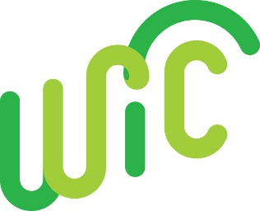
Partnering with Early Head Start

There are many natural connections between WIC and Early Head Start (EHS). Early Head Start offers services to pregnant women, infants and children (through three years) and provides prenatal education on the benefits of breastfeeding.

How WIC can strengthen the Early Head Start program partnership:

- Contact your local EHS program coordinator. Common areas for discussion might include: prenatal resources, farmer’s market, staff training needs, appointment reminders, nutrition screenings, adding program information on enrollment forms (for example, adding WIC ID information on the EHS enrollment form), sharing outreach materials and parent classes --- to name a few!
- Invite EHS staff to your visit your agency. Encourage them to observe the clinic flow or attend a group nutrition education or breastfeeding session.
- Visit an EHS parent meeting. Consider hosting a joint “health fair” to recruit and enroll children/families and perform health screenings used by both programs.
- Encourage the referral of pregnant women, infants and children between programs.
- Offer breastfeeding support to EHS staff. Consider providing breastfeeding training or encouraging their attendance at the Breastfeeding Basics training in Portland
- Check out the Oregon Head Start Association’s website for more information

