
Top of Form
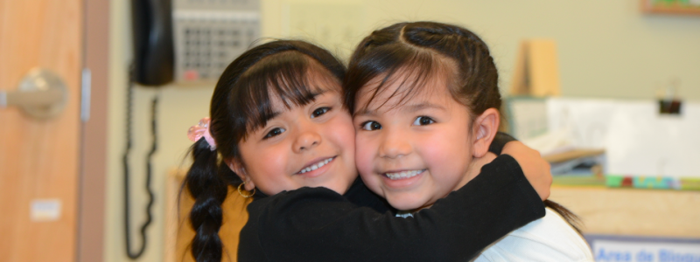

Our Mission
Oregon Child Development Coalition (OCDC) is dedicated to improving the lives of children and families by providing early childhood education, care and advocacy with unique and supportive services to enhance family growth and community success.

Our Vision
We believe that every single child should be cared for, educated and loved. We prepare young children for success in school, which prepares them for success in life. We also support parents to help families learn and grow together, and we help families engage with their community.
The Oregon Child Development Coalition believes that every child, family, community partner and employee that we interact with deserves:
OCDC provides Early Childhood Care and Education services to Head Start and Early Head Start eligible low-income children, pregnant women and families. We connect families to programs, services and opportunities in the community. We drive children to school, teach kids to read and write, and visit moms and dads in their homes. We provide well-paying living wage jobs in communities throughout Oregon and embrace cultural diversity and practice inclusiveness.
Oregon Child Development Coalition
P.O. Box 2780
9140 SW Pioneer Court Suite E
Wilsonville, OR 97070
503-570-1110 | 503-682-9426
info@ocdc.net
For information about enrolling in a program, please contact the center nearest you.
Hood River & Wasco County
1300 W 9th St The Dalles, OR 97058 P 541.296.0100 F 541.296.0143
Jackson (& Josephine) County
265 N Main St. #1 Ashland, OR 97520 P 541.488.6919 F 541.488.7689
Klamath County
5534 S 6th St. #207 Klamath Falls, OR 97603 P 541.723.3068
Marion & Clackamas County
P.O. Box 263 1310 Meridian Drive Woodburn, OR 97071 P 503.981.3001 F 503.981.0851
Malheur County
482 SE 3rd St. Ontario, OR 97914 P 541.889.5325 F 541.889.6281
Multnomah County
2727 SE Anderson Rd. Gresham, OR 97080 P 503.663.0896 F 503.663.0447
Polk & South Marion County
P.O. Box 370 535 G St Independence, OR 97351 P 503.838.2745 F 503.838.2793
Umatilla (& Morrow) County 403 Peabody Milton-Freewater, OR 97862 P 541.938.3170 F 541.938.9597
Washington County 1389 S. Dogwood St. Cornelius, OR 97113 P 503.359.0144 F 503.359.0710
Data Summary 2014
Enrollment Children Served Migrant and Seasonal— Early Head Start
Funded Enrollment: 3075
Total Enrollment Served: 2950
Average monthly enrollment: 91.5%
For general information, email us at info@ocdc.net and someone will respond as soon as possible.
Donalda Dodson, Executive Director: Donalda.dodson@ocdc.net
Karen Ayers, Program and Partnerships Manager: Karen.ayers@ocdc.net
Beatriz Marron-Molina, Lead Family & Health Services Specialist: Beatriz.marron@ocdc.net

Joy Rowley, Early Head Start Child Care Program Coordinator: Joy.rowley@ocdc.net

