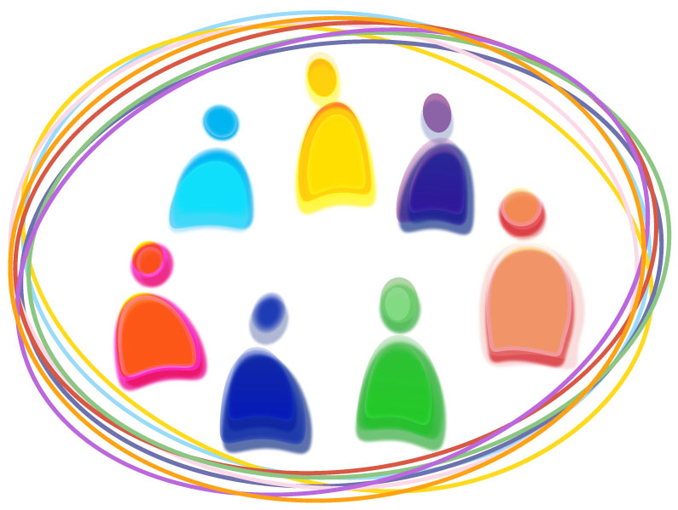
Participant Centered Group Session Guide
Final Session Title:
Session Focus

Target Audience:

Session Goal:

Key Content Points:
- Point 1:
- Point 2:
- Point 3:

Session Objectives:.
- Objective 1:
- Objective 2:
- Objective 3:

Session Planning

Draft Session Title:

Location Considerations:

Materials Needed and Their Location:
- -
- -

Preparation Needed:
- -

Time Needed:

Facilitator Considerations or Expertise Needed:

Session Outline

Facilitator notes:

Time | Learning activity (Supports participant centered content/instruction) – Key Open Ended Questions - Important concepts to cover | Objective covered
X min | Opening the session:
X min | Warm-up activity:  - 
X min | Activity 1:  - 
X min | Activity 2:  - 
X min | Optional Activity:  - 
X min | Closing the session:

Facilitator review:
- How well does the session support the “teach less, learn more” philosophy? (Lecture less, involve more)
- What have I included in the activities to help participants be involved in their own learning?
- How do I allow for participants to have a potential ah-ha moment?
- How do I include time for the participants to digest and reflect on what was covered?
- What was the participant’s reaction to the session?
- Consider making changes to the guide as you experiment. After you try it, ask yourself - What went well? What would I change next time?

