


Materials Order Form

Store details
Store name:
Mailing address:
Requestor name:
Email:
Phone:

WIC materials list
- Image | - Description | - Order amount
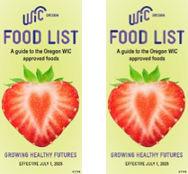 | “Oregon WIC Food List”  Keep at cash registers. | English:  Spanish:
 | “Oregon WIC Food” shelf tags (42 tags per sheet)  Place under authorized foods. | Number of sheets:
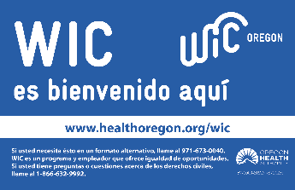   | “WIC is welcome here” window clings  Display on doors or windows. | English:  Spanish:
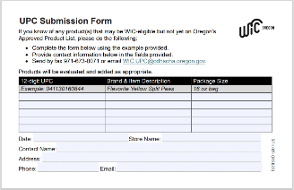 | “UPC Submission Form” (packs of 25) | Number of packs:
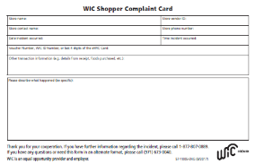 | “WIC Shopper Complaint Card” (packs of 25)  Keep at cash registers. | Number of packs:
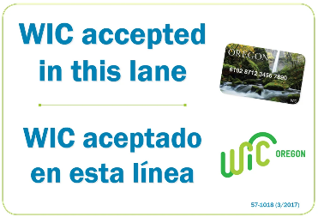 | “WIC accepted in this lane” sign  * Required for stores that only accept WIC in certain lanes. | Number of signs:
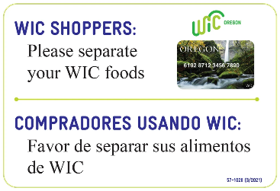 | "Separate your WIC foods” sign  For stores using stand-beside terminals. | Number of signs:

Oregon State WIC Program contact information
Submit this form to the State WIC office. Materials can also be ordered online using Shopify.
Mailing address: Oregon WIC Vendor Team
P.O. Box 14450
Portland, OR 97293
Fax: (971) 673-0071
Email: WIC.VendorServices@odhsoha.oregon.gov
Phone: (877) 807-0889
Monday through Friday, 8 a.m. to 5 p.m. (except holidays)

