Oregon WIC Transaction Guide
Scanning WIC Foods
- Scan WIC foods individually using the UPC on the product or PLU code for produce.
- Allow shoppers to use coupons, discounts and store loyalty cards.
The WIC Payment

- WIC must be the first form of payment.
- Shopper swipes the eWIC card and enters their PIN.
The Mid-Transaction Receipt
- Give the shopper the mid-transaction receipt to review before they approve the WIC purchase.
- The mid-transaction receipt shows:
  - The beginning WIC benefit balance and
  - A list of foods that will be covered by WIC.
Foods Not Covered By WIC
- If a food doesn’t scan as WIC-approved, the cashier can’t override it.
- Ask the shopper if they want to buy that food with another form of payment.
  - If not, remove the food from the remaining balance.
- Voiding foods from the remaining balance might require voiding the WIC payment first.
Final Receipt
- Give the final receipt to the shopper.
- The final receipt shows:
  - The foods they purchased with WIC and
  - The WIC benefits they have left.
Exchanges and Recalls
- If the shopper wants a different formula, refer them to their WIC clinic.
- Substitutions and refunds for cash or store credit are not allowed.
  - Defective, spoiled or expired foods can only be exchanged for the same item.
  - In the event of a recall, follow manufacturer and WIC Program guidance.

eWIC Balance Inquiry
- An eWIC Balance Inquiry receipt shows a shopper’s current benefit balance.
- No purchase is required to print an eWIC Balance Inquiry.
- This receipt must be provided if requested by a shopper.
Sample eWIC Balance Inquiry Receipt
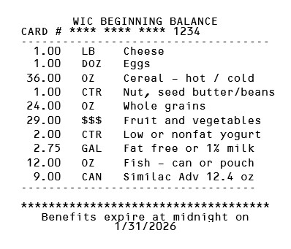

- The WIC beginning balance lists the quantity, unit of measurement and foods available for the shopper to buy.
- Most units of measurement are abbreviated:
  - LB is Pound
  - DOZ is Dozen
  - OZ is Ounces
  - CTR is Container
  - $$$ is Dollar Amount
  - GAL is Gallon (.5 GAL is a half-gallon, .25 GAL is a quart)
- This receipt shows broad categories of foods. Refer to the WIC Food List for details about eligible brands, flavors and sizes.

Questions? Contact the Oregon WIC Vendor Team
Monday – Friday, 8 a.m. to 5 p.m. (except holidays)
WIC.VendorServices@ohdhsoha.oregon.gov
1-877-807-0889

