

Shopify Instructions for WIC Vendors
Easily order WIC materials and signs for your store through Oregon WIC’s Shopify store. All orders are free and no payment is required.

Create your account

Go to the WIC Shopify website.

Select “Create Account” and enter an email address to receive order status updates.

To enter your information:
  - First, select Profile.
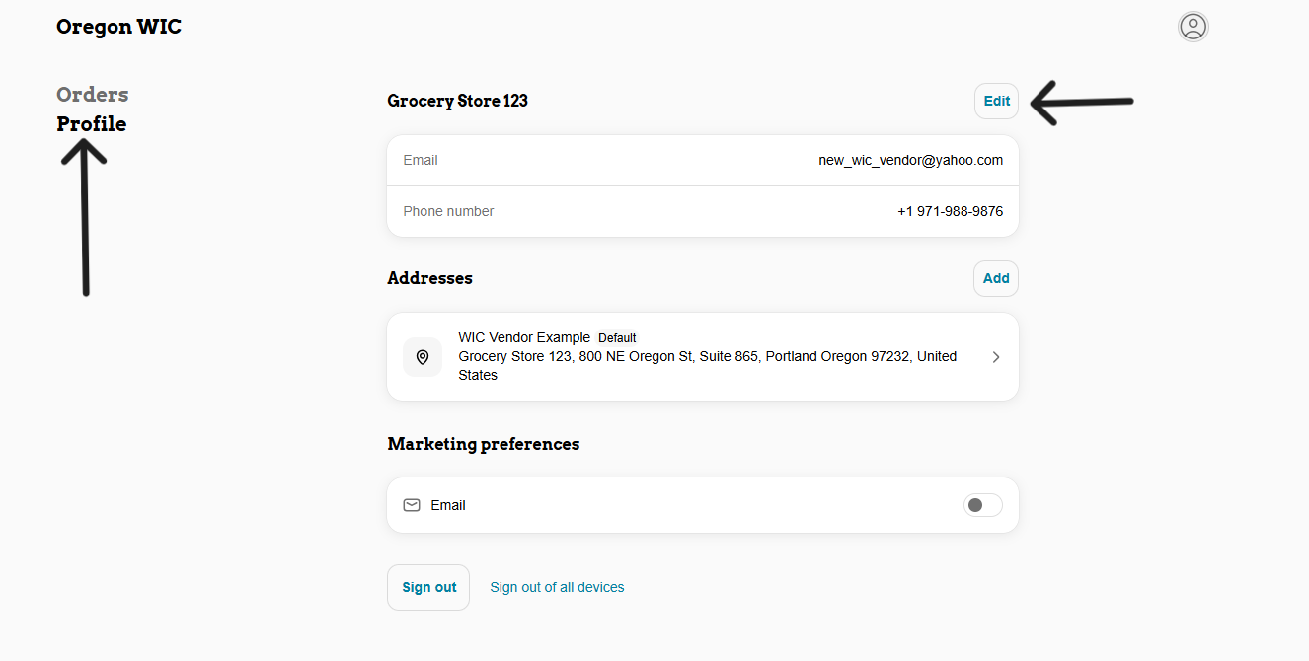
  - Then, select Edit.

  - Complete the Name fields as described below, and select Save.
    - First name: Use your grocery store name and your chain number, if applicable.
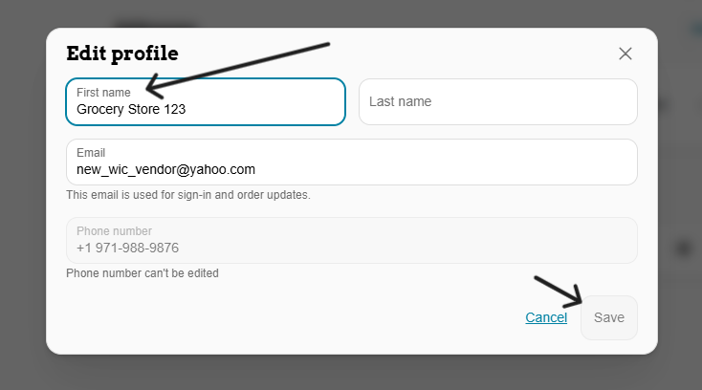
    - Last name: Leave this field blank.

Place an order

Log in to the WIC Shopify website.

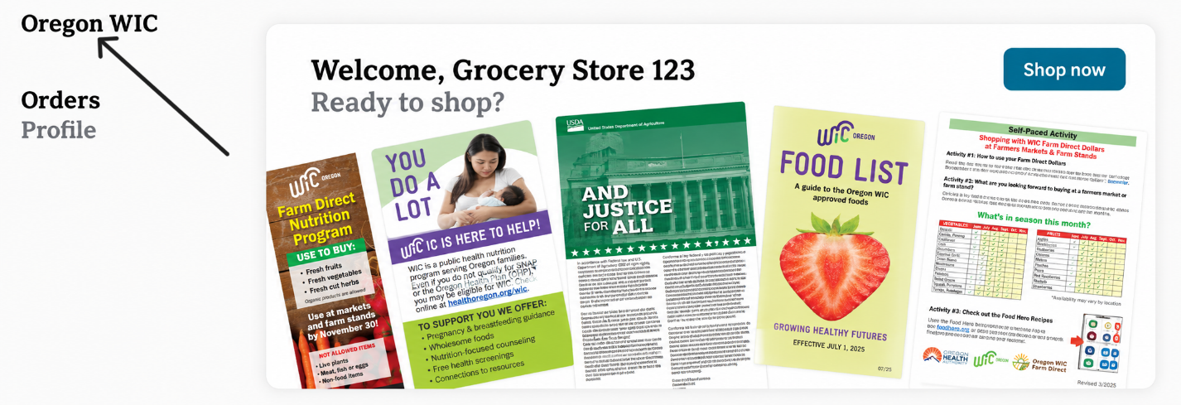
Select “Oregon WIC”.


Select “For WIC vendors”.

Select a product to view item details.

Select “Add to Cart” and enter a quantity.

Select the shopping cart to review your order and check out.

Update and review shipping information:
  - First name and Last name fields: Name of store employee who will receive the order.
  - Company: Store name
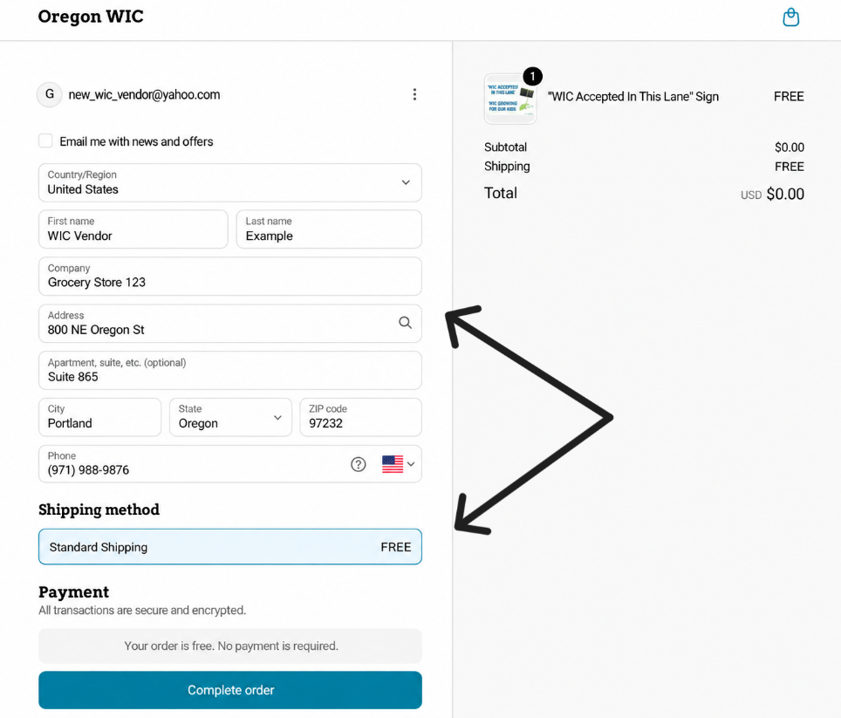
  - Address: Shipping address

Select “Complete order”.
  - You will receive an order confirmation number and a confirmation email.
Questions? Contact the Oregon WIC Vendor Team
Monday through Friday, 8 a.m. to 5 p.m. (except holidays)
WIC.VendorServices@odhsoha.oregon.gov
1-877-807-0889

