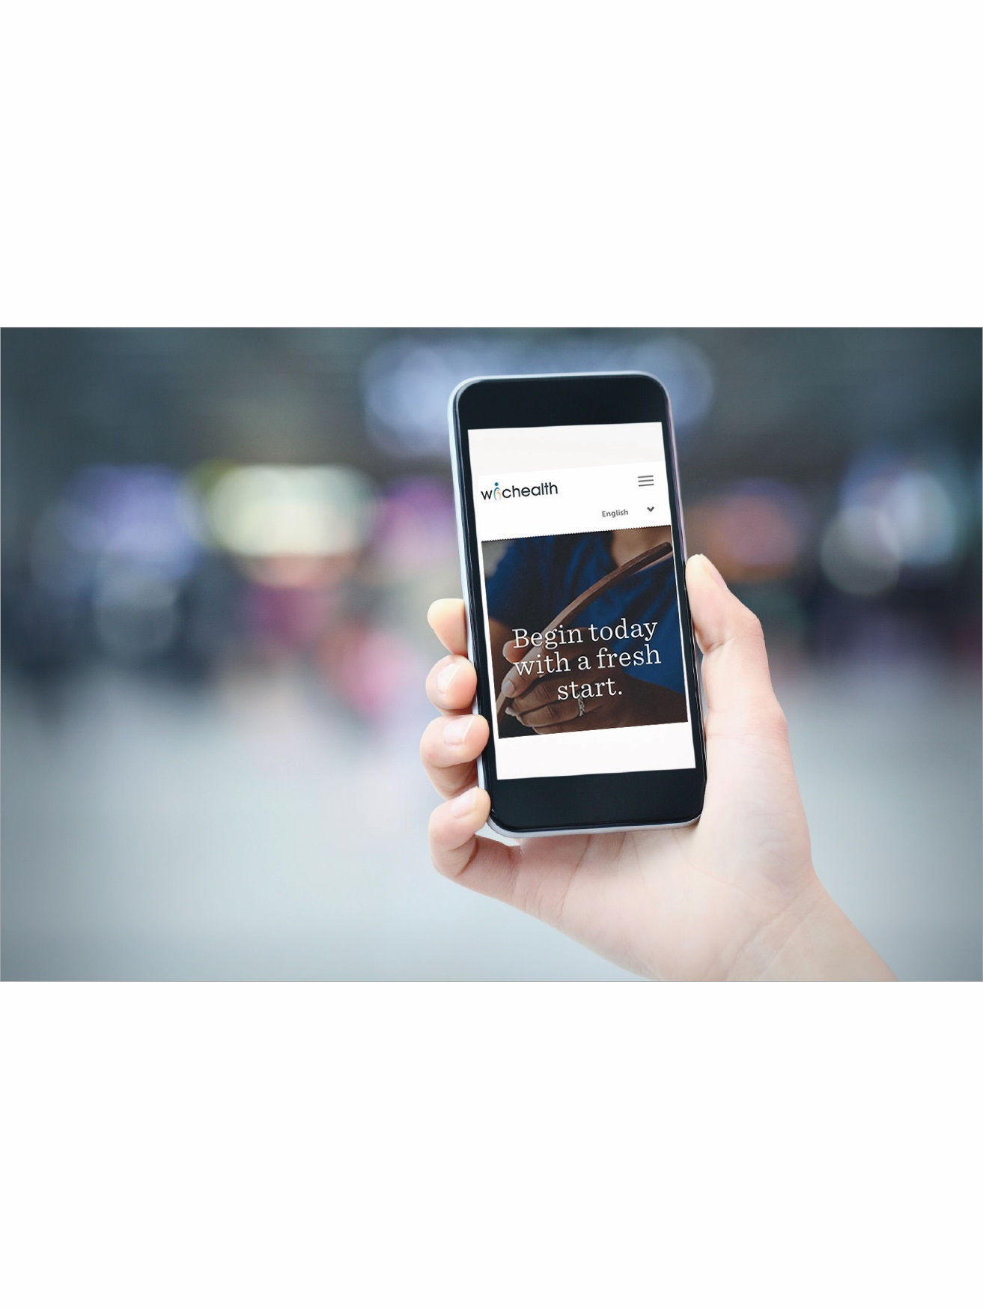

**WIC is mobile!**

**WIC is mobile!**



**Questions?** (888) 888-8888

Clinic@county.org ⦁ Mon-Fri 8:00 am – 6:30 pm

**\*First time** taking aWIChealth.orglesson? You will need:

WIC Family ID (ex: 00123456) _______________________

WIC Agency Name: WIC agency’s name on wichealth.org

**What lesson did you take?** ______________________________

**What is 1 thing you learned or plan to do differently now?** ________________________________________________________________________________________________

1. Go to **wichealth.org** and log in or sign up*
2. **Take a lesson.** We suggest ____________________
3. **Answer 2 questions** in gray box below
4. **Call us at** 888-888-8888 **in** _____________________ to get benefits issued.

**\*First time** taking aWIChealth.orglesson? You will need:

WIC Family ID (ex: 00123456) _______________________

WIC Agency Name: WIC agency’s name on wichealth.org

1. Go to **wichealth.org** and log in or sign up*
2. **Take a lesson.** We suggest ____________________
3. **Answer 2 questions** in gray box below
4. **Call us at** 888-888-8888 **in** _____________________ to get benefits issued.

**What lesson did you take?** ______________________________

**What is 1 thing you learned or plan to do differently now?** ________________________________________________________________________________________________

