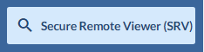
To Start: Begin by clicking the magnifying glass on the left-hand side of the page.
To access the search fields, click on the drop-down arrow in the function you want to use.
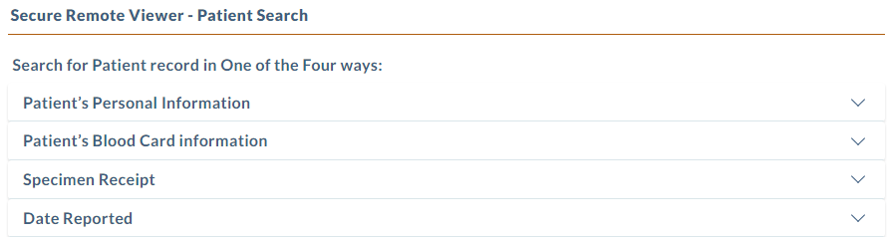
Searches
3.
2.
4.
1.
Search 1. Search for results by patient. Enter DOB and just one other field.

This section requires the use of limited search criteria and can render limited results.
- You must enter a date of birth to search in this section.
- Enter just one other field directly below the date of birth such as “parent’s first name”.
- Do not pick a state-leave this blank
- Use the asterisk key in the name field to search for any record starting with those letters. ie: Baby’s last name: Jo*
- 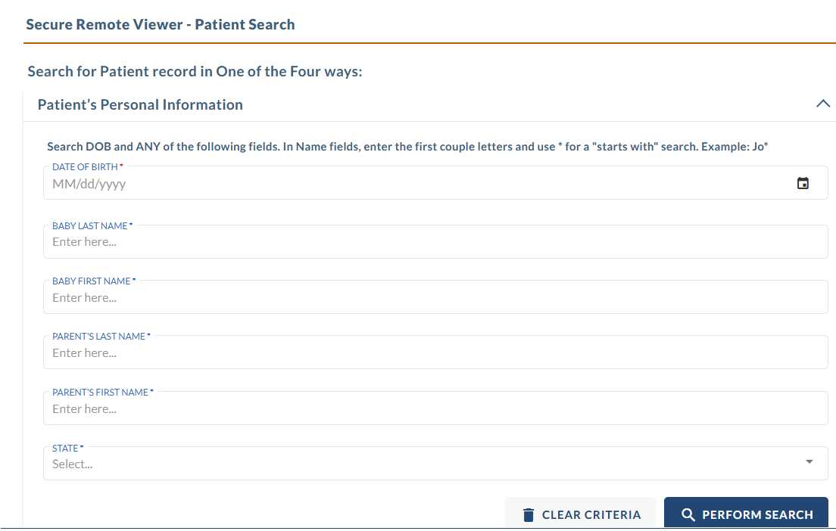
Search 2. Search for all results by patient. This is the most simple and thorough way to search. Search by only ONE of the three fields: Medical Record ID, Kit #, or Lab #.
Medical Record ID: This is what your facility wrote on the “Chart ID” field of the NBS kit. This can be inconsistent depending on how the # is written and entered into our system.
Kit #: This is the 10-digit # under the bar code on every specimen kit (also printed on the blue copy and stickers for your use). If being entered directly from the kit, omit the 1st digit, and enter only 9 digits to search.
Lab #: If you have a copy of our result, the Lab # is on the top right of the report. This number starts with the year the sample was received, ie. 2026*******
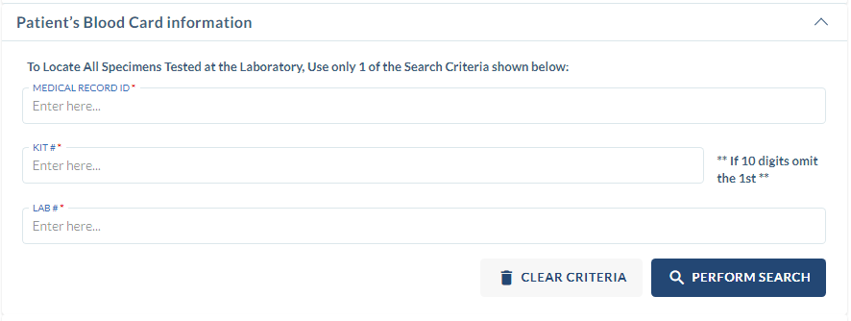
Search 3. Search for all samples collected on a specified date. This report is useful for tracking and confirming that a sample has been received at the lab.
Date Collected: This is the Specimen Date on the requisition form. The date that the dried bloodspot sample was collected.
Submitter ID #: This is your unique OSPHL ID issued for your hospital or clinic. You can find the Submitter ID # located on the right-hand side of the report check our website for a list of codes.
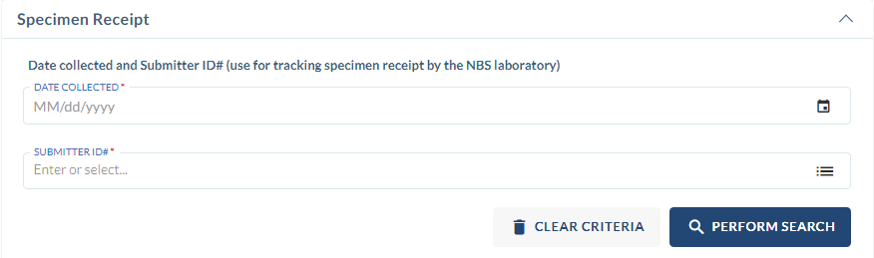

Search 4. Search for all samples reported/resulted on specified date. This report is useful for daily downloading of reports. You can view the reports available for your facility on the selected day. Reports can be downloaded individually, or you can choose to download them all at once.
Date Results Reported: This is the report date on the official results.
Submitter ID #: This is your unique OSPHL ID issued for your hospital or clinic. You can find the Submitter #: The submitter # is located on the right-hand side of the report or by calling us for assistance.
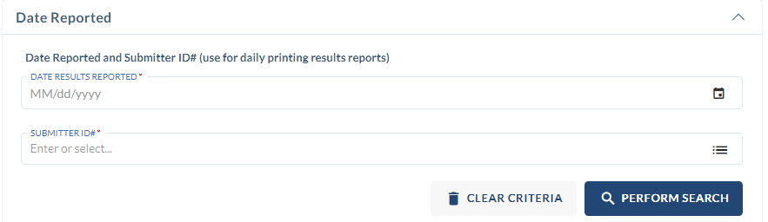

TIPS AND TRICKS
- Enter search criteria in only one section of the search functions screens. Entering criteria in more than one section (ie. Search 1 and 4 above) will lead to a failed search.
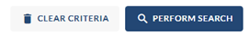
- Use the Clear Criteria button (found at the bottom of the search page) to clear the form before starting another search.

- The * sign is a variable that is useful searching, especially if you only know the partial name or are uncertain about the correct spelling. For example, to search for a last name beginning with “Geo”, please enter it as “Geo*”.
- When results are found check the box and click “View mailer” button to access the report PDF.
- Reports populate daily in the SRV after 12pm PST.
- Samples that have arrived at the lab but are not finished being tested will show a status of “PENDING” in the SRV.

For additional help please contact the Newborn Bloodspot Screening Program
- By phone: 503-693-4174
- By email: nwregional.nbs@odhsoha.oregon.gov

