

|  |  |
| --- | --- |
| Immunizations Toolkit | |
| Thank you to San Diego Immunizations for sharing their toolkit information with us. | |
|  | Please feel free to use the provided toolkit samples for your organization.  Additional Flu Immunization Toolkit Resources can be found at the [Health care worker immunization toolkit resources](http://public.health.oregon.gov/PreventionWellness/VaccinesImmunization/ImmunizationProviderResources/Pages/HCWImmToolkit.aspx) page. |
| Contributors from Oregon Health Authority/ Center For Public Health Practice :  Collette Young (Center Administrator)  Immunization Program:  Jenne McKibben (Director of ALERT IIS), Aaron Dunn (Immunizations Program Manager), Mike Day (Operations and Policy Analyst), Jeanine Whitney RN (Public Health Nurse), Anne VanCuren (Admin Support Specialist)  Acute and Communicable Diseases: Richard Leman MD (Public Health Physician)  Preparedness: Jennifer Graham (Medical Countermeasures Coordinator) | |
| Other resources available from Oregon Immunizations that you may find helpful:  <http://public.health.oregon.gov/PreventionWellness/VaccinesImmunization/ImmunizationProviderResources/Pages/provresources.aspx> | |

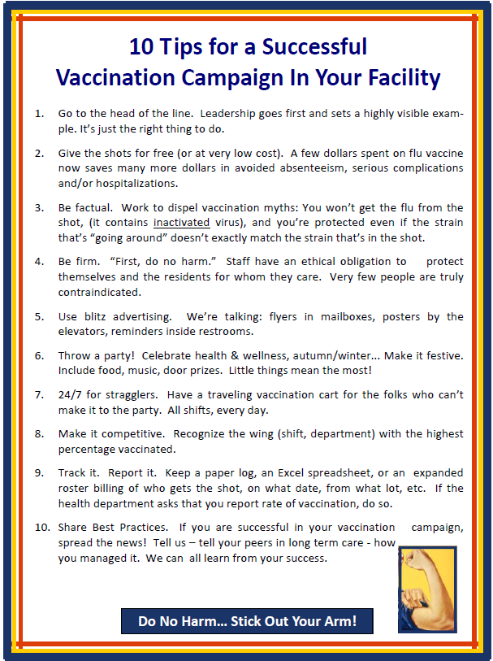

|  |
| --- |
| **It’s flu shot time again!**  **Stick out your arm on:**  **[Insert Date]**  **[Insert Location]**  **[Insert Time Frame]**  **[Additional Information]** |
| Don’t let the flu bug get you!    [Insert Facility Name Here] has officially started its flu campaign.  Please note various times and places we will be holding “FLU CLINICS”  We thank you for **STICKING OUT YOUR ARM!** |

|  |
| --- |
| **Do your part to prevent the spread of influenza.**  **You’ve Got The Time… Get the shot!**  This coupon allows you 1‐hour off to go and receive your influenza vaccine.  **Staff Name______________________________**  **Date and Time Scheduled _________________**  ***This coupon must be stamped or signed by the vaccine clinic or pharmacy and returned to your supervisor.***  **Location and vaccinator’s signature below**  **_______________________________________________________** |
| **Do your part to prevent the spread of influenza.**  **You’ve Got The Time… Get the shot!**  This coupon allows you 1‐hour off to go and receive your influenza vaccine.  **Staff Name______________________________**  **Date and Time Scheduled _________________**  ***This coupon must be stamped or signed by the vaccine clinic or pharmacy and returned to your supervisor.***  **Location and vaccinator’s signature below**  **_______________________________________________________** |
| **Do your part to prevent the spread of influenza.**  **You’ve Got The Time… Get the shot!**  This coupon allows you 1‐hour off to go and receive your influenza vaccine.  **Staff Name______________________________**  **Date and Time Scheduled _________________**  ***This coupon must be stamped or signed by the vaccine clinic or pharmacy and returned to your supervisor.***  **Location and vaccinator’s signature below**  **_______________________________________________________** |

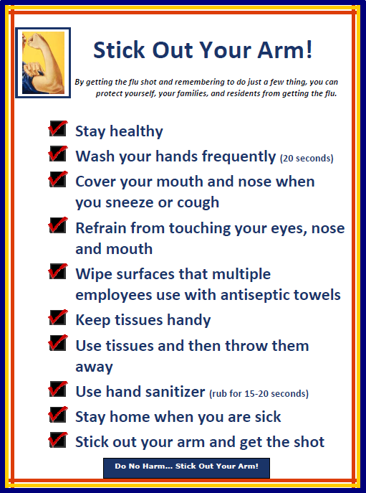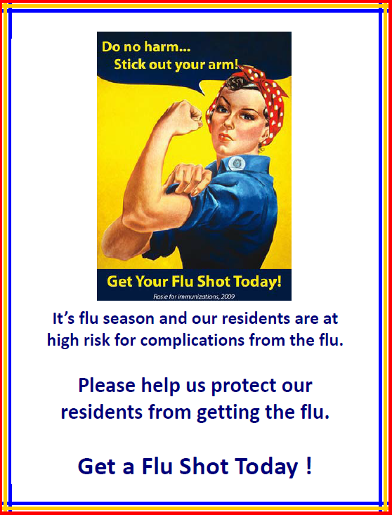

Protect Your Residents

**What can you do?**

Protect Yourself

Protect Your Family

What can you do?

You can help to stop the spread of germs by:

* Covering your mouth and nose when you sneeze or cough with your elbow or tissue
* Avoid touching your nose and eyes
* Staying home when you are sick
* Wiping surfaces that multiple employees use with antiseptic towels *(telephone receivers, keyboards, etc.)*
* Having trash cans accessible
* Washing hands frequently (20 seconds)
* Keeping tissues handy
* Using a tissue and then throwing it away
* Using hand sanitizer

*(Rubbing for at least 15-20 seconds)*



***Stick out your arm!***

# As Health Care Workers We Have a Special Obligation to Our Residents

As professionals, working in long-term care facility, we have been given the distinction of protecting our residents.

We need to be aware of what we can do to protect our elders, but also our family, and ourselves. Knowing a few simple facts about influenza and what you can do to stop the spread of germs is essential.

Sharing those facts with others can also help decrease the spread and keep your long-term care facility influenza-free this season.

**Facts about Influenza:**

* It infects the throat, lungs, and nose
* It is caused by a virus
* It is spread from person to person through respiratory droplets *(coughing and sneezing)*



**Healthy Lifestyle**

Although our lives may seem like they are busier than ever, maintaining a healthy lifestyle that includes: eating a variety of nutritious foods, drinking non-caffeinated beverages, and getting seven to eight hours of sleep, in addition to being vaccinated, can help you stay healthy and fight off the flu.

Don’t forget that exercising three times a week for 30 minutes will also aid in battling the flu.

# Vaccines Will Be Available Soon

This year [insert organization name] aims to immunize [INSERT GOAL, I.E., 75 PERCENT] of employees against influenza. Vaccination will be offered free of charge to all employees in October. To encourage participation, we will [insert details about incentives, department competition, etc. here].

** INFLUENZA (FLU) VACCINATION FORM**

**Employee Acknowledgment**

I have received information about the influenza vaccine, including its efficacy, safety and benefits and have had the opportunity to ask questions regarding the vaccine. I understand that my employer cannot require me to get a flu vaccine as terms of my employment however, they may ask that I wear a mask while providing care even if I have no symptoms of illness. I acknowledge that I attended the influenza campaign presentation and that I am aware of the following facts:

* Influenza is a serious respiratory disease that kills thousands of people in the United States each year
* Influenza vaccination is recommended for me and all other healthcare workers to protect this facility’s patients from influenza, its complications, and death
* The vaccine is provided free of cost to me
* If I am infected with influenza, I can shed the virus for 24 hours before influenza symptoms appear; my shedding the virus can spread influenza to patients in this facility who may be at risk of complications
* If I become infected with influenza, I can spread severe illness to others even when my symptoms are mild or non-existent
* I understand that the strains of virus that cause influenza infection change almost every year and, even if they don’t change, my immunity declines over time; this is why vaccination against influenza is recommended each year
* I understand that I cannot get influenza from the influenza vaccine
* The consequences of my refusing to be vaccinated could have life-threatening consequences to my health and the health of those with whom I have contact, including:
  + All patients in this healthcare facility
  + My coworkers
  + My family
  + My community

I am choosing to be vaccinated for influenza today / decline influenza vaccination today for the following reason:

 I choose to be vaccinated today

I received immunization at another site; Date________________ Location_______________________

I decline this vaccine for non-medical reasons

I decline this vaccine due to an active medical condition that contraindicates administration of the flu vaccine

I understand that I can change my mind at any time and accept influenza vaccination, if vaccine is still available. I have read and fully understand the information on this declination form.

Printed Name: _____________________________________________________________________________________________

Signature: ___________________________________________________________ Date: ___________________________

**REFERENCE**

Centers for Disease Control & Prevention. [Prevention and Control of Influenza with Vaccines: Recommendations of the Advisory Committee on Immunization Practices](http://www.cdc.gov/flu/professionals/acip/index.htm)

🛠

*Sample Letter - Staff*

The following is a sample letter for employees that LTCF administrators might consider enclosing with paychecks just prior to the facility’s vaccination campaign. Details of the campaign (date, time, location) can be inserted.

Dear [Employee],

Each year on average over 40,000 people die from vaccine-preventable influenza and pneumonia in the U.S., despite the availability of effective vaccines. Some 50-80% of these deaths could be prevented with vaccination.

You can protect yourself and our long-term care residents from flu and its complications by getting immunized each year. A flu vaccination will protect you from getting influenza and will prevent you from passing this serious illness to our most vulnerable residents. Getting immunized demonstrates your professional commitment to preserving the health of our residents.

Our goal is to increase influenza immunization rates to 90% or better this year. If you have any questions please contact _________________________________.

Thank you, as always, for making a difference!

Sincerely,

[Name]

***Do No Harm…Stick out your arm!*** 

*Sample Letter - Family*

🛠

The following is a sample letter for families that LTCF administrators might consider mailing or handing out to visitors just prior to the facility’s vaccination campaign.

Dear [Family Member],

Each year on average over 40,000 people die from vaccine-preventable influenza and pneumonia in the U.S., despite the availability of effective vaccines. Some 50-80% of these deaths—most of which occur in persons 65 years of age and older—could be prevented with timely and widespread vaccination.

You can protect your loved one from flu by making sure that you are immunized each year. A flu vaccination will protect you from getting the flu and will prevent you from passing this serious illness to our most vulnerable residents. Getting immunized against influenza demonstrates your commitment to preserving the health of your loved one.

If you do become sick with a cold or a flu virus, or any other contagious illness, we ask that you postpone your visits here until you recover. Many of our residents are frail and are at risk for severe complications from the flu and other illnesses.

Ask your employer, health plan, family doctor, or pharmacist about getting a flu shot. It’s the right thing to do!

Sincerely,

[Name]

***Do No H*** ***arm…Stick out your arm!*** 

🛠

🛠

*Sample Letter - MD*

The following is a sample letter for the LTCF medical director or other physicians involved with the facility.

Dear [Doctor],

As you are no doubt aware, each year on average over 40,000 people die from vaccine-preventable influenza and pneumonia in the U.S., despite the availability of effective vaccines. Some 50-80% of these deaths—most of which occur in persons 65 years of age and older—could be averted with vaccination.

In an effort to improve immunization coverage rates, we have set an immunization goal of 90% or better among residents and employees in our facility.

Getting vaccinated will provide a safe environment for both residents and employees. We seek your support and ask that you get vaccinated as well as encourage family members to get immunized.

Thank you, as always, for making a difference.

Sincerely,

[Name]