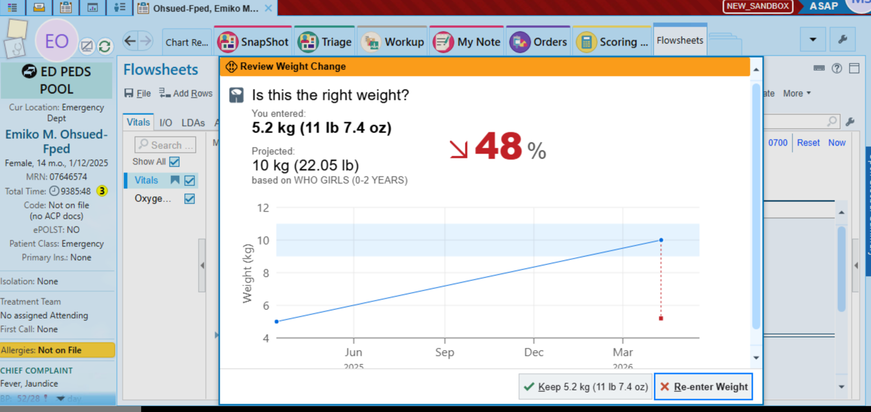
EPIC alert reminds providers when a weight might be out of range and should be double-checked prior to medication administration. This alert comes up as a weight is being inputted into the flowsheets

