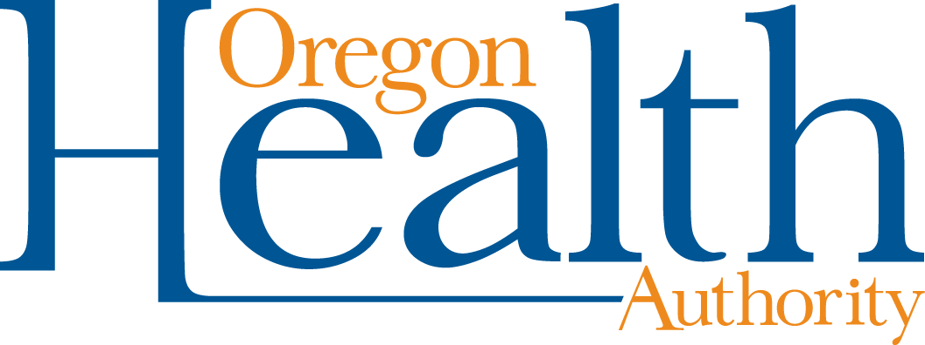

Notification: Exposure to COVID-19
Use this notification message to alert caregivers, parents, and families when their child/student has been exposed to a positive case of COVID-19
OR
to alert Staff members when they have been exposed to a positive case of COVID-19.
Dear Caregivers, Parents and Families (or staff),
Health and school officials have identified individuals at [insert school] who may have been exposed to a person with COVID-19 at school. It has been determined that your student [you] may have had close exposure to an ill person with COVID-19 symptoms/a person with a confirmed positive COVID-19 case. This does not mean that your student has COVID-19, but you may wish to take additional precautions according to your individual needs.
In consultation with the local public health department, we are taking the following action: [Describe your school’s response plan with a positive case in school, such as closing cohorts, deep cleaning classrooms and surfaces, etc.]
We ask they watch for symptoms of COVID-19 after being exposed, and if your student develops primary symptoms of COVID-19, that they isolate at home and get tested. Primary symptoms include cough, fever, shortness of breath, and loss of smell or taste. If your student has non-primary symptoms such as sore throat, headache, or fatigue, please work with the school to determine if your student should stay home.
*If your school is enrolled in the OHA Diagnostic Testing program AND your LPHA is in agreement, your school may wish to implement the new test-to-stay enhanced exposure testing protocol for students or staff at increased risk of severe COVID-19 illness. This may include students or cohorts with medically fragile individuals. Include your school protocols if applicable.
It’s important to notify us if any household members become ill with COVID-19. Additional protocols will be followed to ensure a safe return to school.
We know this is a hard time for everyone and our hearts go out to those who are ill. We will remain in contact with you to update the status of the school(s). Please check our school district webpage for updated information.
If you have questions, please contact______.
Document accessibility: For individuals with disabilities or individuals who speak a language other than English, OHA can provide information in alternate formats such as translations, large print, or braille. Contact the Health Information Center at 1-971-673-2411, 711 TTY or COVID19.LanguageAccess@dhsoha.state.or.us

