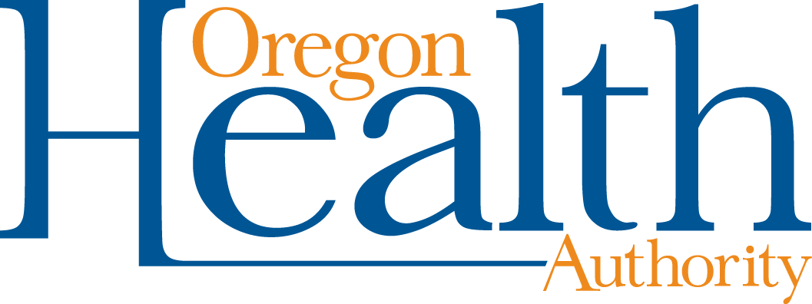

Letter to Staff, Caregivers, Parents, and Families: Case of COVID-19 in School
Dear Staff, Caregivers, Parents, and Families,
Recently, we were notified that a person in [insert school] has been diagnosed with COVID-19. As members of the school community, we understand that you might be concerned. We are working closely with [INSERT local public health authority] to respond to this news and protect the health of our community by [Describe action taken in response to the positive COVID-19 diagnosis, i.e. isolating the individual, closing cohorts, etc.]
Each situation calls for different protocols. In this case, we will conduct the following steps:
- [customize steps]
- [INSERT steps taken here. They can include – but are not limited to – explaining cohort impacts, any relevant information on staying home or testing, a deep clean of classrooms and common areas in the school, manual wiping of surfaces, and other disinfection plans.
The best way to prevent the spread of COVID-19 is by getting vaccinated if eligible, staying home when ill or exposed to someone with COVID-19, wearing face coverings, physical distancing, and practicing good health hygiene habits. Be sure to wash your hands frequently with soap and water, cover your coughs and sneezes, and avoid contact with people who have signs of illness. Get plenty of rest, exercise, and eat a healthy diet. Protect the community by following Oregon Department of Education’s Ready Schools, Safe Learners safety recommendations. Wearing cloth face coverings reduces the spread of the virus.
We will keep you updated with any new information as it comes out, while meeting the requirements to honor everyone's right to privacy.
More information can be found on the Oregon Department of Education’s Ready Schools, Safe Learners page, the Oregon Health Authority’s COVID-19 page and [INSERT district website with COVID information, if applicable]. If you have any questions, please contact [INSERT contact information].
Sincerely,

Superintendent
Document accessibility: For individuals with disabilities or individuals who speak a language other than English, OHA can provide information in alternate formats such as translations, large print, or braille. Contact the Health Information Center at 1-971-673-2411, 711 TTY or COVID19.LanguageAccess@dhsoha.state.or.us

