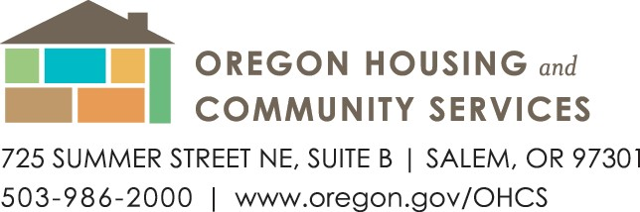

Date: October 1, 2022

To: Community Action Partnership of Oregon
Agency Directors
Energy Assistance Coordinators

From: Tim Zimmer, Assistant Director Energy Services
David Kaufman, Energy Assistance Coordinator
Lisa Goben, Senior Energy Compliance & Policy Officer

Re: Temporary Eligibility Guidelines for the
Low-Income Home Energy Assistance Program (LIHEAP)

To address the continued impacts of COVID-19 on the economy and public health, OHCS is continuing the following temporary policies applicable to the Low-Income Home Energy Assistance Program (LIHEAP).

Application Method
Applications require the applicant signature on the disclaimer. In some cases, such as when taking an application by phone, the applicant’s signature cannot be obtained. In these cases, after updating OPUS with all required information, the worker taking the application is to read the disclaimer to the applicant. If the applicant agrees the information submitted is true and accurate to the best of their knowledge, and agrees to the language in the disclaimer, intake worker will select “Signature exception” in the Payment New Screen and a note must be made in the payment comment box in OPUS explaining why the signature cannot be obtained. The workers first and last name must accompany the comment.

If a signature exception is granted, OPUS has a report available to show all signature exceptions and will allow exceptions to be rectified and removed from the report if signatures are obtained at a later date.
Required Documentation
Social Security Number (SSN) verification and income documentation are required to process applications. Every attempt should be made to obtain required documentation as outlined in the PY-21 Program Intake Operations Manual; however, not all applicants have the ability to take photos of documents, scan documents, make copies, text, use e-mail or have access to the internet. If an applicant possesses the required documentation but is unable to provide it, the worker is to accept the information verbally as a hardship case, select “documentation exception” from the income dropdown box and make a note in the payment comment box in OPUS, the reason for the hardship (e.g., elderly individual has neither the internet nor a smart phone).

If a documentation exception is granted, OPUS has a report available to easily show all documentation exceptions and will allow exceptions to be rectified and removed from the report if documents are obtained at a later date.

Utility Bills
Utility bills are requested of applicants to verify client accounts (Manual requirements regarding utility bill criteria still apply e.g., name on account, residential account etc.). If unable to obtain utility bills from applicants, agencies are to use utility portals, or contact the utility directly to verify information via a Utility Verification Form (UVF) as appropriate.

Maximum Crisis Payment Amount
The maximum payment amount for year-round crisis assistance will be unchanged at $750.
(See page 4.2 in the 2021manual.)

All other manual requirements as outlined in the 2023 intake operations manual apply. Please contact OHCS directly if you have any questions/concerns about applying these temporary policies, or any existing policies, so that we may work through them together and also identify other areas of potential concern. None of us can possibly anticipate every eventuality and we need your help to compile a comprehensive (and useful) resource for the entire network.

