EXHIBIT G

LOAN RESERVATION CHECKLIST
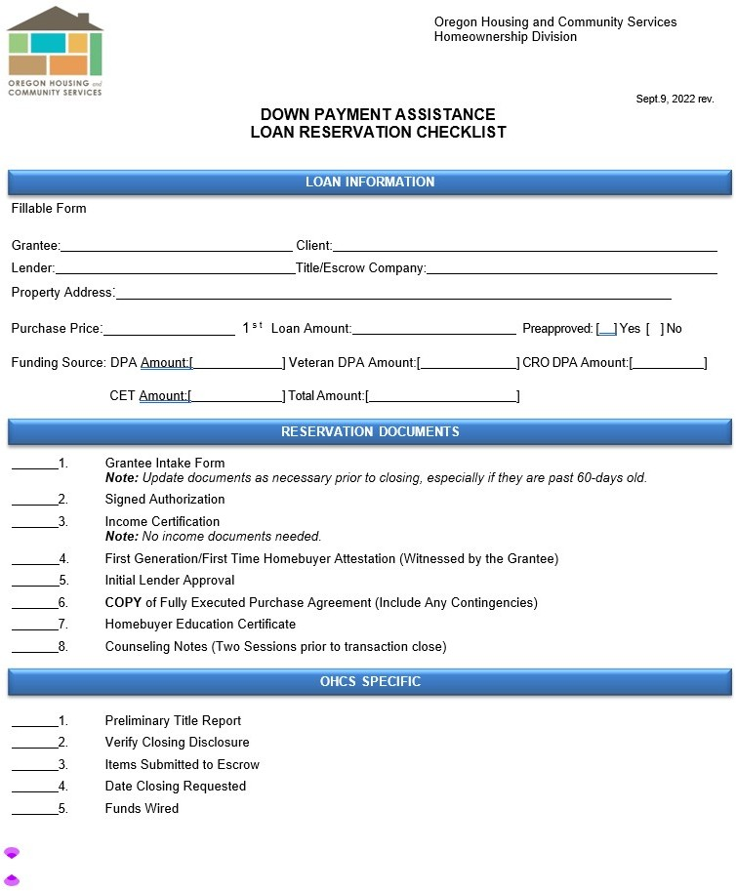

Grant Agreement #7279, HOAP DPA Grant Agreement Page 43 of 47 (PCS AM) RFA #7279

