ATTACHMENT B
RFA #7344
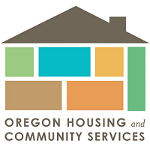
Homeownership Language Access and Targeted Outreach Checklist

RFA Requirements
Complete the RFA Application and Certification Sheet (Attachment A)

Response to the Round 1 Evaluation Criteria (See Section 4.10.3 for reference)
Authorized Representation to sign Application (see RFA section 3.2.3)
Submit Application prior to closing date via email to ohcs.contracts@hcs.oregon.gov and reference the RFA number 7344 in the email subject line (see RFA section 3.22 for reference)
Complete and Submit Attachment H – Disclosure Exemption Affidavit

For questions related to the RFA process or any technical or contractual requirements of the RFA, please email the Single Point of Contact (SPC) for this RFA, Lisa Cimino, at ohcs.contracts@hcs.oregon.gov and reference the RFA number 7344 in the email subject line.

