ATTACHMENT C APPLICANT INFORMATION AND CERTIFICATION SHEET

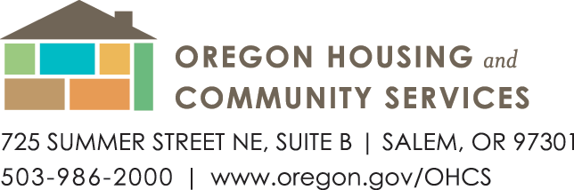
RFA #7365
Homeownership Support Services
Application
(Fillable form)

Applicant Name:
Applicant Address:
Contact Name:
Contact Email:
Contact Phone:
Tax ID:
Authorized Representative: Email:
Secretary of State Business Registry: (If Not Applicable: Explain or put N/A)

- Select Applicant’s Eligible Organization type:
Non-profit Organization Housing Authority Local Government Federally Recognized Indian Tribe

- Does Applicant sponsor and manage homeownership programs?
Select “Yes” or “No”.
Yes – Applicant sponsors and manages Low-Income homeownership programs
No – Applicant does not

- Does Applicant serve Low-Income homeowners?
Yes – Applicant serves Low-Income homeowners
No – Applicant does not

- Funding Request - Enter desired amount of funds requested. Total maximum funding request is not to exceed $300,000.00 per Eligible Organization in all four (4) categories per the RFA requirements.
- Applicant is requesting $ for technology and software. Technology expenses exceeding $2,500 in total, require preauthorization with supporting documents from Agency.
Click here to enter list of purchased or to be purchased items in this category. Please include the cost and/or estimated cost of items to be purchased

- Applicant is requesting $ for Operational Capacity Building Support.
Click here to enter list of purchased or to be purchased items in this category. Please include the cost and/or estimated cost of items to be purchased.

- Applicant is requesting $ for additional expenses related to the COVID-19 pandemic.
Click here to enter list of purchased or to be purchased items in this category. Please include the cost and/ or estimated cost of items to be purchased.

- Applicant is requesting $ for expansion to Unserved and Underserved populations.
Click here to enter list of purchased or to be purchased items in this category. Please include the cost and/or estimated cost of items to be purchased.

Eligible and approved goods or services must be purchased and received between March 1, 2022, and June 30, 2023.

- Certification:

Applicant: I hereby certify and affirm that I have reviewed the RFA material, any addenda, and understand only specific RFA activities (eligible and approved purchases or services) are authorized upon acceptance of an Agency-approved Application (in whole, part, or as negotiated and approved by Agency) and executed Agreement. An authorized representative may sign the Agreement electronically.

Authorized Representative Signature: ______________________________ Date: _________
Director or designee

Printed name and title of signer: __________________________________________________________

For Agency Use

Date Received: __________ Received by: _________ Amount Approved: _________
Approved Date: __________ Approved by: _________ Reason for denial: _________
Denied: __________ Denied by: _________

