Occupant Impact Statement
Project Name: OMD Anderson Readiness Center
Project Address: 3225 State Street, Salem, OR 97309
OMD Project Number: 209996D001
Date: May 8, 2023 through July 3, 2023
Point Of Contact: Dan Loreto
Construction Work Hours
Ausland Group proposes the following work schedule for the Construction of New Sidewalk and Concrete ADA-Compliant Turnout as part of AREA ‘E’ on the dates referred to above
- Work hours for Area E will be M - F: 7:00 AM to 3:30 PM
- No nighttime or weekend work is planned
- The work is anticipated to begin Monday, May 8, 2023.
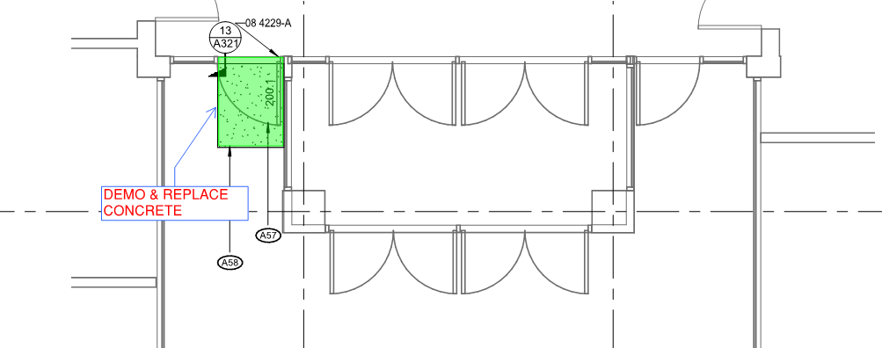

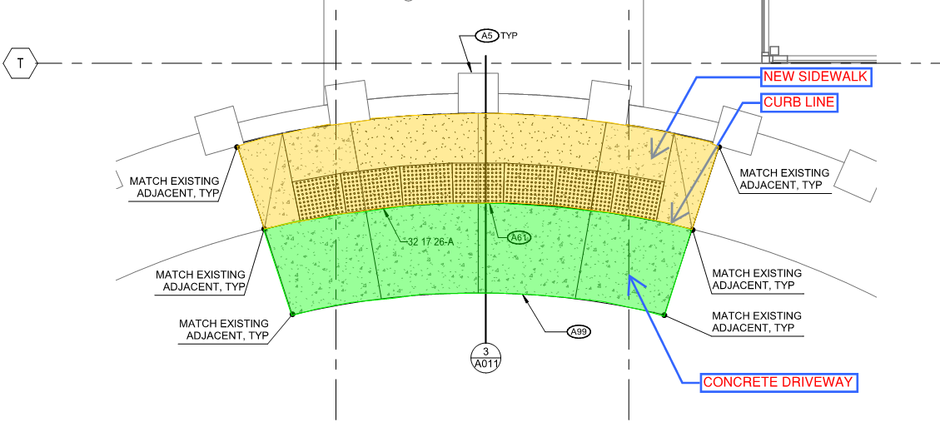
South Entrance of Anderson Readiness Center

Concrete Turnout and South Entrance Door
work will consist of sawcutting affected highlighted areas and removing existing concrete, preparing subgrade, placing reinforcing steel, and replacing concrete at sidewalk and turnout with ADA-compliant truncated dome panels. During construction, it is not anticipated any material will be disturbed which hasn’t already been disturbed from previous construction activities. Ausland Group will coordinate with OMD to make sure a Historical Preservation Representative is available during demolition and excavation activities to confirm and verify no historically significant findings are identified at the site of work. In the event there are items of significance identified, work will stop immediately until the proper actions ca be taken to remedy the situation.
The door and threshold will need to be temporarily removed to replace damaged concrete. Ausland intends to board up the opening while the concrete work in front of the door is completed. Once the concrete has cured sufficiently, the threshold will be reattached, the door reinstalled, and returned to normal operation.

Impact To Occupants
The impacts to building occupants include the use of alternate access to OMD while the concrete driveway is removed, replaced, and properly cured. Every attempt will be made to ensure alternate access points are available at the East and West entrances and free from obstructions.
During demolition activities, there may be temporary traffic restrictions. Traffic cones will delineate the area of reduced flow which should be primarily relegated to the area in front the turnout. This impact is expected to last for only two (2) days.
Ensuring minimum concrete strength has been achieved will impact use of the concrete turnout. As soon as we can confirm the concrete has achieved the required compressive strength, the turnout will be turned over for normal use.
Work Area Impact
Ausland Group anticipates that impacts will be typical of “minor “construction work. Noise and dust on the exterior of the building will be present. Ausland Group will take appropriate measures to reduce dust created during sawcutting and concrete demolition activities. Noise will include the use of pneumatic and power-operated equipment, transportation vehicles delivering material, and any power tools and equipment used during construction activities.

Odor Mitigation none anticipated
Portable Facilities: none anticipated
Material Storage Containers: none anticipated
Work Safety Zone: as identified on the drawings.

