Occupant Impact Statement
Project Name: OMD Owen Summers Building
Project Address: 1776 Militia Way SE, Salem, OR 97301
OMD Project Number: 209996D001
Date: April 21, 2023
Point Of Contact: Dan Loreto
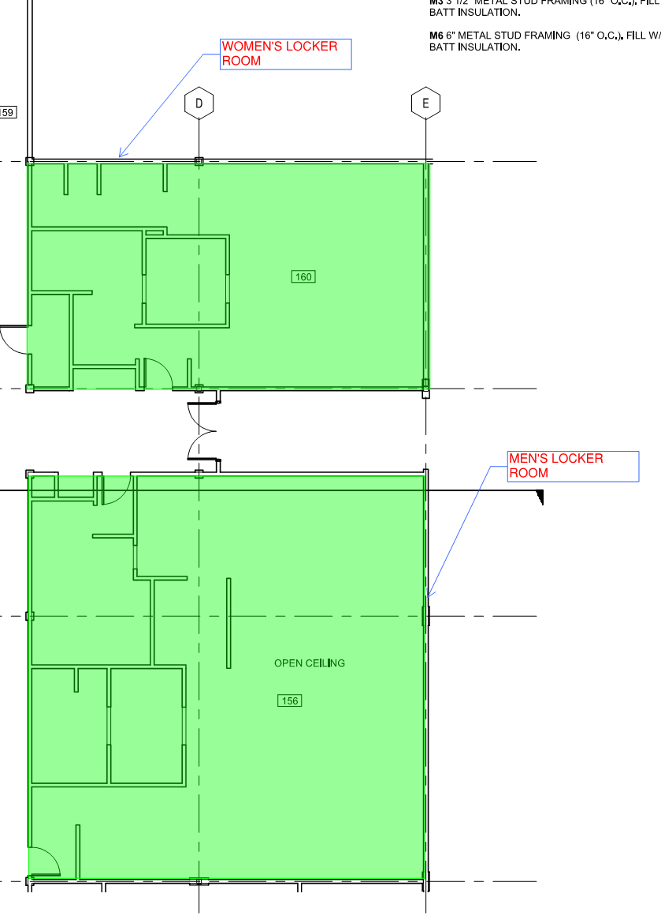
Construction Work Hours
Ausland Group proposes the following work schedule for the construction of AREA ‘A2’ on the dates referred to above
- The work will begin on April 21, 2023 starting at 10:00 AM and is expected to take no more than 8 hours.
- No nighttime or weekend work is planned

The sequence of construction activities for the duration of Area A2 will be as follows:
- Shut off water in boiler room;
- Cut and cap hot and cold water supply lines in Men’s Locker Room;
- Restore water to affected areas;
- Demo remaining plumbing in Room 158C to prepare for wall closure where previous sink had been removed.
Impact To Occupants
The impacts to occupants should be minimal. Once the plumbing has been capped off, water can be restored to the Men’s and Women’s Locker Rooms for use. Ausland Group will immediately inform OMD when water has been restored and tenants are able to use facilities again.
Work Area Impact
Ausland Group anticipates that impact will be typical of “minor “construction work.

Odor Mitigation none anticipated
Portable Facilities: none anticipated
Material Storage Containers: none anticipated
Work Safety Zone: To be confined to the work areas as identified on the drawing provided above.

