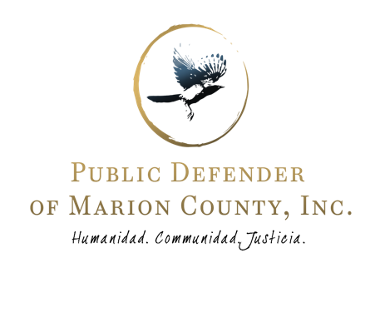
Executive Director  Shannon I. Wilson |  | Assistant Executive Director  Ben Goldberg  Deputy Director  Aaron Jeffers
www.pdmarion.org
503-480-0521

Culture of the Organization: The Public Defender of Marion County (PDMC) strives to provide legal representation using the holistic defense model.
- In a profession that leads to early burn out, we prioritize the wellbeing of our employees and their families.
- We offer a flexible work from home/work from office balance for our attorneys.
- We operate using a modern case management system providing our attorneys with maximum support in managing their day-to-day workload.
- We train monthly as an organization in Justice, Equity, Diversity, and Inclusion and are committed to antiracist work.
- The community at PDMC is strongly rooted in equity and compassion.

Ethical Workloads: We strive to provide high quality representation; within workable levels based on the Sixth Amendment study and the ABA Workload study.
- We refuse to participate in unethical public defense practices and only agree to handle matters where we can guarantee constitutionally sound representation.
- This requires a healthy team atmosphere, and transparency. Mindful communication is necessary to analyze attorney’s workload levels on a weekly basis.

Practice Qualifications: PDMC is hiring attorneys for misdemeanor and lesser felony qualified defense representation.
- Similarly experienced out-of-state attorneys may be eligible for reciprocity through the Oregon State Bar.
- Standards for representation misdemeanor cases are available at the Office of Public Defense Services website.
- Preference given to bilingual candidates, approximately 35% of our clients are Spanish speaking.
- For applicants looking to relocate to Marion County, Oregon, assistance with relocation costs and support with OSB reciprocity process are available for hired applicants.
Salary and Benefits: Salary is commensurate with qualifications and experience.
- Salary range starts at $69,000 per year for Misdemeanor Attorneys & $73,000 per year for Lesser Felony Attorneys.
- 5% pay differential given to candidates fluent in the Spanish language.
- Generous employee benefits package, 100% employer paid health and dental insurance, paid vacation, sick and personal time off, a 401(k) plan with a 5% annual contribution and a matching contribution of up to 5% of payroll.

Submitting Applications: Please apply by sending a cover letter, resume, and 3 professional references to: aneal@pdmarion.org and list "Misdemeanor Attorney Position" in the subject field.

