June 13, 2019

[AGENCY ADDRESS]
Re: Request Regarding S.S.I.
Care & Protection of [CHILD]
Docket No [DOCKET NO.]

Dear [AREA PROGRAM MANAGER],

I hope this letter finds you well. As you know, I represent Mr. [FATHER], the [CHILD]'s father. [FATHER] is requesting that the Department of Children & Families return the designation of Representative Payee for [CHILD]'s Social Security/Disability benefits to the [CHILD]'s mother, Ms. [MOTHER].

As I am sure you are aware, the Department has discretion whether to take over social security payments from a representative payee parent if that parent’s child enters substitute care (110 C.M.R. § 4.09(1)(b)). The Department can allow a non-custodial parent to continue on as the Representative Payee when that parent’s gross income is at or below 150% of the federal poverty level (110 C.M.R. § 4.09(1)(a)). That is what [FATHER] is asking the Department to do, here.

The Social Security Administration’s (SSA) own stated preference for paying benefits to a non-custodian parent over an institution such as the Department is also instructive. In selecting a representative payee for an entitled child, the primary concern of the SSA is “to select the payee who will best serve the beneficiary's interest.” 20 C.F.R. § 404.2021. Under 20 C.F.R. § 404.2021(c), the SSA’s order of preference for selecting a Representative Payee is as follows:

(1) A natural or adoptive parent who has custody of the beneficiary, or a guardian;

(2) A natural or adoptive parent who does not have custody of the beneficiary, but is contributing toward the beneficiary's support and is demonstrating strong concern for the beneficiary's well being;

(3) A natural or adoptive parent who does not have custody of the beneficiary and is not contributing toward his or her support but is demonstrating strong concern for the beneficiary's well being;

(4) A relative or stepparent who has custody of the beneficiary;

(5) A relative who does not have custody of the beneficiary but is contributing toward the beneficiary's support and is demonstrating concern for the beneficiary's well being;

(6) A relative or close friend who does not have custody of the beneficiary but is demonstrating concern for the beneficiary's well being; and

(7) An authorized social agency or custodial institution.

20 C.F.R. § 404.2021(c) (emphasis added). As you can see, the SSA has articulated a strong preference in maintaining a natural parent as an eligible child’s Representative Payee, even a parent who does not have custody of his or her child.

In addition to these considerations, there is the Department’s ongoing obligation to make reasonable efforts to make it possible for children in its care to return safely to their parent. Care and Protection of Walt, 478 Mass. 212, 221 (2017), citing M.G.L. c. 119, § 29C.

[INDIVIDUALIZED FACTS RE: FAMILY’S FINANCIAL STATUS]

[FATHER] therefore requests that the Department exercise its discretion—pursuant to 110 C.M.R. § 4.09(1)(a)—by asking the SSA to reappoint [MOTHER] as [CHILD]'s representative payee. [FATHER] would be open to any other suggestions or approaches as outlined under that same regulation (e.g., having parents give DCF a proportion of the monthly payment). Should the Department want more details regarding [FATHER]’s and [MOTHER]'s income and expenses, or has any other questions, my client would be happy to have a meeting at which we can discuss these matters. Please include either the social worker on [FATHER]' legal team or [FATHER]’s counsel at any such meetings.

As I am sure you can appreciate, this is a time-sensitive request: rent comes due on the first day of each month, and other living expenses continue to accrue while these parents work towards reunification. I therefore will bring the matter before the Court if I have not received a response to this request by June 27, 2019.

I thank you for your time and attention to this critically important matter and look forward to receiving your response.

Sincerely,

Emily Herder
Staff Attorney

Cc (email): [DCF COUNSEL]
[CHILD'S COUNSEL]
[MOTHER'S COUNSEL]

Cc (first class): Mr. [FATHER]

COMMONWEALTH OF MASSACHUSETTS

[COUNTY], ss JUVENILE COURT
XXXXXXXX DIVISION

DOCKET NO. [DOCKET NO]

)
IN RE: Care and Protection of ) JOINT MOTION FOR ORDER
[CHILD] [LAST NAME] ) REQUIRING DCF TO RETURN SSI
) PAYMENTS TO MOTHER
)

NOW COMES the Child, [CHILD] [LAST NAME] (hereinafter "[CHILD]" or "Child"), Ms. [MOTHER] [LAST NAME] (hereinafter "Mother" or "Ms. [LAST NAME]"), and [CHILD] [LAST NAME], Jr. (hereinafter "Father" or "Mr. [LAST NAME]"), in the above-captioned matter, and respectfully requests that this Honorable Court order the Department of Children and Families (hereinafter "DCF" or "Department") to submit an application to the Social Security Administration ("SSA") requesting that Mother be reappointed as [CHILD]' Representative Payee. As grounds therefore, Child, Mother, and Father state as follows:

- [CHILD] has been in the temporary custody of DCF since this matter was filed on or about [FILING DATE].

- Prior to [CHILD]' removal in March 2019, this family made ends meet by combining [INDIVIDUALIZED FACTS] with the SSI payments Ms. [LAST NAME] received on behalf of [CHILD] (approximately $700 per month), who has special medical needs.

- On June 13, 2019, Mr. [LAST NAME] asked DCF if it would apply to the SSA to have Ms. [LAST NAME] reappointed as [CHILD]' representative payee so that she can maintain their family home (Mother and Father are currently in a relationship and cohabitating), vehicle, and other critical necessities that must remain in place in order to support reunification. (Exhibit A)

- On July 3, 2019, the DCF supervisor assigned to this family, [DCF SUPERVISOR], stated that, after discussing the request with the Area Director, the Department would not support Ms. [LAST NAME] being reappointed as [CHILD]' representative payee because:

  - Child is not going home in the next four months;
  - Child is in a specialized foster home with a specialized foster care payment rate higher than the regular foster care rate; and
  - The money is not the only barrier to reunification.

- The goal for [CHILD] is reunification.

- Without the continued SSI payments, this family is at risk of losing the family's home.

- Since the Department assumed representative payee status, Mother and Father, no longer able to afford their monthly motor vehicle and insurance payments, lost their vehicle, which is (and has been) critical to their ability to attend [CHILD]' medical appointments in Boston and, upon reunification, will be necessary to bring [CHILD] to these appointments.

- [INDIVIDUALIZED FACTS]

- Mother and Father also risk losing their cell phones, which are also critical to their ability to schedule and follow through with appointments with service providers and the Department.

- Mother, Father, and Child are asking for the Court to help this family by making an order directing DCF to apply through the SSA for Ms. [LAST NAME] to be reappointed as [CHILD]' representative payee.

- The Court is authorized to make this order on the basis that the Department has abused its discretion—which the Department has done in this case.

- The Court is furthermore empowered to make specific orders in light of the Department’s failure to make reasonable efforts by depriving this family of essential financial resources.

- The full extent of these arguments are outlined in the Memorandum of Law In Support of Joint Motion for Order Requiring DCF to Return SSI Payments to Mother, filed concurrently with this Motion.

WHEREFORE, Mother, Father, and Child hereby respectfully request that the Court:
- Enter an order requiring the Department of Children and Families to undertake all necessary steps to have representative payee status of [CHILD] returned to Ms. [LAST NAME], as outlined in the PROPOSED ORDER; and,
- Grant such other and further relief as this Court deems just and proper.
Dated: Respectfully Submitted,
[FATHER] [LAST NAME], Father
[CHILD] [LAST NAME], Child By His Attorney
By His Attorney

______________________ ________________________________________
Child’s Counsel EMILY HERDER, BBO NO. 691430
Committee for Public Counsel Services
[MOTHER] [LAST NAME], Mother Children and Family Law Division
By Her Attorney 184 North Street, Suite 301A
Pittsfield, MA 01201-5189
_______________________ eherder@publiccounsel.net
Mother’s Counsel (413) 442-0052
COMMONWEALTH OF MASSACHUSETTS

[COUNTY], ss JUVENILE COURT
XXXXXXXX DIVISION

DOCKET NO. [DOCKET NO]

)
IN RE: Care and Protection of ) JOINT MOTION FOR ORDER
[CHILD] [LAST NAME] ) REQUIRING DCF TO RETURN SSI
) PAYMENTS TO MOTHER
)
)

Affidavit of [FATHER]

I, [FATHER], hereby swear and affirm the following is true, to the best of my knowledge:

- I am the father of [CHILD] [LAST NAME]. [CHILD]' mother is [MOTHER] [LAST NAME], who I live with.

- [CHILD] has been in the temporary custody of the Department of Children and Families since on or about [FILING DATE].

- Prior to [CHILD]' removal in March 2019, my family made ends meet with the SSI payments Ms. [LAST NAME] received on behalf of [CHILD] (approximately $700 per month), who requires specialized medical care.

- [INDIVIDUALIZED FACTS]

- On June 13, 2019, I asked DCF, through my lawyer, if it would apply to the SSA to have Ms. [LAST NAME] reappointed as [CHILD]' representative payee so that she can maintain our family home (we are currently in a relationship and living together), vehicle, and other critical necessities that must remain in place in order to support reunification. (Exhibit A)

- The current goal for [CHILD] is reunification.

- I am trying to engage in services, but it is made more difficult by the economic challenges which have come up after DCF took over representative payee status for [CHILD].

- Without the continued SSI payments, my family is at risk of losing our home; [CHILD]' home.

- Ms. [LAST NAME] and I are in arrears on our electric bill and are at risk of losing our cell phones if we cannot continue to make cell phone payments. Our cell phones are also critical to our ability to schedule and follow through with appointments with service providers and the Department.

Signed by me this _____ day of _____________, 2019, under the penalties of perjury.

_________________________________
[FATHER] [LAST NAME]

EXHIBIT A

LETTER TO DCF REQUESTING SSI

COMMONWEALTH OF MASSACHUSETTS

[COUNTY], ss JUVENILE COURT
XXXXXX DIVISION

DOCKET NO. XXXXXXX

)
IN RE: Care and Protection of )
[CHILD] )
)
)

PROPOSED FINDINGS AND ORDER

AFTER REVIEW AND CONSIDERATION of the testimony offered in hearing conducted on [HEARING DATE], the Court hereby finds that the decision of Department of Children and Families (hereinafter "Department") to remain as Representative Payee for Social Security Income benefits received by [CHILD] is both arbitrary and capricious as well as inconsistent with the reasonable efforts necessary to reunify [CHILD] with his parents, [MOTHER] and [FATHER].

Prior to coming into the custody of the Department, [CHILD] was found eligible to receive Social Security, and was receiving that income via [HIS/HER/THEIR] Representative Payee, [MOTHER]. At this time, the Department's goal is to reunify [CHILD] with [HIS/HER/THEIR] parent[s]. While a reunification date has not been set, the parents' ability to maintain all elements of a household for him to be returned to is an essential element to the reunification plan.

THEREFORE, it is ORDERED as follows:

- The Department shall in no way interfere with [MOTHER]'S receipt of the Social Security Disability Income to which [CHILD] is entitled going forward, without further order of the Court.

- The Department is not entitled to any balance of SSI owed to [CHILD]'s representative payee by the Social Security Administration (hereinafter "SSA") since [C&P FILING DATE], the filing date of this matter.

- As such, the Department shall promptly petition the SSA to resume [MOTHER]’s designation of [CHILD]'s Representative Payee; request the SSA pay any balance of unpaid SSI, dating back to [C&P FILING DATE], to [MOTHER]; and shall file a copy of said petition with the Court upon its submission.

_______________________ __________________________________
Date Associate Justice of the Juvenile Court
COMMONWEALTH OF MASSACHUSETTS

[COUNTY], ss JUVENILE COURT
XXXXXXXXXXX DIVISION

DOCKET NO. [DOCKET NO]

)
IN RE: Care and Protection of )
[CHILD] [LAST NAME] )
)
)
)

MEMORANDUM OF LAW IN SUPPORT OF JOINT MOTION FOR ORDER REQUIRING DCF TO RETURN SSI PAYMENTS TO MOTHER

- STATEMENT OF FACTS AND PROCEDURAL HISTORY

(See JOINT MOTION FOR ORDER REQUIRING DCF TO RETURN SSI PAYMENTS TO MOTHER)

- LAW

As an arm of the executive branch of government, the Department of Children and Families ("DCF" or "Department") has broad authority in how it carries out its duties. As such, this court has limited authority to order the Department in how to perform its functions. Article 30, Massachusetts Declaration of Rights. However, a judge may order an administrative agency such as DCF to act in accordance with the law. See Attorney General v. Sheriff of Suffolk County, 394 Mass. 624, 629-30 (1985). “Only when, at the time a judicial order is entered, there is but one way in which that obligation may properly by fulfilled, is a judge warranted in telling a public agency precisely how it must fulfill its legal obligation.” In re McKnight, 406 Mass. 787, 792 (1990) (citations omitted).

As such, the court—in reviewing a discretionary decision by the Department—must review the decision in light of whether the decision is arbitrary or capricious. In applying this standard, the Supreme Judicial Court instructs the trial court judge to consider, among other factors: (1) whether the action unduly interferes with the goal of reuniting a child with his or her biological parents; (2) whether appropriate consideration has been given to maintaining connections among siblings and other family members; and (3) whether the Department has complied with its own regulations. Care and Protection of Isaac, 419 Mass. 602, 614 (1985).

In light of the Supreme Judicial Court's recent decision in Care and Protection of Walt, the trial court arguably has the authority to enter remedial orders where the Department has breached its duty to support reunification. See Care and Protection of Walt, 478 Mass. 212, 221 (2017) (holding that the trial court has equitable authority to enter remedial orders where the Department has failed to make reasonable efforts to avoid an initial removal of children from their natural parent(s)). The Department is obligated to make “reasonable efforts to make it possible for the child to return safely to his parent[.]” G.L. c. 119, § 29C; Walt, at 221. In the context of federal legislation, part of the rationale behind this requirement is “[to] protect children and families against unwarranted removal of children from their homes. . . .” H. Rep. 96–136, 96th Cong., 1st. Sess. (1979). The policy of the Commonwealth is first and foremost to direct efforts towards strengthening and encouraging family life. G.L. c. 119, § 1. Substitute care is only intended as a last resort, when “the family itself or the resources available to the family are unable to provide the necessary care and protection to insure the rights of any child to sound health and normal physical, mental, spiritual and moral development.” Id.
With respect to the Department’s own regulations, 110 C.M.R. § 4.09 governs the Department’s actions with regard to assuming representative payee status for children in its court-ordered custody. (Exhibit A, 110 C.M.R. § 4.09) Under 110 C.M.R. § 4.09(1)(a), the Department may allow a non-custodial parent to remain as their children’s representative payee and either (a) pay the Department 75% of the benefits in which they are in receipt; or, (b) the Department may take 0% of the benefits from that non-custodial parent where such parent’s income is at or below 150% of the federal poverty level. In deciding whether a parent’s income meets this threshold, “Supplemental Security Income (SSI) . . . will not be used in calculating gross income.” 110 C.M.R. § 4.08A(1)(a) (emphasis added). Exhibit C.

Significantly, the SSA shows preference for continued representative payee status for non-custodial parents over an agency such as DCF. In selecting a representative payee for an entitled child, the primary concern of the SSA is “to select the payee who will best serve the beneficiary's interest.” 20 C.F.R. § 404.2021. Under 20 C.F.R. § 404.2021(c), the SSA’s order of preference for selecting a Representative Payee is as follows:

(1) A natural or adoptive parent who has custody of the beneficiary, or a guardian;

(2) A natural or adoptive parent who does not have custody of the beneficiary, but is contributing toward the beneficiary's support and is demonstrating strong concern for the beneficiary's well being;

(3) A natural or adoptive parent who does not have custody of the beneficiary and is not contributing toward his or her support but is demonstrating strong concern for the beneficiary's well being;

(4) A relative or stepparent who has custody of the beneficiary;

(5) A relative who does not have custody of the beneficiary but is contributing toward the beneficiary's support and is demonstrating concern for the beneficiary's well being;

(6) A relative or close friend who does not have custody of the beneficiary but is demonstrating concern for the beneficiary's well being; and

(7) An authorized social agency or custodial institution.

20 C.F.R. § 404.2021(c) (emphasis added).

C. ARGUMENT

I. THE DEPARTMENT ABUSED ITS DISCRETION BY DECIDING TO APPLY AS REPRESENTATIVE PAYEE FOR THE CHILD WHEN THE CHILD’S MONTHLY SSI BENEFITS WERE THE FAMILY’S SOLE SOURCE OF INCOME.

- The Department, by assuming representative payee status, will unduly interfere with the goal of reuniting the Child with his parents and will contravene the Department’s obligation to make reasonable efforts to reunify the child.

The Child has been in the temporary custody of the Department and in substitute care for approximately four months. [INDIVIDUALIZED FACTS RE: PARENTS’ DILIGENCE AND PROGRESS IN SERVICES] Mother and Father are committed to working with the Department and doing what is asked of them in order to have [CHILD] returned home to their care and custody. The Department is required to make reasonable efforts to accomplish that end.

Enabling and empowering Mother and Father to keep their apartment—[CHILD]' home—is a reasonable effort towards reunifying the [CHILD] with his parents. See Care and Protection of Walt, 478 Mass. 212, 221 (2017). If Mother and Father are unable to pay their rent and are subsequently evicted, a slew of possible outcomes are possible, in addition to the most apparent and troubling: that [CHILD] will not have a home he can be reunified to. Mother and Father, homeless, would then need to dedicate precious time and energy towards finding housing, when they could be working on the tasks that the Department has requested of them in the FAP. A housing search will require time and financial resources that could be put towards other items and opportunities for the child.

The most direct and effective way for the Department to empower Mother and Father to maintain their family’s home is to ask Social Security to reappoint Ms. [LAST NAME] as her son's representative payee for her son’s Social Security payments. The Department already receives federal reimbursement for the substitute care costs for these Children due to this court’s finding at the temporary custody hearing that the Department made reasonable efforts prior to removal. If these payments are returned to the family, there is no articulable harm that will befall the Department.

Mother and Father, however, face the serious and devastating effects, as outlined herein and in the accompanying motion, and are being significantly undermined in their efforts at reunification. This leads to their son's continuation in substitute care and increases the risk of a termination of parental rights.

Loss of income also jeopardizes Mother and Father's continued use and reliance on those tools and supports that are critical to their cooperation with the Department and participation in services, including their cell phones. [INDIVIDUALIZED FACTS] Creating more barriers to reunification (e.g., without a cell phone Mother and Father cannot call to confirm their weekly visits, so they risk cancellation of those visits if they are unable to confirm) also falls short of the Department’s obligation to make reasonable efforts to achieve reunification.

As such, not only does this interference in reunification bear upon the abuse of discretion analysis, but it also provides the trial court equitable authority, under Walt, to order the Department to apply to the Social Security Administration to have Ms. [LAST NAME] reappointed as [CHILD]' representative payee.

- If Mother and Father are evicted from the family home, reunification will likely be delayed, thereby perpetuating the child’s placement in substitute care and limiting critically important family time between parents and child.

[CHILD] is placed in a Departmental comprehensive or "CFC" foster home. He is not placed with kin or family friends. [CHILD] spends just one hour per week, supervised by Department staff, with his Mother and Father. Such limited interpersonal contact between [CHILD] and his parents undermines connections with one another. This type of separation amounts to the type of interference the Supreme Judicial Court ("SJC") has warned of; the Department “is extraordinarily influential in its capacity to interfere with family relationships between parents and children." Petition of Department of Social Services to Dispense with Consent to Adoption, 384 Mass. 707, 712 (1981).

[ADD LANGUAGE FROM RECENT ACF IM RE: FAMILY TIME]

If Mother and Father are evicted from the family home, such is the status quo that will be maintained: weekly, one-hour doses of familial contact.

- The Department’s regulations do not require it to seek representative payee status and in fact provide for flexibility where—as here—the family’s income is at or below poverty level.

The Department’s own regulations give it discretion in how it handles the social security benefits for children in its court-ordered custody. Where regulations such as 110 C.M.R. § 4.09 allow for thoughtfulness and careful consideration of what will most strengthen the family, applying for representative payee status without an individualized analysis of this family’s situation is clearly erroneous and an abuse of discretion. Currently, Mother and Father's only source of income is through the Supplemental Nutrition Assistance Program ("SNAP").

The Department could have crafted a number of thoughtful, individualized solutions to this scenario, some of which are described in detail in in 110 C.M.R. § 4.09 (1). This regulation permits the Department to allow a non-custodial parent to remain as the child’s representative payee and either (a) pay the Department 75% of the benefits in which they are in receipt; or, (b) take 0% of the benefits from that non-custodial parent where such parent’s income is at or below 150% of the federal poverty level. Neither Supplemental Security benefits nor Title II benefits count towards determining income in this instance. 110 C.M.R. § 4.08A(1)(a). Exhibit C.

This family's sole source of income is SNAP benefits totaling $353 per month or $4,224 annually. This income clearly places this family in the category of individuals whom the Department may allow to retain representative payee status, notwithstanding their child’s placement in substitute care. Had the Department considered this approach, the Department would have fostered housing stability for the family, while suffering no tangible loss itself. The Department could have permitted Ms. [LAST NAME] to remain her child’s representative payee and asked her to provide some reimbursement each month, as contemplated in its own regulations; but DCF did not. Instead, the Department has insisted upon stripping this family of the financial stability, security, and benefits to which [CHILD] is entitled and, in so doing, created additional barriers to reunification for these parents; the Department has abused its discretion.

- CONCLUSION

Allowing Mother and Father to remain living in the family home is a reasonable step towards achieving reunification. By deciding to apply for representative payee status for the benefits to which [CHILD] is entitled, the Department creates an avoidable obstacle to reunification: the loss of the family home and other important resources (i.e., the car they have already lost). Additionally, DCF creates new barriers for Ms. [LAST NAME] and Mr. [LAST NAME] to overcome in order to reunify with their son. The Department’s own regulations underscore the importance of flexibility when handling the scarce financial resources—the financial security—of a low-income family such as this one. Moreover, prolonged placement in substitute care contravenes the Department’s duty to promote and maintain familial ties. In sum, the Department’s decision to apply to be the representative payee for [CHILD] constitutes a clear abuse of discretion and contravenes its obligations to make reasonable efforts and this court is thereby empowered to order the Department to request that the SSA reappointment [MOTHER[ as her son's representative payee, as outlined in the PROPOSED ORDER.

Exhibit A
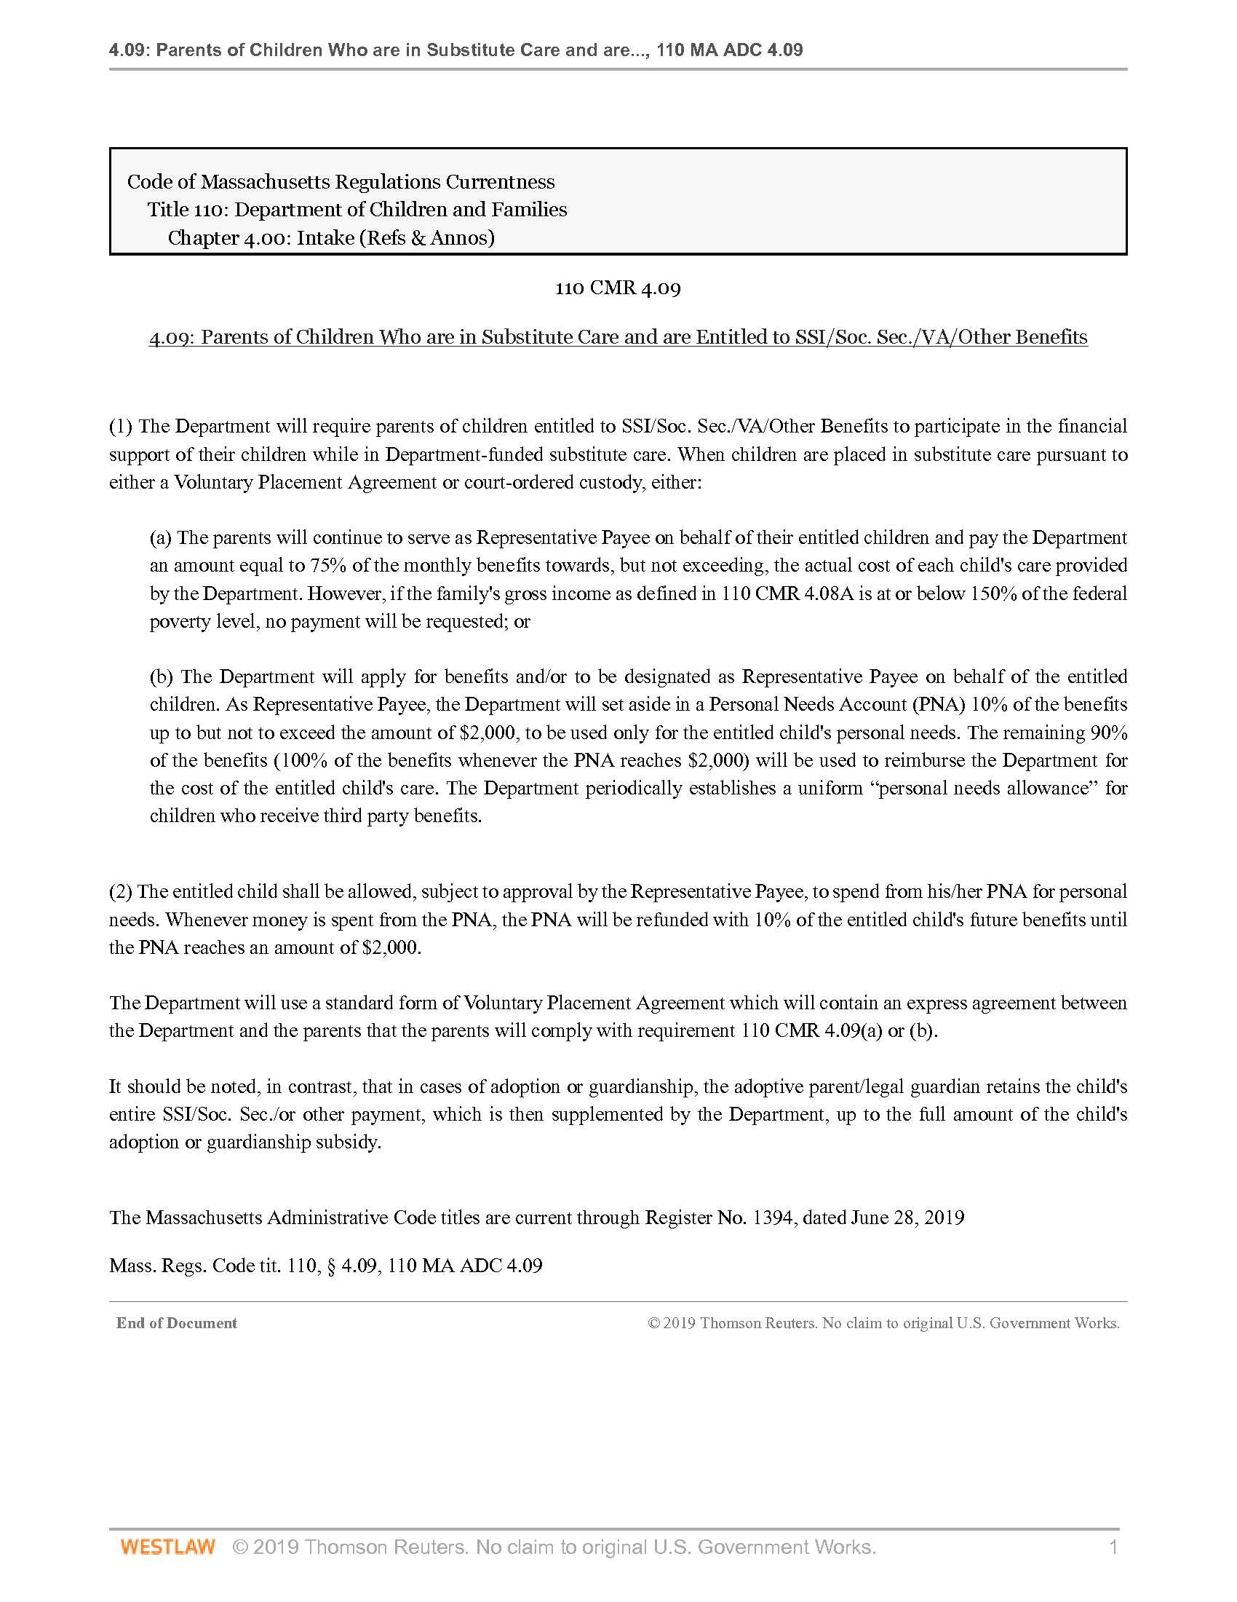

Exhibit B
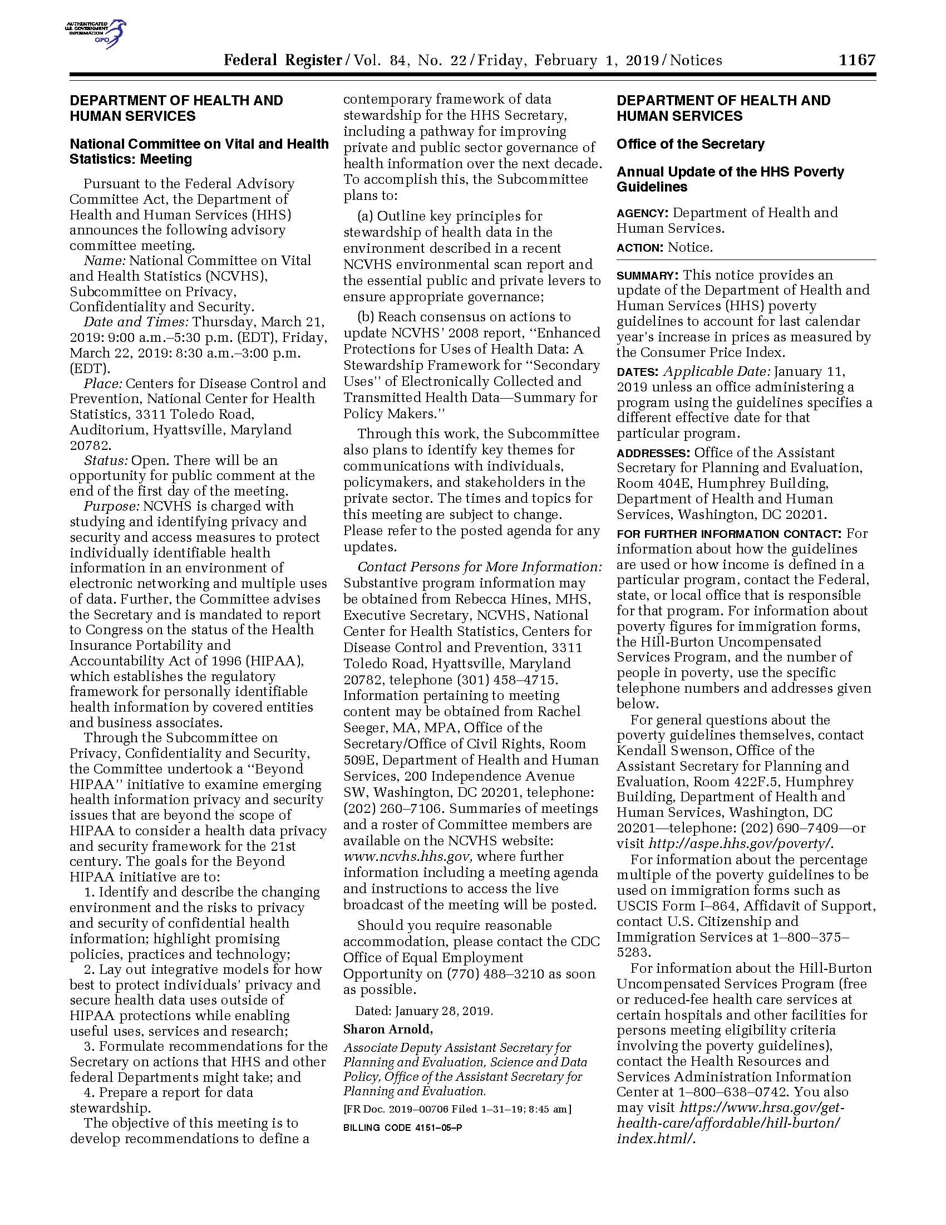
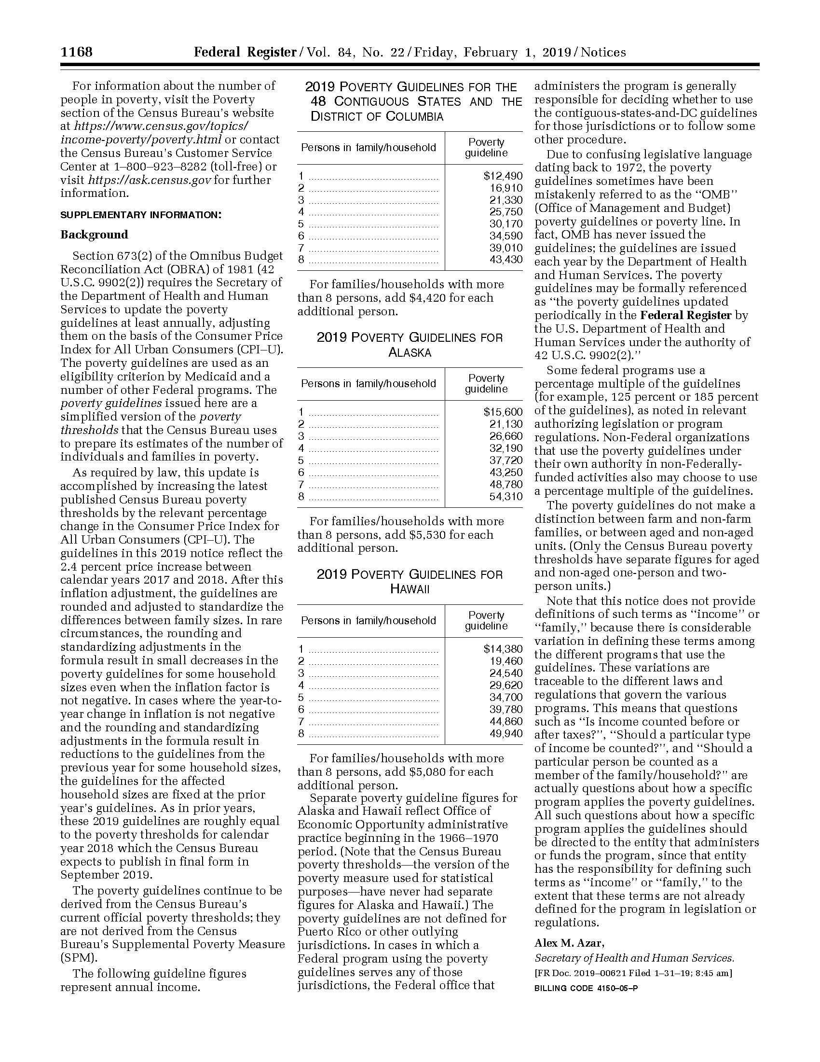

Exhibit C
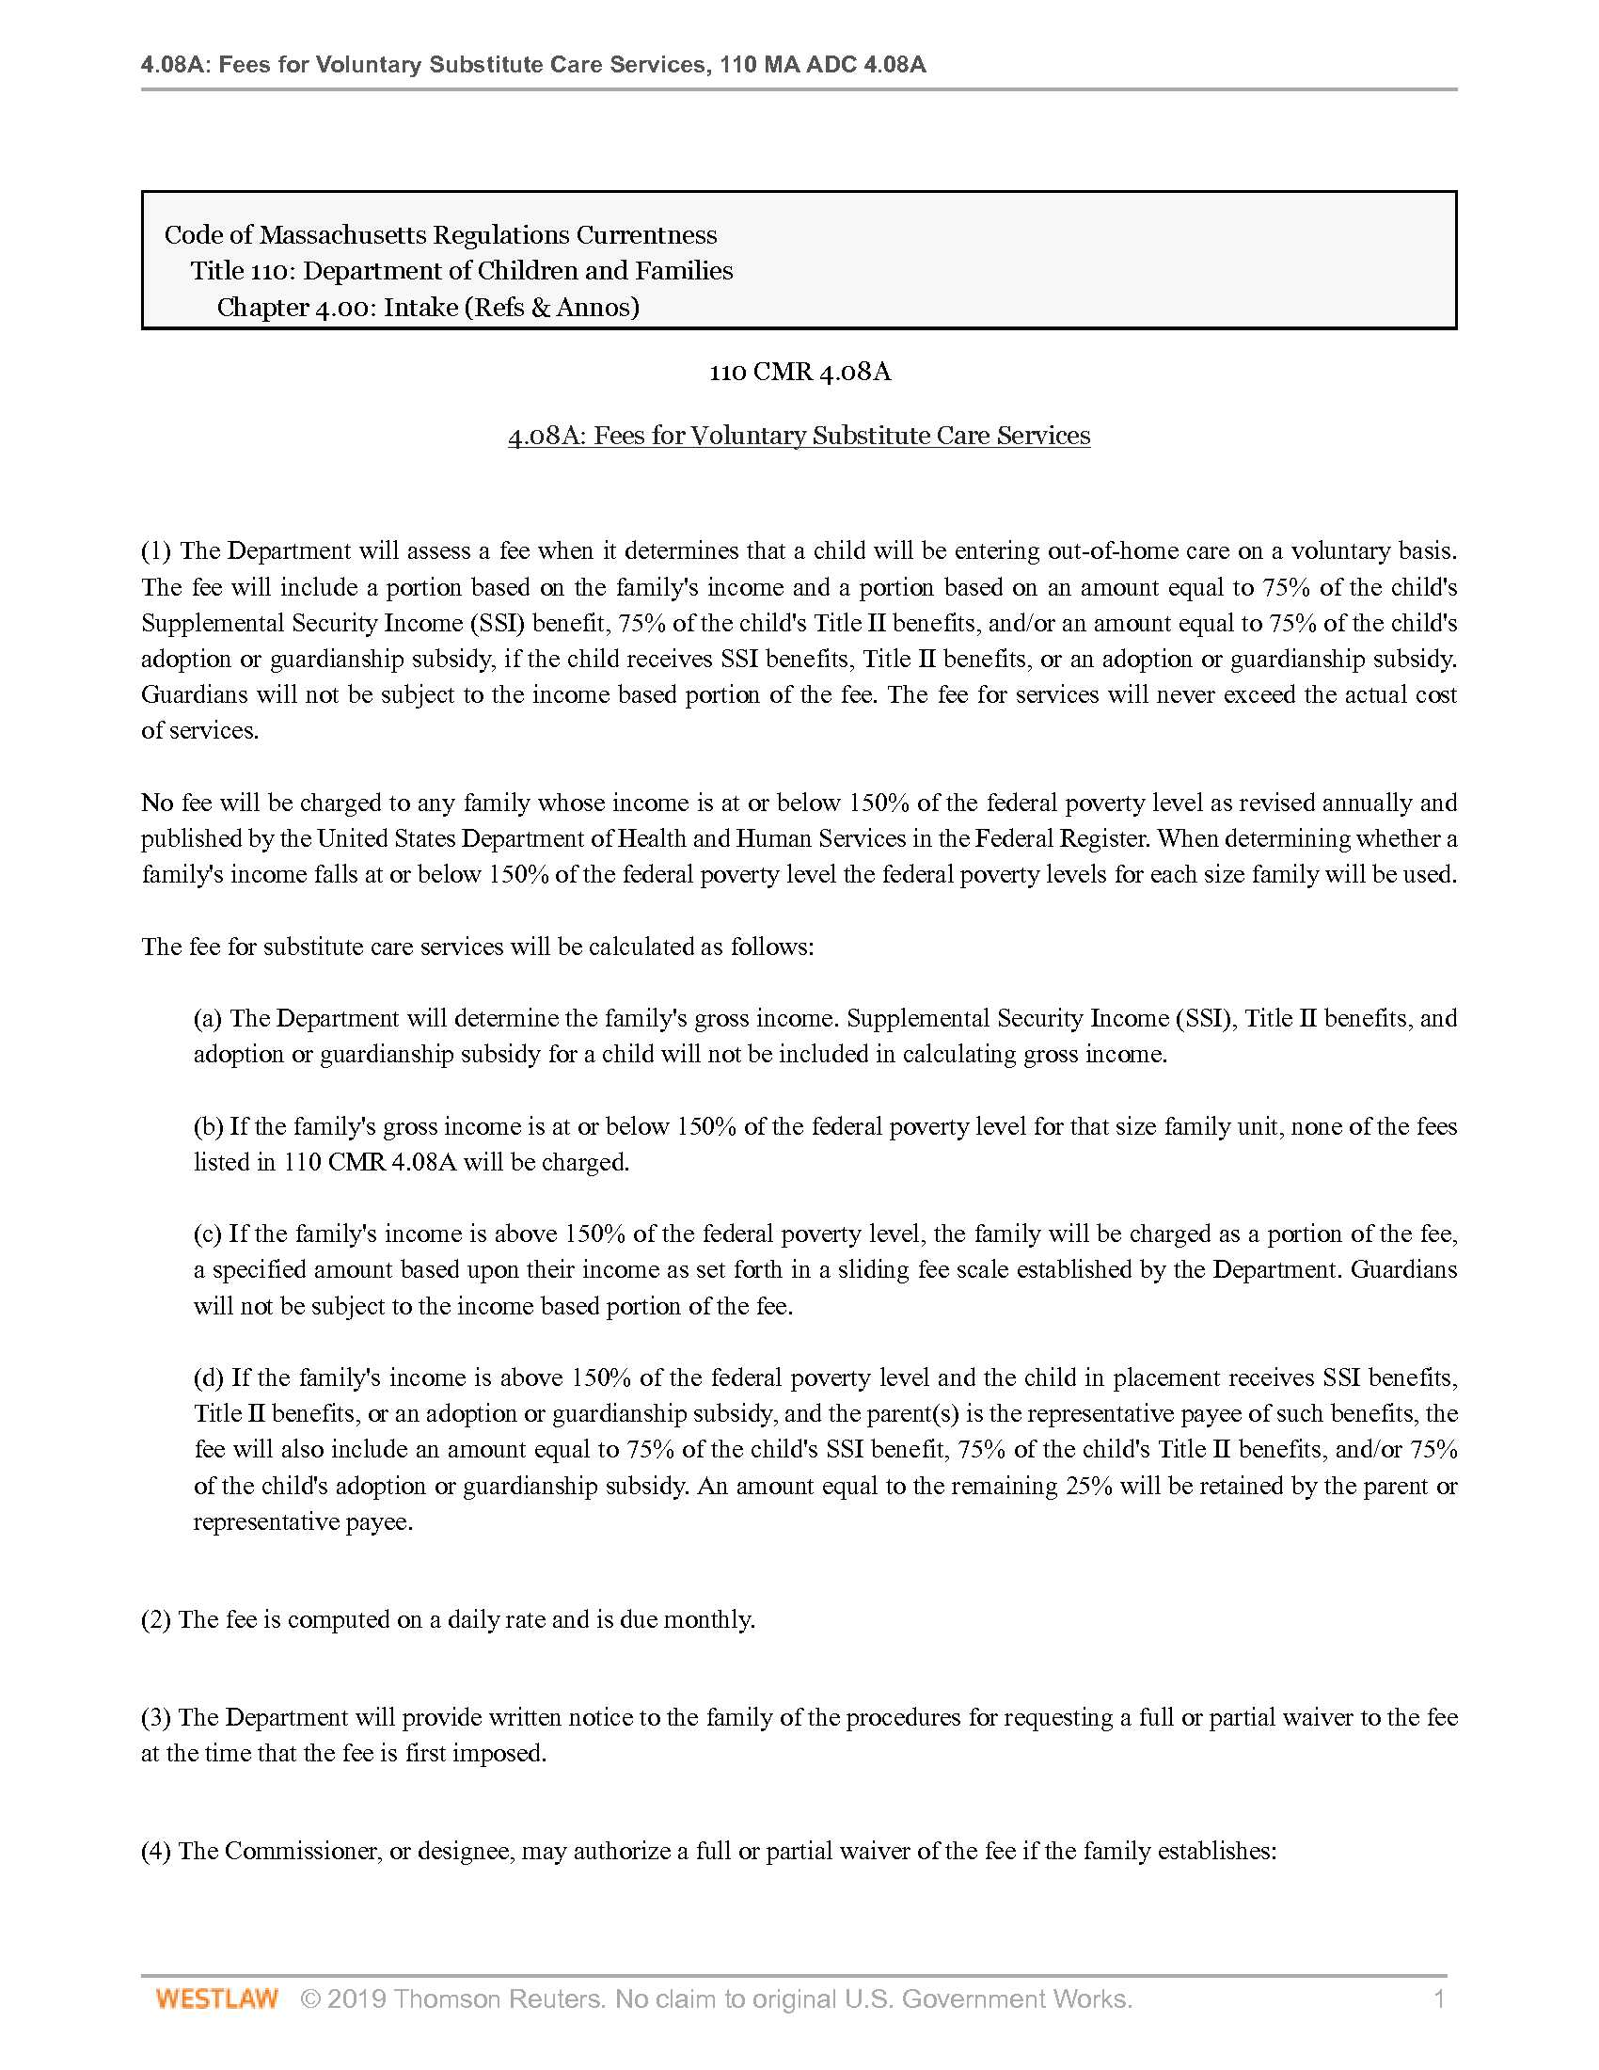
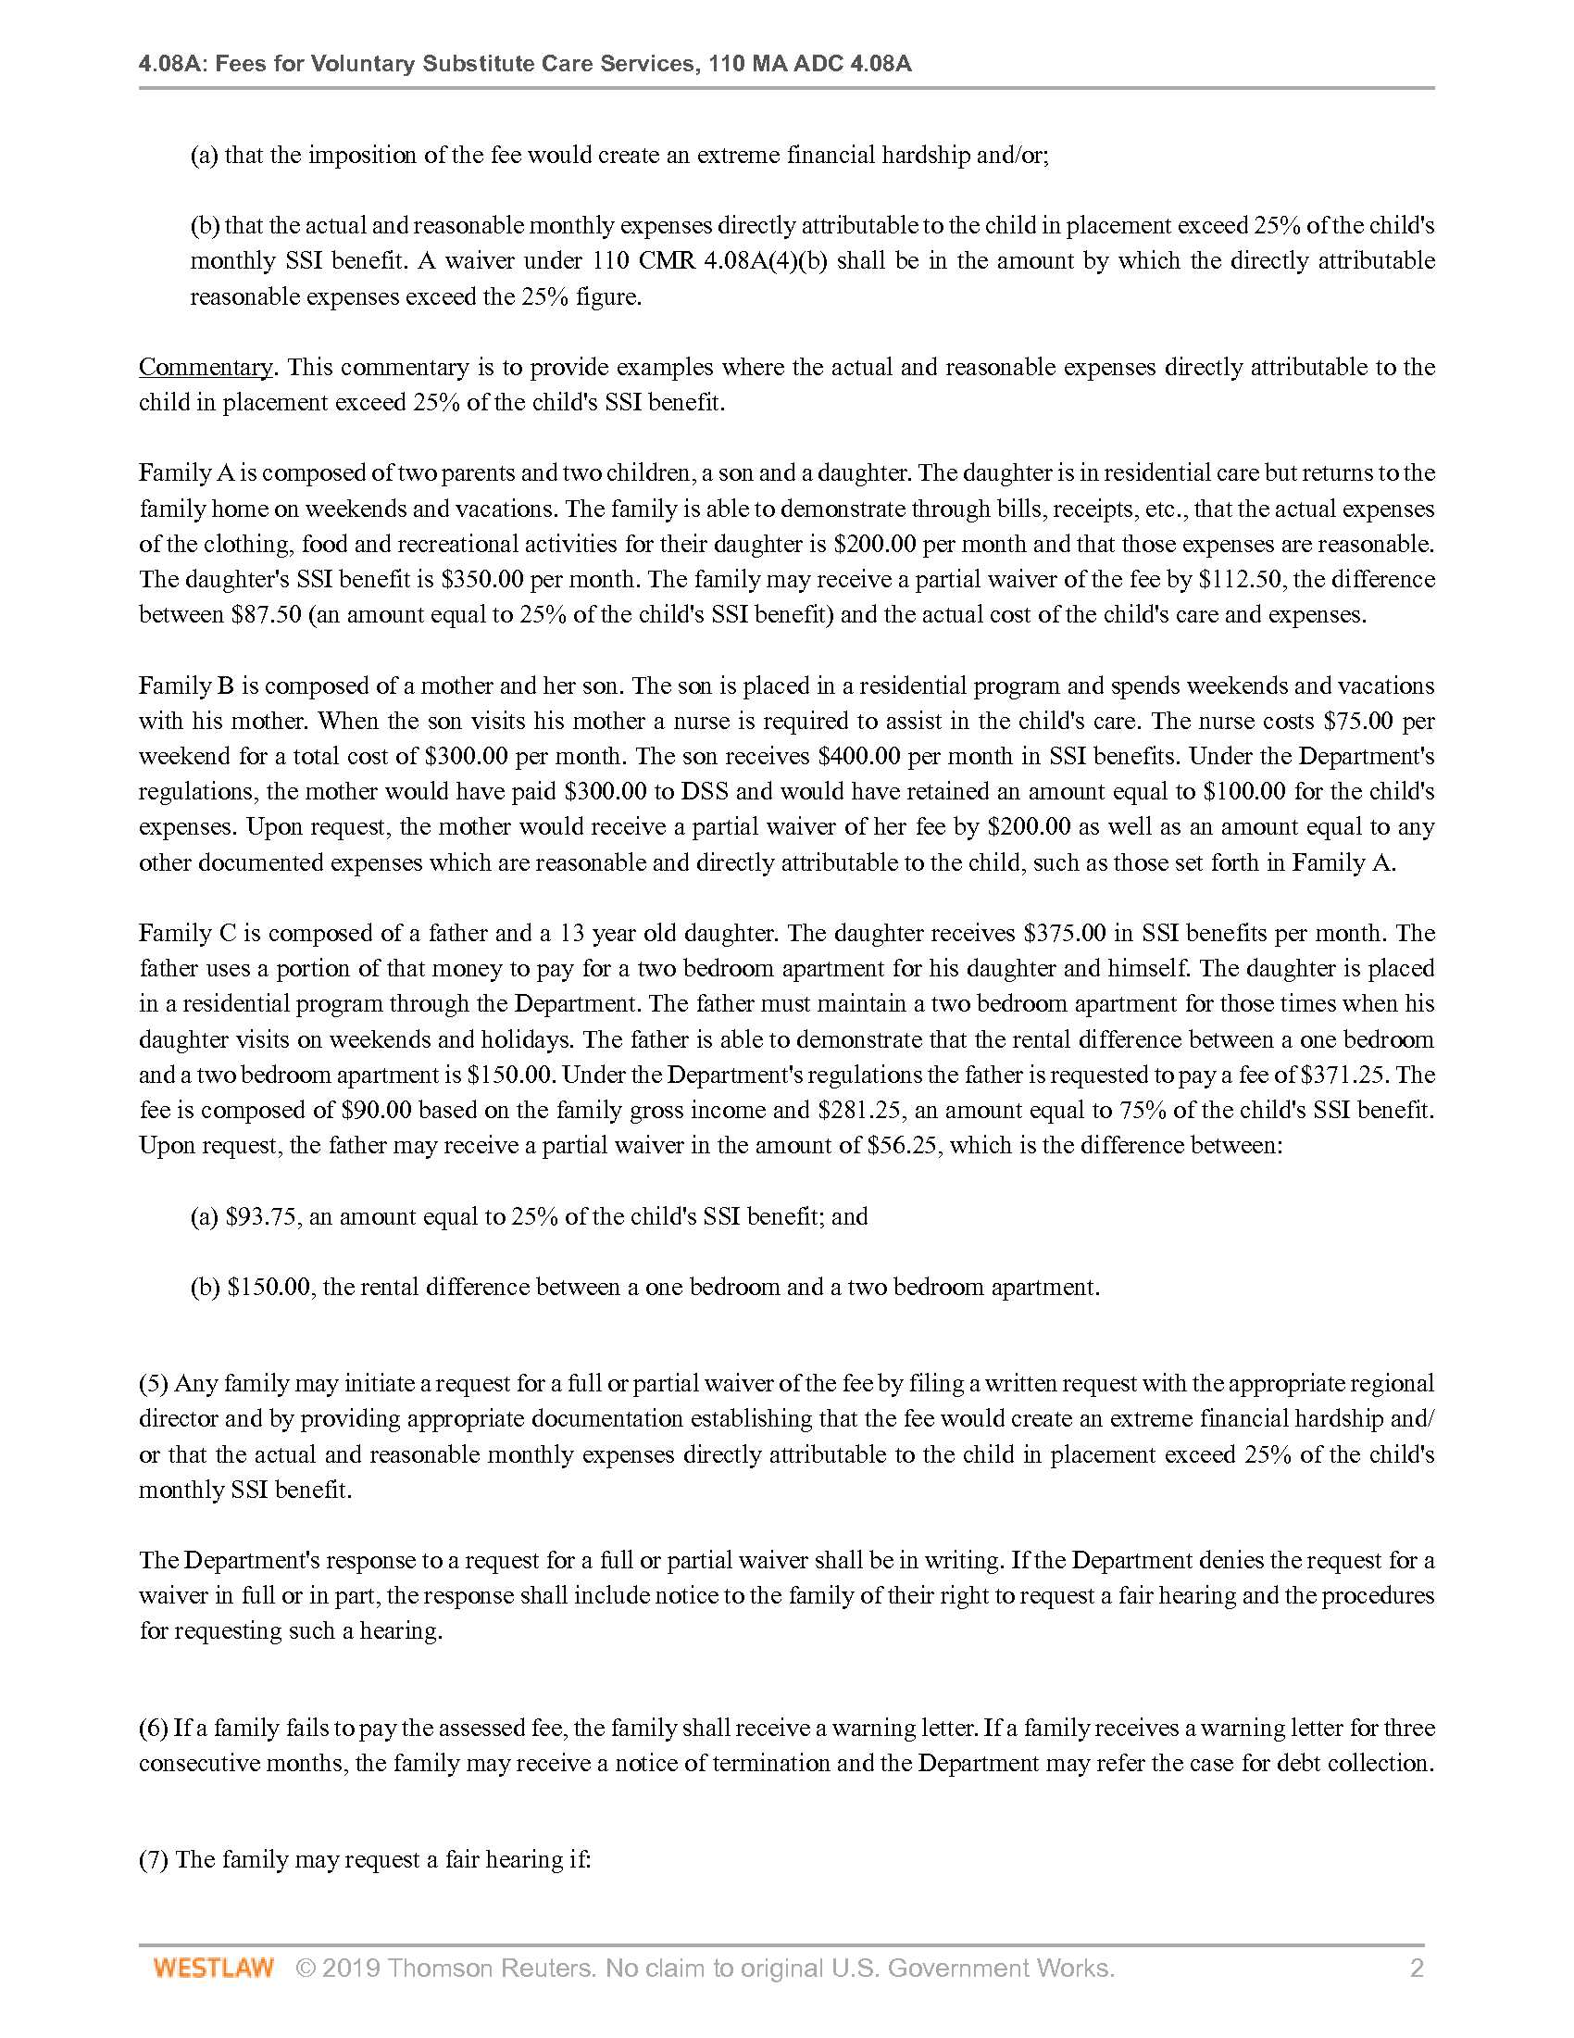
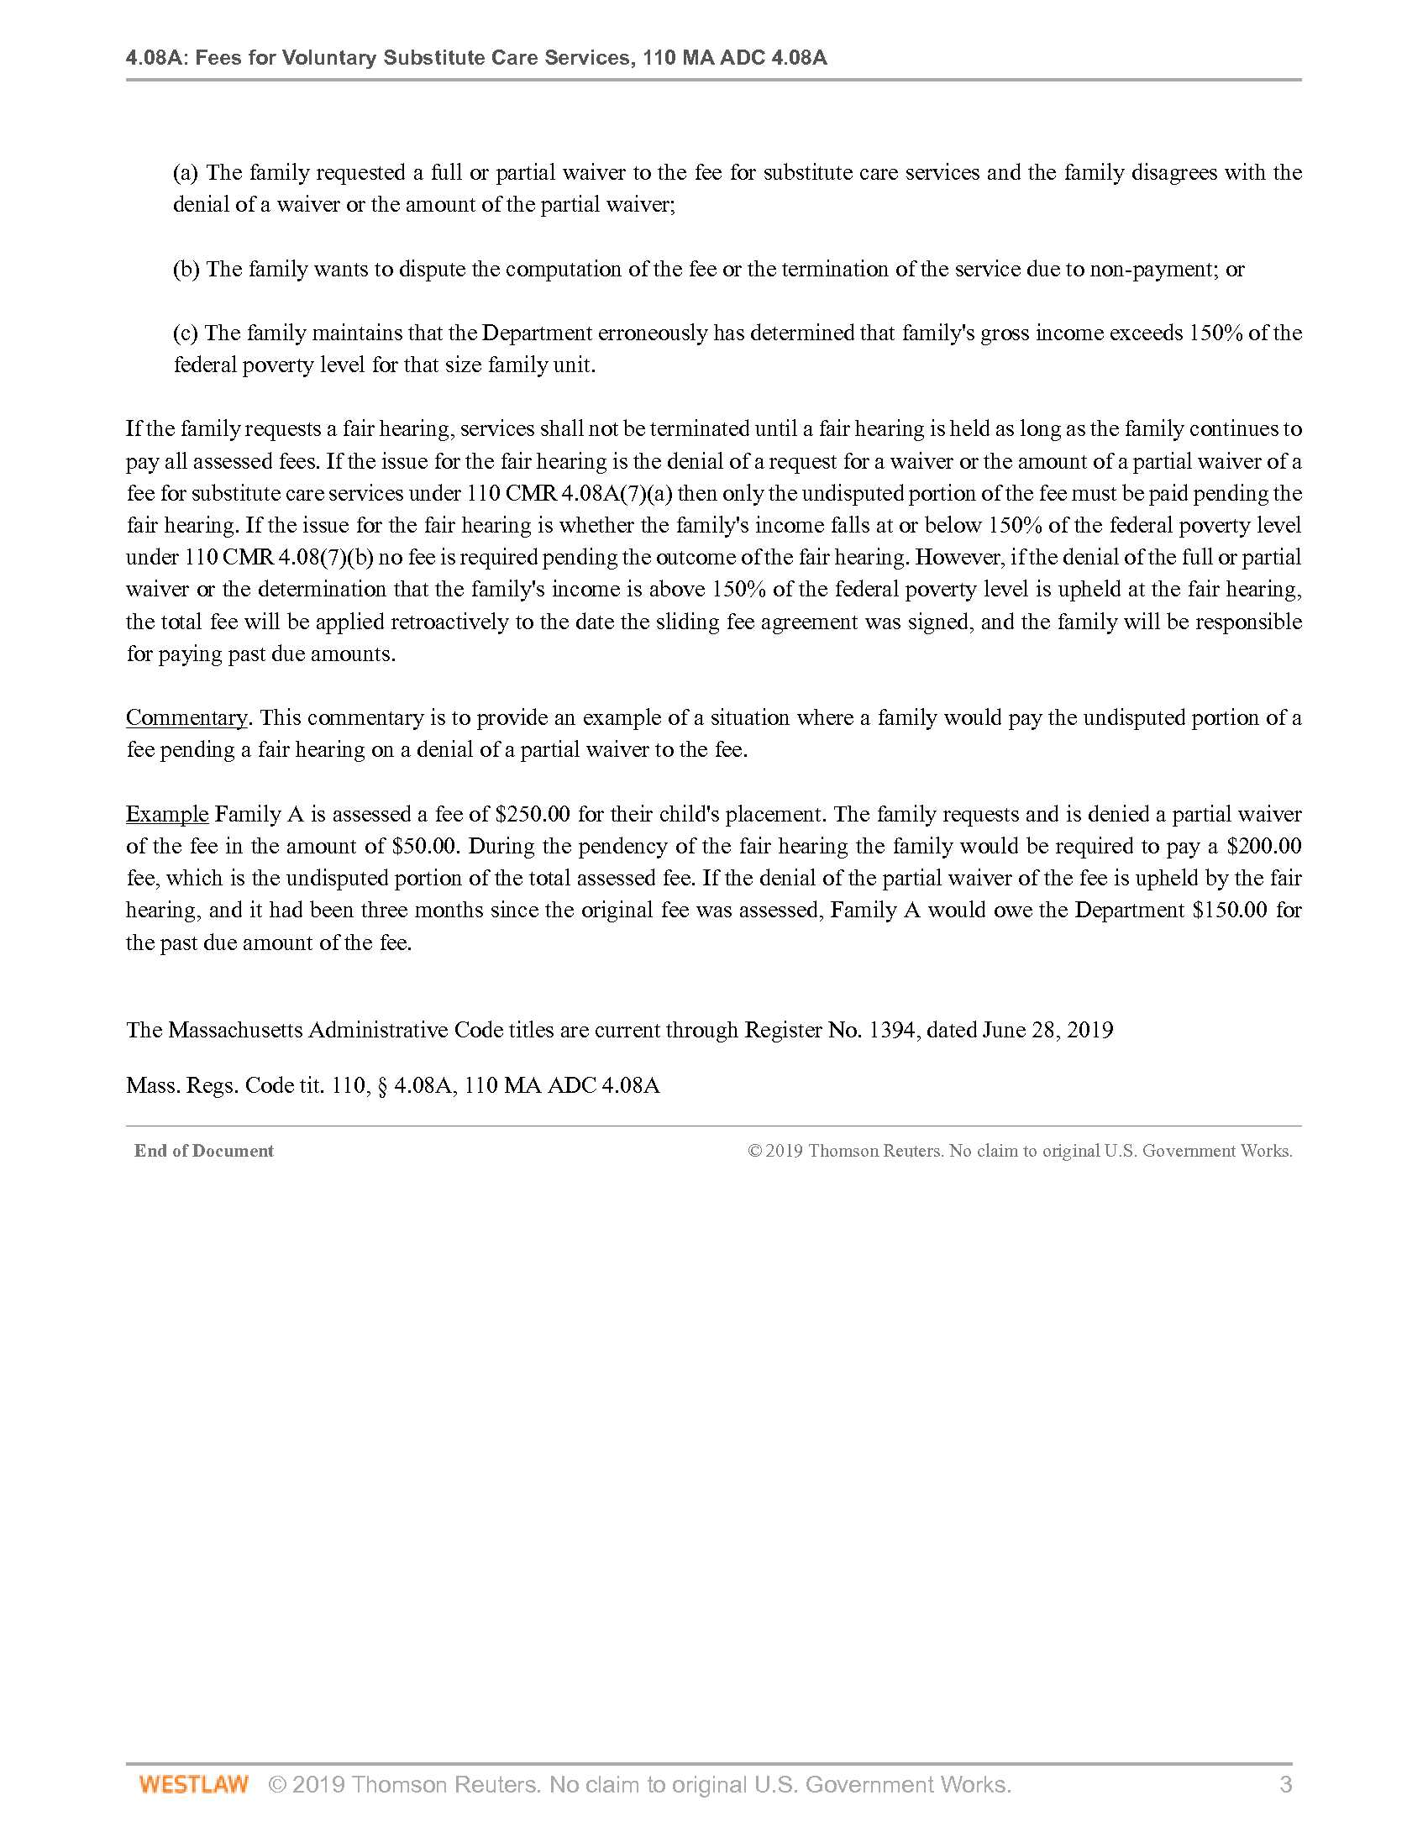

The 2019 Poverty Guideline for a family of one is $12,490; for a family of two, the Poverty Guideline is $16,910; for a family of three, $21,330. (Exhibit B, Federal Register Vol. 84, No. 22, Annual Update of the HHS Poverty Guidelines.)

